

**Capstone Project Report**

**Report 6 – Software User Guides**

– Ho Chi Minh, April 2022 –

Table of Contents

VI. Release Package & User Guides 3

1. Deliverable Package 3

1.1 Source codes & documents 3

1.2 Known Issues, Limitations & Restrictions 3

2. Installation Guides 3

2.1 System Requirements 3

2.2 Setup Files 4

2.3 Installation Instruction 4

3. User Manual 21

3.1 System requirements 21

3.2 Application Usage 22

**Table of Figures**

Figure 1: <Mobile> Mobile installation 10

Figure 2: <Mobile> App install success 11

Figure 3: <Application> PostgreSQL installation 12

Figure 4: <Application> PostgreSQL components 12

Figure 5: <Application> PostgreSQL data directory 13

Figure 6: <Application> PostgreSQL installation 13

Figure 7: <Application> DBeaver components 14

Figure 8: <Application> DBeaver data directory 14

Figure 9: <Application> DBeaver install 15

Figure 10: <Application> Select database 15

Figure 11: <Application> Setup connection 16

Figure 12: <Application> Setup connection 16

Figure 13: <Application> Setup connection 17

Figure 14: <Application> Setup connection result 17

Figure 15: <Application> JDK installation 17

Figure 16: <Application> JDK data directory 18

Figure 17: <Application> JDK installation 18

Figure 18: <Application> Open project in IDE 19

Figure 19: <Application> Run project 19

Figure 20: <Application> Database result 20

Figure 21: <Application> NodeJS installation 20

Figure 22: <Application> NodeJS data directory 21

Figure 23: <Application> NodeJS setup 21

Figure 24: <Application> NodeJS installation 22

Figure 25: <Application> NodeJS installation 22

Figure 26: <Application> Open project in IDE 23

Figure 27: <Application> Start project 23

Figure 28: <Web> Login screen 23

Figure 29: <Application> Docker installation 24

Figure 30: <Application> Flask server install 24

Figure 31: <Application> Flask server install 25

Figure 32: <Application> Run Docker 25

Figure 33: <Application> Run Docker result 25

Figure 34: <Application> Run Docker result 26

Figure 35: <Web> Login with email and password 27

Figure 36: <Web> Login with email and password 28

Figure 37: <Mobile> Login with Google 28

Figure 38: <Web> Login with Google 29

Figure 39: <Web> Logout 29

Figure 40: <Web> Logout 30

Figure 41: <Web> View profile (Step 1) 30

Figure 42: <Web> View profile (Step 2) 31

Figure 43: <Web> Profile screen 31

Figure 44: <Web> Update profile information (Step 1) 32

Figure 45: <Web> Update avatar image (Step 2) 32

Figure 46: <Web> Update avatar image (Result) 33

Figure 47: <Web> Change password (Step 1) 33

Figure 48: <Web> Change password (Step 2) 34

Figure 49: <Web> View notification list 34

Figure 50: <Web> View notification list (Result) 35

Figure 51: <Web> View configuration 35

Figure 52: <Web> Configuration dialog - Manager 36

Figure 53: <Web> Configuration dialog - Shift manager 36

Figure 54: <Web> Update configuration (Step 2) 37

Figure 55: <Web> View account list 37

Figure 56: <Web> Search account 38

Figure 57: <Web> View account detail (Step 1,2) 38

Figure 58: <Web> View account detail (Step 3) 39

Figure 59: <Web> Account detail screen 39

Figure 60: <Web> Create an account (Step 1) 40

Figure 61: <Web> Create an account (Step 2) 40

Figure 62: <Web> Create an account - Role staff (Step 3) 41

Figure 63: <Web> Create an account - Role examinee (Step 3) 42

Figure 64: <Web> Import account (Step 1) 43

Figure 65: <Web> Import accounts (Step 2) 43

Figure 66: <Web> Examinee information excel example 44

Figure 67: <Web> Import accounts (Step 3) 44

Figure 68: <Web> Import account result 45

Figure 69: <Web> Example of error file 45

Figure 70: <Web> Update account (Step 1,2) 45

Figure 71: <Web> Update account (Step 3) 46

Figure 72: <Web> Disable account on account screen (Step 1,2) 46

Figure 73: <Web> Disable account on account detail screen 47

Figure 74: <Web> Confirm dialog for disable account 47

Figure 75: <Web> Reset password (Step 1) 48

Figure 76: <Web> Confirm dialog for reset password (Step 2) 48

Figure 77: <Web> Embed face (Step 1) 49

Figure 78: <Web> Embed face (Step 2) 49

Figure 79: <Web> Embed face (Step 3) 50

Figure 80: <Web> View tool list 50

Figure 81: <Web> Search and filter tool 51

Figure 82: <Web> Create tool (Step 1) 51

Figure 83: <Web> Create tool (Step 3) 52

Figure 84: <Web> Update tool (Step 1, 2) 53

Figure 85: <Web> Update tool (Step 4) 53

Figure 86: <Web> Disable tool (Step 1, 2)) 54

Figure 87: <Web> Disable tool (Step 3) 54

Figure 88: <Web> View subject list 55

Figure 89: <Web> Search and filter subject 55

Figure 90: <Web> Create subject (Step 1) 56

Figure 91: <Web> Create subject (Step 2) 56

Figure 92: <Web> Update subject (Step 1,2) 57

Figure 93: <Web> Update subject (Step 3) 58

Figure 94: <Web> Disable subject (Step 1,2) 58

Figure 95: <Web> Disable subject (Step 3) 59

Figure 96: <Web> Add tool to subject (Step 1,2) 59

Figure 97: <Web> Add tool to subject (Step 3) 60

Figure 98: <Web> Add tool to subject (Step 4) 61

Figure 99: <Web> Remove tool from subject (Step 1,2) 62

Figure 100: <Web> Remove tool from subject (Step 3) 62

Figure 101: <Web> Remove to from subject (Step 4) 63

Figure 102: <Web> View semester list 64

Figure 103: <Web> Search, filter and sort semester 64

Figure 104: <Web> Create semester (Step 1) 65

Figure 105: <Web> Create semester (Step 3) 65

Figure 106: <Web> Semester detail screen (Step 1,2) 66

Figure 107: <Web> Semester detail screen 66

Figure 108: <Web> Update semester (Step 1,2) 67

Figure 109: <Web> Update semester (Step 4) 67

Figure 110: <Web> DIsable semester on semester screen (Step 1,2) 68

Figure 111: <Web> DIsable semester on semester detail screen 68

Figure 112: <Web> Confirm dialog for disable semester 69

Figure 113: <Web> Add subject to semester (Step 1) 69

Figure 114: <Web> Add subject to semester (Step 2) 70

Figure 115: <Web> Add subject to semester (Step 3) 70

Figure 116: <Web> Remove subject from semester (Step 1) 71

Figure 117: <Web> Remove subject from semester (Step 2) 71

Figure 118: <Web> View room list 72

Figure 119: <Web> Search and filter room 72

Figure 120: <Web> Create room (Step 1) 73

Figure 121: <Web> Create room (Step 3) 73

Figure 122: <Web> View detail room (Step 1,2) 74

Figure 123: <Web> Room detail screen 74

Figure 124: <Web> Update room (Step 1,2) 75

Figure 125: <Web> Update room (Step 4) 75

Figure 126: <Web> Disable room on room screen (Step 1,2) 76

Figure 127: <Web> Disable room in room detail screen 76

Figure 128: <Web> Confirm dialog for disable room 76

Figure 129. <Web> View subject assignments list 77

Figure 130. <Web> Search and filter subject assignments 77

Figure 131. <Web> Import examinees (Step 1) 78

Figure 132. <Web> Import examinees - Format in file excel example. 78

Figure 133. <Web> Import examinees (Step 3) 79

Figure 134. <Web> Import examinees – Result 80

Figure 135. <Web> Import examinees - Error file example 80

Figure 136. <Web> View subject assignment detail 81

Figure 137. <Web> Subject assignment detail screen 81

Figure 138. <Web> Remove examinee from semester's subject (Step 1) 82

Figure 139. <Web> Remove examinee from semester's subject (Step 3) 82

Figure 140. <Web> View shift list 83

Figure 141. <Web> Filter shift 83

Figure 142. <Web> Auto assign shifts (Step 1, 2) 84

Figure 143. <Web> Auto assign shifts (Step 4) 84

Figure 144. <Web> View shift detail (Step 1, 2) 85

Figure 145. <Web> Shift detail screen 85

Figure 146. <Web> Create shift (Step 1, 2) 86

Figure 147. <Web> Create shift (Step 3, 4) 86

Figure 148. <Web> Update shift (Step 1, 2) 87

Figure 149. <Web> Update shift (Step 3) 87

Figure 150. <Web> Delete shift on shift screen (Step 1, 2) 88

Figure 151. <Web> Delete shift on shift detail screen (Step 1, 2) 88

Figure 152. <Web> Delete shift (Step 3) 89

Figure 153. <Web> Start shift registration on shift screen (Step 1, 2) 89

Figure 154. <Web> Start shift registration on shift screen (Step 4) 90

Figure 155. <Web> Start shift registration on shift detail screen 91

Figure 156. <Web> Start shift registration on shift screen (Step 1, 2) 91

Figure 157. <Web> Start shift registration on shift screen (Step 4) 92

Figure 158. <Web> Start shift registration on shift detail screen 93

Figure 159. <Web> Export shifts 93

Figure 160. Content of file excel about shift 94

Figure 161. <Web> Create exam room (Step 1) 94

Figure 162. <Web> Create exam room (Step 3) 95

Figure 163. <Web> Create exam room (Step 4) 95

Figure 164. <Web> Create exam room - Create empty or occupied room 1 96

Figure 165. <Web> Create exam room - Create empty or occupied room 2 96

Figure 166. <Web> Create exam room - Move examinee 1 97

Figure 167. <Web> Create exam room - Move examinee 2 97

Figure 168. <Web> Create exam room - Move examinee 3 98

Figure 169. <Web> Create exam room (Step 5) 98

Figure 170. <Web> View detail semester (Step 1, 2) 99

Figure 171. <Web> Exam room detail screen 99

Figure 172. <Web> Update exam room (Step 1, 2) 100

Figure 173. <Web> Update exam room (Step 4) 100

Figure 174. <Web> Remove exam room on shift detail screen (Step 1, 2) 101

Figure 175. <Web> Remove exam room on exam room detail screen 101

Figure 176. <Web> Confirm dialog for remove exam room 102

Figure 177. <Web> Assign staff (Step 1, 2) 102

Figure 178. <Web> Assign staff (Step 4) 103

Figure 179. <Web> Create attendance (Step 1) 103

Figure 180. <Web> Create attendance (Step 3) 104

Figure 181. <Web> Delete attendance 104

Figure 182. <Web> Export attendances 105

Figure 183. <Web> Export attendance - File excel example 105

Figure 184. <Web> View report list 106

Figure 185. <Web> Search and filter report 106

Figure 186. <Web> View report detail 107

Figure 187. <Web> Report detail screen 107

Figure 188. <Web> Resolve report 108

Figure 189. <Staff app> Overview 108

Figure 190. <Staff app> Login step 1 109

Figure 191. <Staff app> Login step 2 109

Figure 192. <Staff app> Login with google 110

Figure 193. <Staff app> Log out 110

Figure 194. <Staff app> Shift registration (Step 1) 111

Figure 195. <Staff app> Shift registration (Step 2) 111

Figure 196. <Staff app> Shift registration ( Step 3) 112

Figure 197. <Staff app> View assigned shift (Step 1) 113

Figure 198. <Staff app> View assigned shift (Step 2) 113

Figure 199. <Staff app> View notifications 114

Figure 200. <Staff app> Change password (Step 1) 115

Figure 201. <Staff app> Change password (Step 2) 115

Figure 202. <Staff app> Change password (Step 3) 116

Figure 203. <Staff app> Change password (Step 4) 116

Figure 204. <Staff app> Update profile (Step 1) 117

Figure 205. <Staff app> Update profile (Step 2) 117

Figure 206. <Staff app> Update profile (Step 3) 118

Figure 207. <Staff app> Update profile (Step 4) 118

Figure 208. <Staff app> QR Scanner 119

Figure 209. <Examinee app> Overview 120

Figure 210. <Examinee app> Log in (Step 1) 120

Figure 211. <Examinee app> Login (Step 2) 121

Figure 212. <Examinee app> Login with Google 121

Figure 213. <Examinee app> Log out 122

Figure 214. <Examinee app> View exam schedule (Step 1) 122

Figure 215. <Examinee app> View exam schedule (Step 2) 123

Figure 216. <Examinee app> View notifications 123

Figure 217. <Examinee app> Change password (Step 1) 124

Figure 218. <Examinee app> Change password (Step 2) 124

Figure 219. <Examinee app> Change password (Step 3) 125

Figure 220. <Examinee app> Change password (Step 4) 125

Figure 221. <Examinee app> Update profile (Step 1) 126

Figure 222. <Examinee app> Update profile (Step 2) 126

Figure 223. <Examinee app> Update profile (Step 3) 127

Figure 224. <Examinee app> Update profile (Step 4) 127

Figure 225. <Examinee app> QR Scanner 128

Figure 226. <Camera app> Overview 129

Figure 227. <Camera app> Login (Step 1) 129

Figure 228. <Camera app> Login (Step 2) 130

Figure 229. <Camera app> Login with Google 130

Figure 230. <Camera app> Login with QR 131

Figure 231. <Camera app> Check attendance (Step 1) 131

Figure 232. <Camera app> Check attendance (Step 2) 132

Figure 233. <Camera app> Check attendance (Step 3) 132

Figure 234. <Camera app> Verify success modal 133

Figure 235. <Camera app> Verify fail modal 133

Figure 236. <Camera app> Attendance tab 134

Figure 237. <Camera app> Check attendance (Step 4) 134

Figure 238. <Camera app> Check attendance (Step 5) 135

Figure 239. <Camera app> View current exam room detail 136

Figure 240. <Camera app> Update attendance (Step 1) 136

Figure 241. <Camera app> Update attendance (Check) 137

Figure 242. <Camera app> Update attendance (Uncheck) 137

Figure 243 <Camera app> Update attendance (Finish) 138

Figure 244. <Camera app> Create report (Step 1) 138

Figure 245. <Camera app> Choose report type 139

Figure 246. <Camera app> Create report form 139

Figure 247. <Camera app> Create report (Step 3) 140

Figure 248. <Camera app> Update report (Step 1) 140

Figure 249. <Camera app> Update report (Step 2) 141

Figure 250. <Camera app> Update report (Step 3) 141

Figure 251. <Camera app> Update report (Step 4) 142

Figure 252. <Camera app> Finish exam 142

Figure 253. <Camera app> Log out 143

# VI. Release Package & User Guides

## 1. Deliverable Package

### 1.1 Source codes & documents

Table 1. Source codes & documents

| **No.** | **Items** | **Sub-Items** | **Type** | **Version** |
| --- | --- | --- | --- | --- |
| ***Code Package*** | | | | |
| 1 | APIs Server | valua-be.zip | New | 1.0 |
| 2 | Web Application | valua-web.zip | New | 1.0 |
| 3 | Verify server | valua-ai.zip | New | 1.0 |
| 4 | Staff mobile application | valua-staff.zip | New | 1.0 |
| 5 | Examinee mobile application | valua-examinee.zip | New | 1.0 |
| 6 | Camera mobile application | valua-camera.zip | New | 1.0 |
| ***Documents*** | | | | |
| 1 | Project Introduction | VaLua_Report1_ProjectIntroduction.docx | New | 1.0 |
| 2 | Project Management Plan | VaLua_Report2_ProjectManagementPlan.docx | New | 1.0 |
| 3 | System Requirement Specification | VaLua_Report3_SystemRequirementSpecification.docx | New | 1.0 |
| 4 | Software Design Document | VaLua_Report4_SoftwareDesignDocument.docx | New | 1.0 |
| 5 | Test Documentation | VaLua_Report5_TestDocumentation.docx | New | 1.0 |
| 6 | Software User Guides | VaLua_Report6_SoftwareUserGuides.docx | New | 1.0 |
| 7 | Final Project Report | VaLua_Report7_FinalProjectReport.docx | New | 1.0 |
| 8 | Sprint Backlog | VaLua_SprintBacklog.docx | New | 1.0 |

### 1.2 Known Issues, Limitations & Restrictions

* The VaLua system can only assist staff in checking attendances, does not completely replace them, and still needs supervisors to manually check attendances in case of AI errors as well as manage the exam in the room they are assigned to.
* Brightness and others environmental elements that possibly alter the captured image limit the accuracy of attendance checking. The accuracy is also affected by image quality (resolution).
* Due to a library bug, the camera app must be set to stand by to prevent camera freezing if the screen is down.

## 2. Installation Guides

### 2.1 System Requirements

#### 2.1.1. Hardware requirement

##### For mobile applications:

|  |  |
| --- | --- |
| **Operation System** | **Android 6 or higher** |
| Memory | 1GB of RAM or higher |
| Internet | The application required internet to be used |

##### For database:

|  |  |
| --- | --- |
| **Operation System** | **Windows 10 Pro, Windows Server 2019 R2** |
| Memory | 8GB of RAM or higher |
| Hard drive | 256GB or higher |
| DBMS | PostgreSQL 13 |

##### For APIs server:

|  |  |
| --- | --- |
| **Operation System** | **Windows 10 Pro, Windows Server 2019 R2** |
| Processor | Intel Core i5 8th Generation processor or higher |
| Memory | 8GB of RAM or higher |
| Internet | The application required internet to be used |
| Hard drive | 256GB or higher |

##### For web application:

|  |  |
| --- | --- |
| **Operation System** | **Windows 10 Pro, Windows Server 2019 R2** |
| Memory | 8GB of RAM or higher |
| Internet | The application required internet to be used |
| Browser | Chrome (version 87 or higher), IE (version 11 or higher) or any browser that supports HTML5 and CSS3 |

##### For verify server:

|  |  |
| --- | --- |
| **Operation System** | **Windows 10 Pro, Windows Server 2019 R2, Ubuntu** |
| Processor | Intel Core i5 8th Generation processor or higher |
| Memory | 8GB of RAM or higher |
| Hard drive | 256GB or higher |
| GPU | NVIDIA GeForce GTX 1050ti or higher |

### 2.2 Setup Files

|  |  |
| --- | --- |
| **Type** | **File** |
| Web API | valua-be.zip |
| Web Application | valua-web.zip |
| Detection server | valua-ai.zip |
| Staff mobile application | valua-staff.apk |
| Camera mobile application | valua-camera.apk |
| Examinee mobile application | valua-examinee.apk |

### 2.3 Installation Instruction

#### 2.3.1. Mobile application

- For Android devices:

* Copy APK file to the storage of your mobile phone
* Press “Install” to install the application

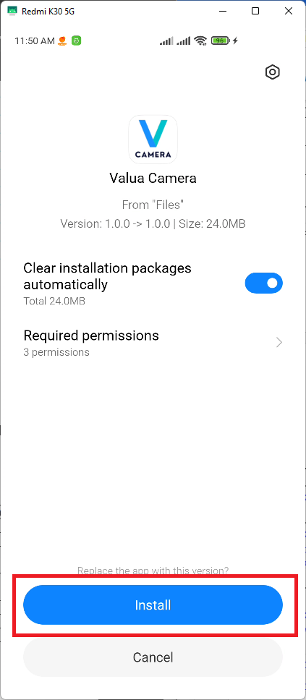

Figure 1: <Mobile> Mobile installation

* After the installation process finish, press the app icon to start the application

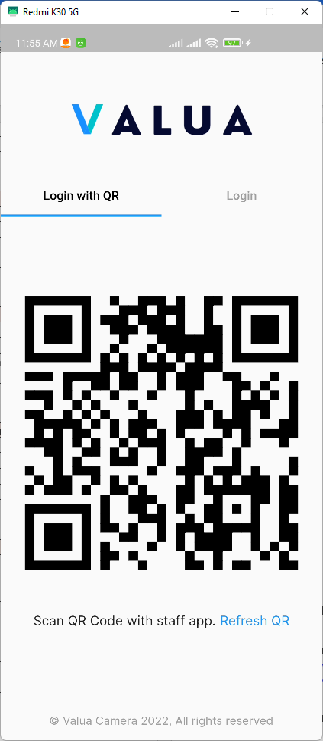

Figure 2: <Mobile> Camera App is installed successfully

#### 2.3.2. Database

* PostgreSQL 13.6 download link: [Download link](https://get.enterprisedb.com/postgresql/postgresql-13.6-2-windows-x64.exe)
* Step-by-step installation guide: [Installation guide](https://www.enterprisedb.com/docs/supported-open-source/postgresql/installer/02_installing_postgresql_with_the_graphical_installation_wizard/01_invoking_the_graphical_installer/)
* Run the setup file and choose install location:

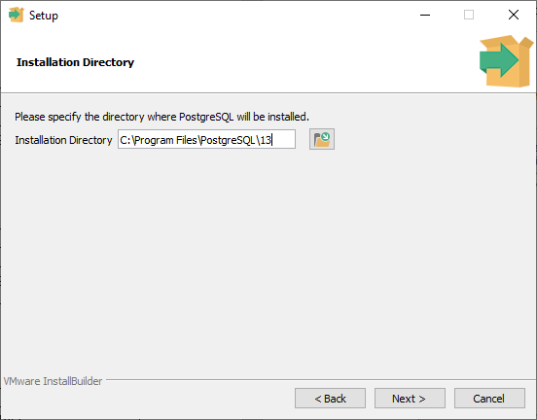

Figure 3: <Application> PostgreSQL installation

* Choose PostgreSQL Server and Command Line Tools

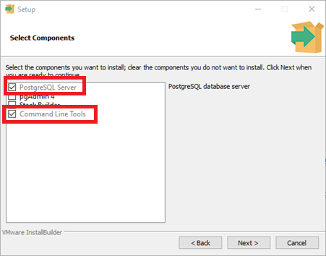

Figure 4: <Application> PostgreSQL components

* Choose data directory location:

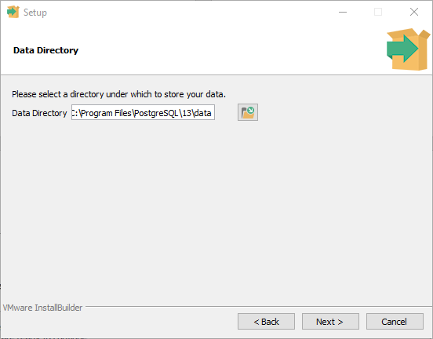

Figure 5: <Application> PostgreSQL data directory

* Wait for the installation program to finish running.

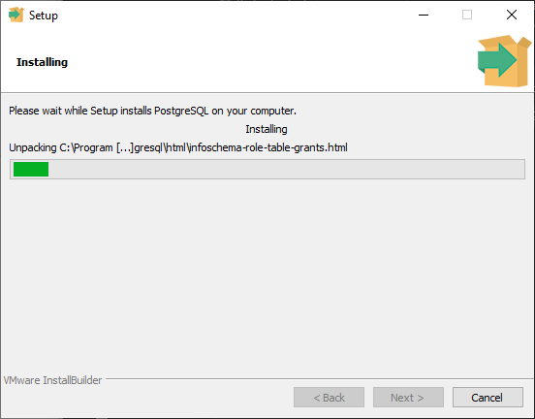

Figure 6: <Application> PostgreSQL installation

* Download the latest available version of DBeaver, link: [Download link](https://dbeaver.io/download/)
* Run the setup file and choose “*DBeaver” Community* and “*Include Java”*

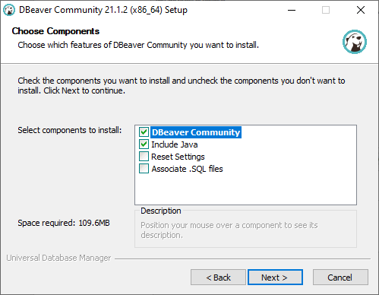

Figure 7: <Application> DBeaver components

* Choose the installation directory.

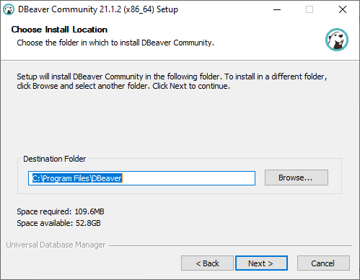

Figure 8: <Application> DBeaver data directory

* Wait for the installation program to finish running.

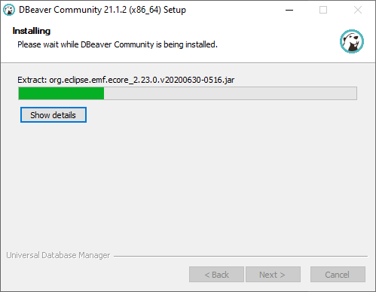

Figure 9: <Application> DBeaver install

* Open DBeaver and create a new database name “evds”
* Left click on database navigator => Create => Connection => Choose PostgreSQL

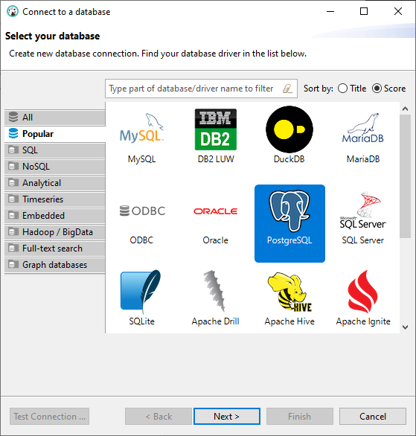

Figure 10: <Application> Select database

* Enter your authentication username and password and empty server database field.

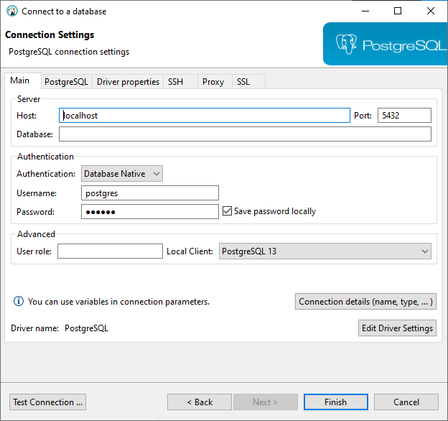

Figure 11: <Application> Setup a connection

- Check “Show all databases” in PostgreSQL tab then click “Finish”

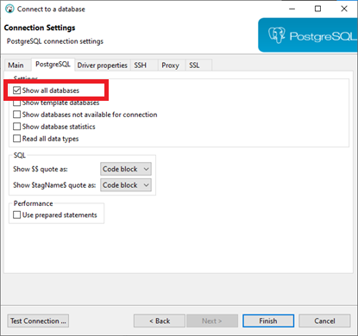

Figure 12: <Application> Setup connection

- Left click on the added PostgreSQL connection => Create => Database with the following config, then click “OK”

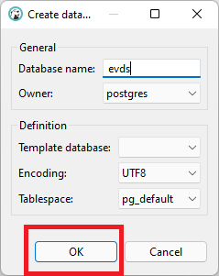

Figure 13: <Application> Setup a connection

* Result:

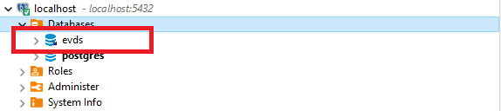

Figure 14: <Application> Setup connection result

#### 2.3.3. For API Server

* Download any Java IDE (Eclipse, NetBeans, IntelliJ IDEA) to run and initialize the backend API. In this guide, we will use IntelliJ IDEA Ultimate Edition
* IntelliJ IDEA Download link: [Download link](https://www.jetbrains.com/idea/download/#section=windows)
* Download Java 11 (Link: [Download link](https://www.oracle.com/java/technologies/javase/jdk11-archive-downloads.html) )

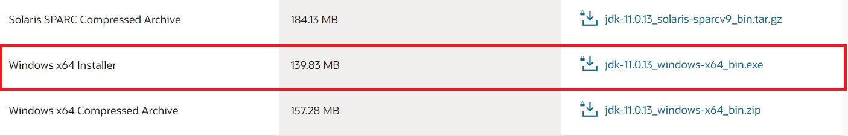

Figure 15: <Application> JDK installation

* Open setup file and select install location, click Next

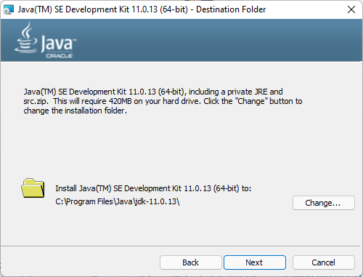

Figure 16: <Application> JDK data directory

* Wait for the installation to complete.

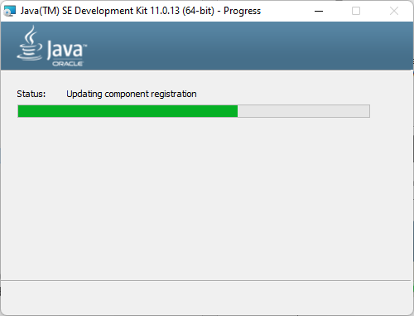

Figure 17: <Application> JDK installation

* Extract valua-be.zip, open the extracted folder in your IDE.

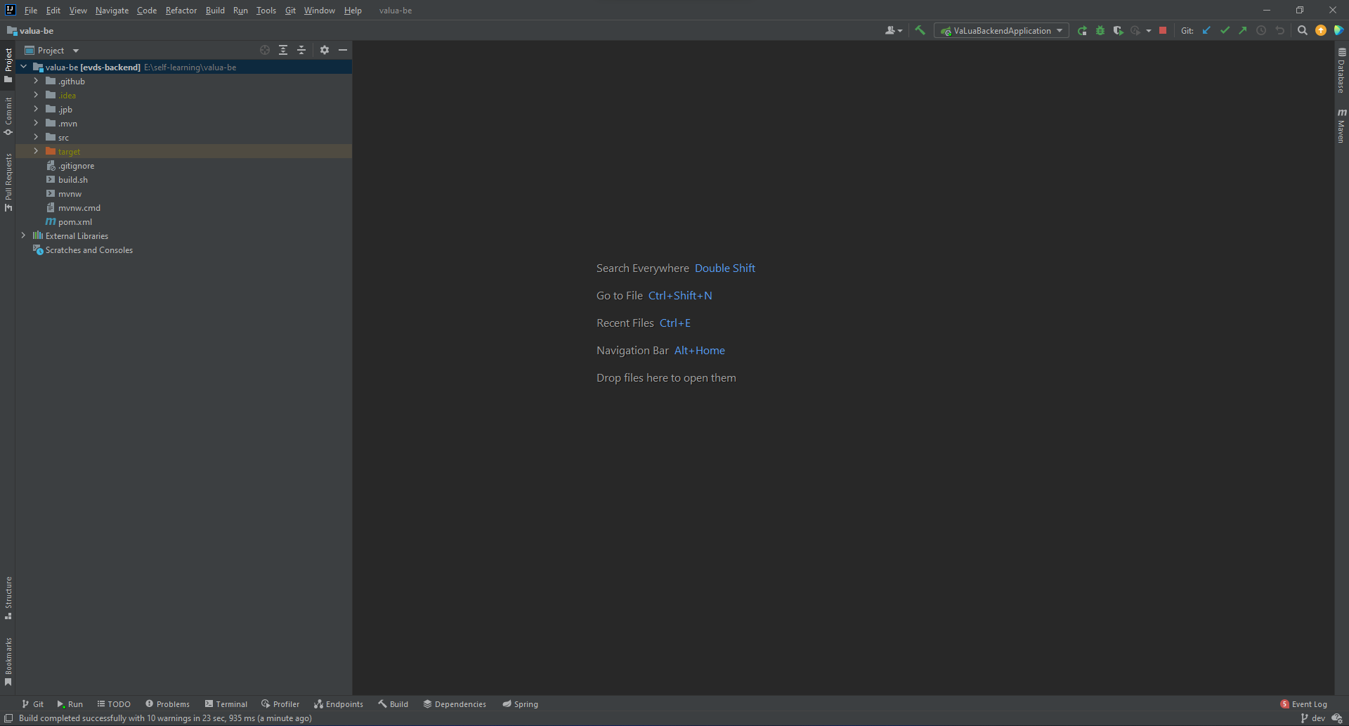

Figure 18: <Application> Open project in IDE

* Run the project. The backend is configured to create the database on started.

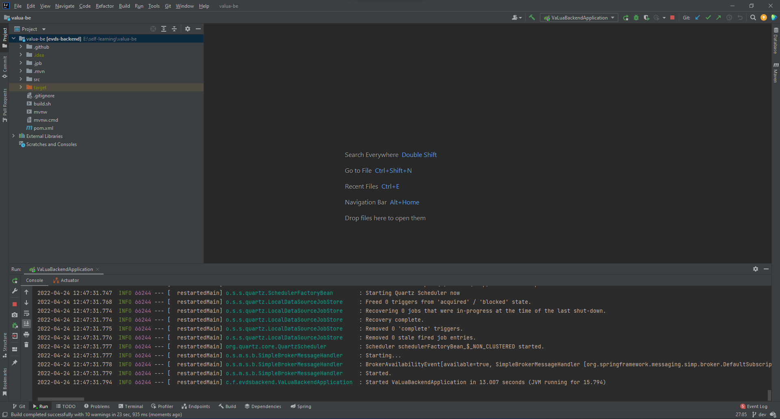

Figure 19: <Application> Run project

* Check your database in DBeaver to check if it was created successfully.

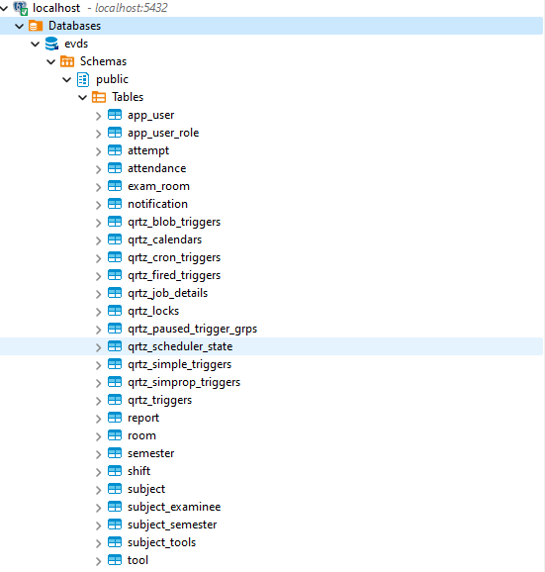

Figure 20: <Application> Database result

#### 2.3.4. For web application

* Install NodeJS 14.16.1 LTS. [Download link](https://nodejs.org/dist/v14.16.1/)

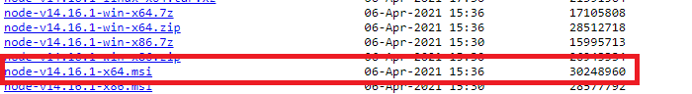

Figure 21: <Application> NodeJS installation

* Open setup file and select install location, click Next

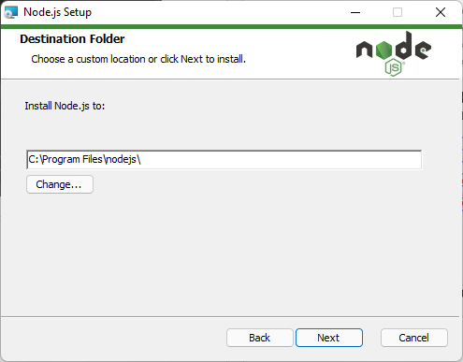

Figure 22: <Application> NodeJS data directory

* Select all component and then click Next

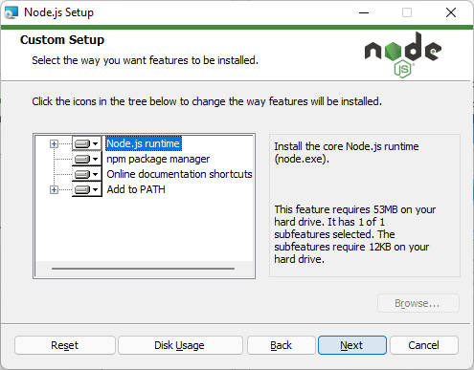

Figure 23: <Application> NodeJS setup

* Click Install and wait for the installation to complete.

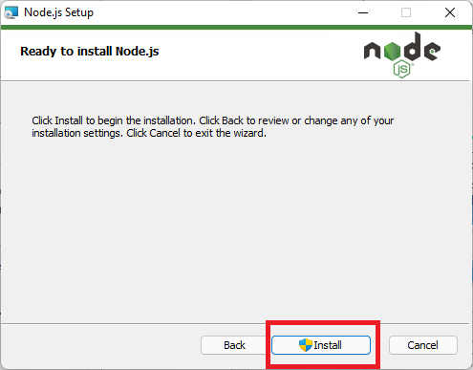

Figure 24: <Application> NodeJS installation

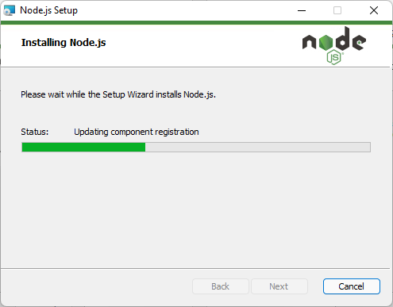

Figure 25: <Application> NodeJS installation

* Extract valua-web.zip, open the extracted folder in your IDE.

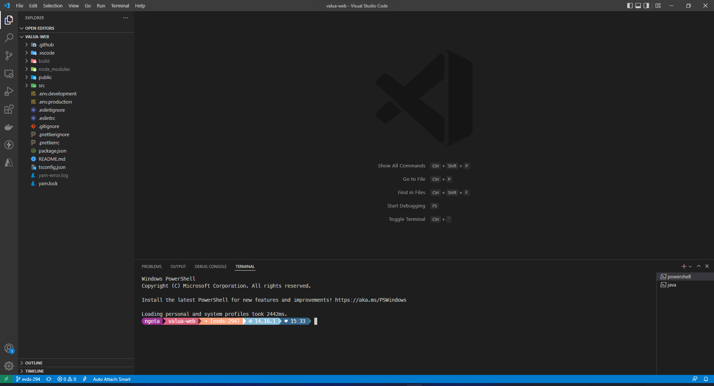

Figure 26: <Application> Open project in IDE

* Run “*yarn start*” to start the project

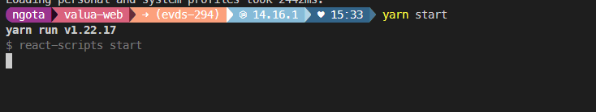

Figure 27: <Application> Start project

* Result: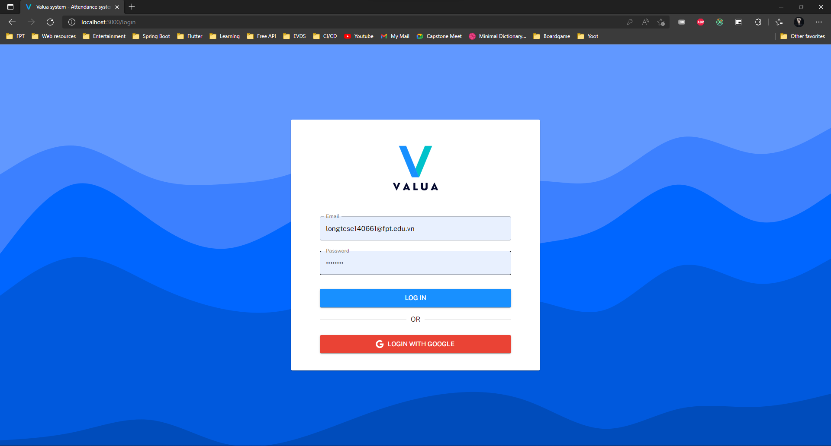

Figure 28: <Web> Login screen

#### 2.3.5. For verify server

* Install Docker Desktop: [Download link](https://www.docker.com/products/docker-desktop/)

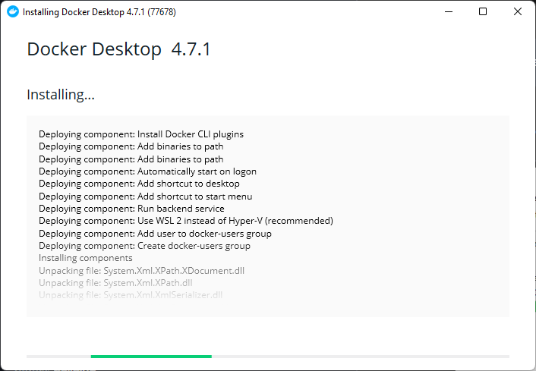

Figure 29: <Application> Docker installation

- After install successfully, pull docker image from the following docker hub: [Verify server image](https://hub.docker.com/r/tlhngslyb/flaskserver) (or run docker pull tlhngslyb/flaskserver:v5)

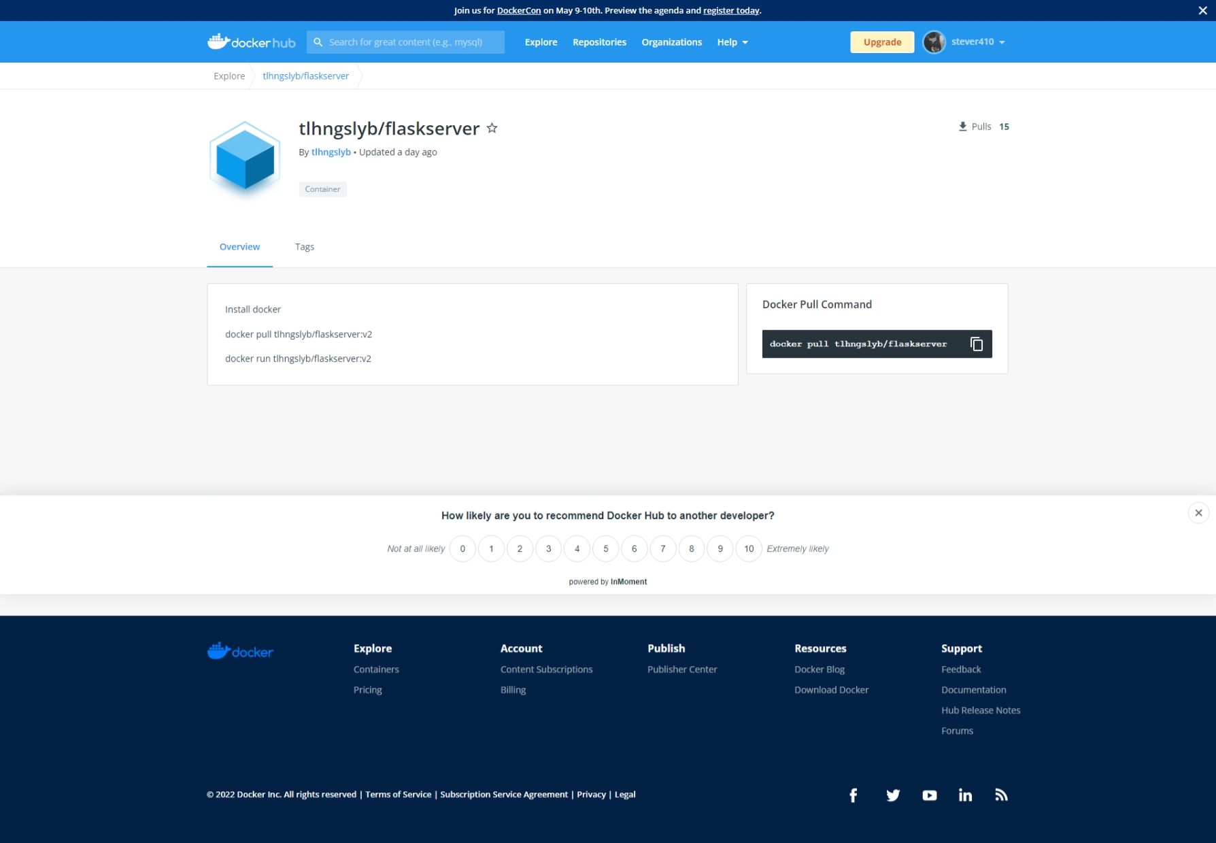

Figure 30: <Application> Flask server install

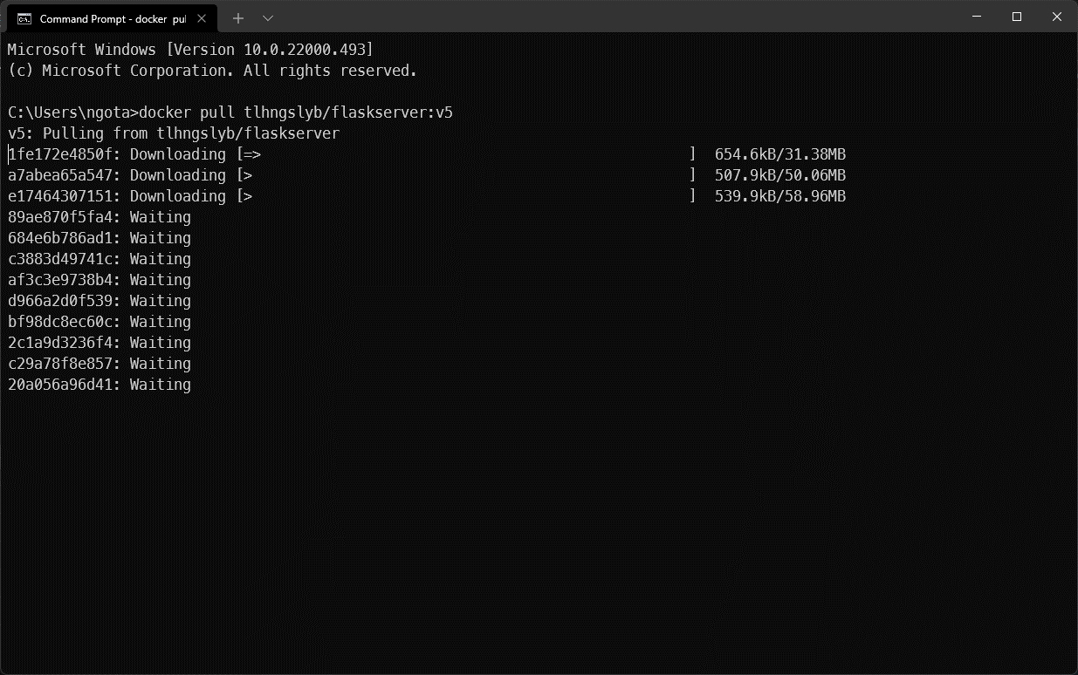

Figure 31: <Application> Flask server install

* When pull successfully, check in docker desktop image to see if image is available

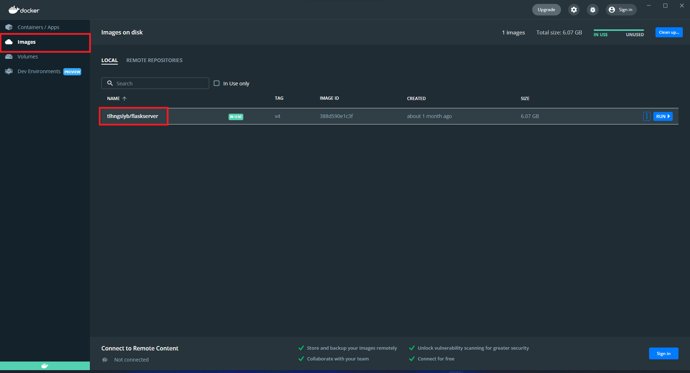

Figure 32: <Application> Run Docker

* To run verify server, run “docker run -it -p 5000:5000 tlhngslyb/flaskserver:v5”

**

Figure 33: <Application> Run Docker result

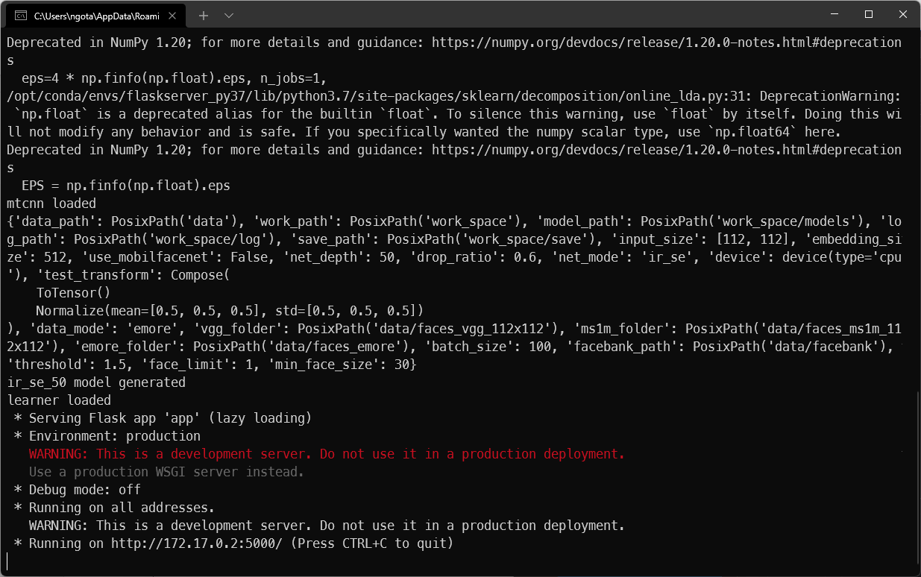

Figure 34: <Application> Run Docker result

## 3. User Manual

### 3.1 System requirements

#### 3.1.1. Hardware requirement

##### For mobile applications:

|  |  |
| --- | --- |
| **Operation System** | **Android 6 or higher** |
| Memory | 1GB of RAM or higher |
| Internet | The application required internet to be used |

##### For database:

|  |  |
| --- | --- |
| **Operation System** | **Windows 10 Pro, Windows Server 2019 R2** |
| Memory | 8GB of RAM or higher |
| Hard drive | 256GB or higher |
| DBMS | PostgreSQL 13 |

##### For APIs server:

|  |  |
| --- | --- |
| **Operation System** | **Windows 10 Pro, Windows Server 2019 R2** |
| Processor | Intel Core i5 8th Generation processor or higher |
| Memory | 8GB of RAM or higher |
| Internet | The application required internet to be used |
| Hard drive | 256GB or higher |

##### For web application:

|  |  |
| --- | --- |
| **Operation System** | **Windows 10 Pro, Windows Server 2019 R2** |
| Memory | 8GB of RAM or higher |
| Internet | The application required internet to be used |
| Browser | Chrome (version 87 or higher), IE (version 11 or higher) or any browser that supports HTML5 and CSS3 |

##### For verify server:

|  |  |
| --- | --- |
| **Operation System** | **Windows 10 Pro, Windows Server 2019 R2, Ubuntu** |
| Processor | Intel Core i5 8th Generation processor or higher |
| Memory | 8GB of RAM or higher |
| Hard drive | 256GB or higher |
| GPU | NVIDIA GeForce GTX 1050ti or higher |

### 3.2 Application Usage

#### 3.2.1. For web application usage

##### Overview:

* Manager uses VaLua web application for managing accounts, tools, subjects, semesters, rooms for exams at FPT University.
* Shift Managers uses VaLua web application for exams organizing and reports management.

##### Features:

###### Login

* **Purpose:** This feature allows users to login to the VaLua System.
* **<Unauthenticated User> Login**:
  + - Login with email and password
      * Step 1: Enter email and password.

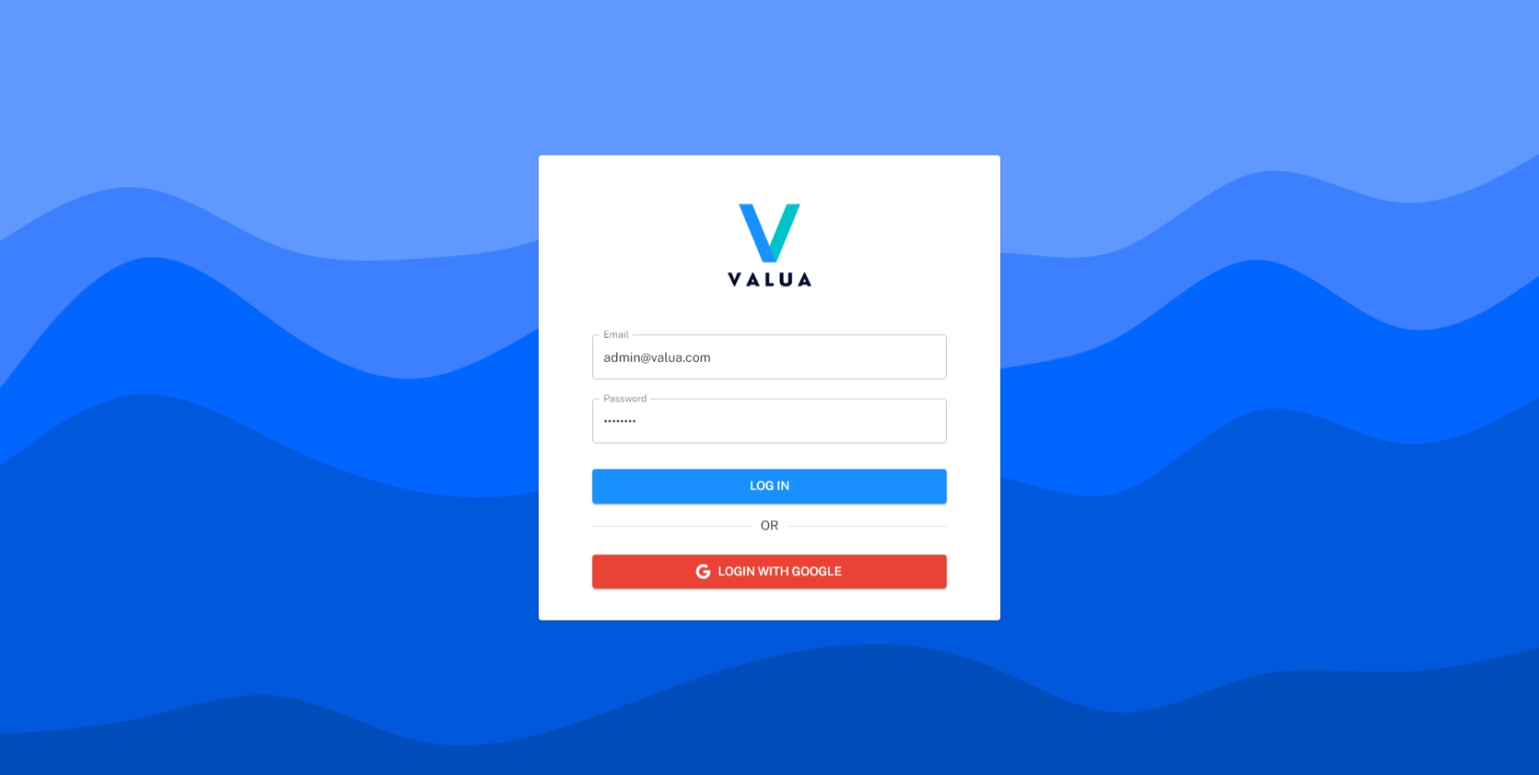

Figure 35: <Web> Login with email and password

* + - * Step 2: Click the “LOG IN” button

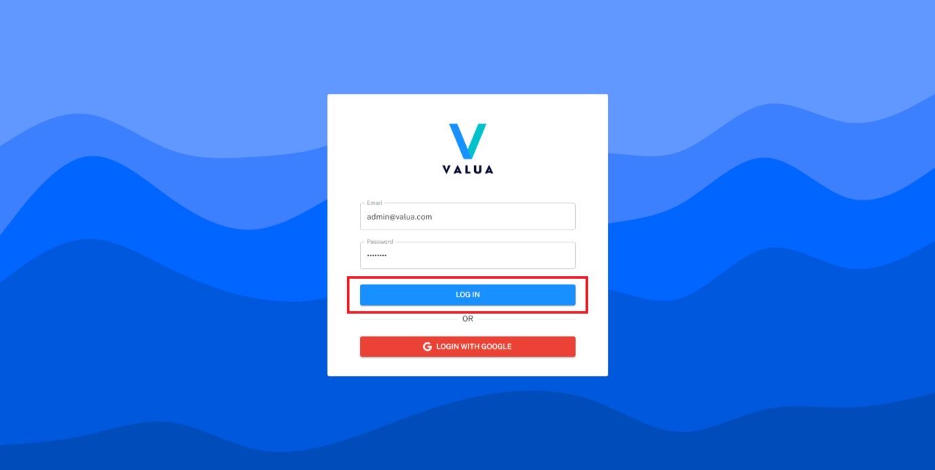

Figure 36: <Web> Login with email and password

* + - Login with google:
      * Step 1: Click the “LOGIN WITH GOOGLE” button.

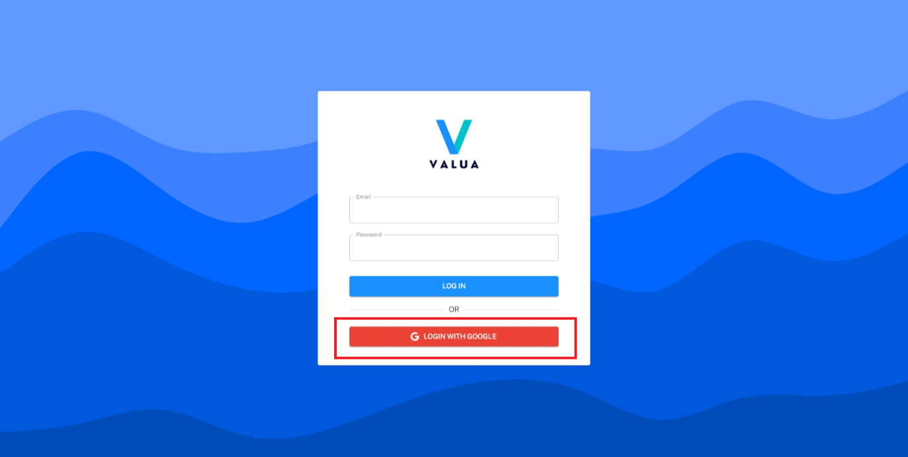

Figure 37: <Mobile> Login with Google

* + - * Step 2: User select the google account.

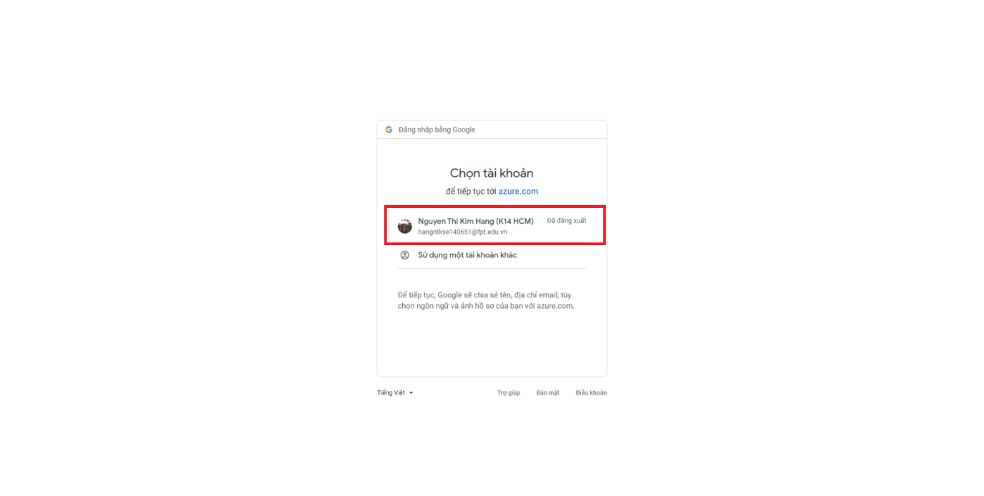

Figure 38: <Web> Login with Google

###### Logout

* **Purpose:** This feature allows Manager or Shift Manager to logout the VaLua System.
* **<Manager, Shift Manager> Logout**:
  + - Step 1: Click the icon at the top right corner.

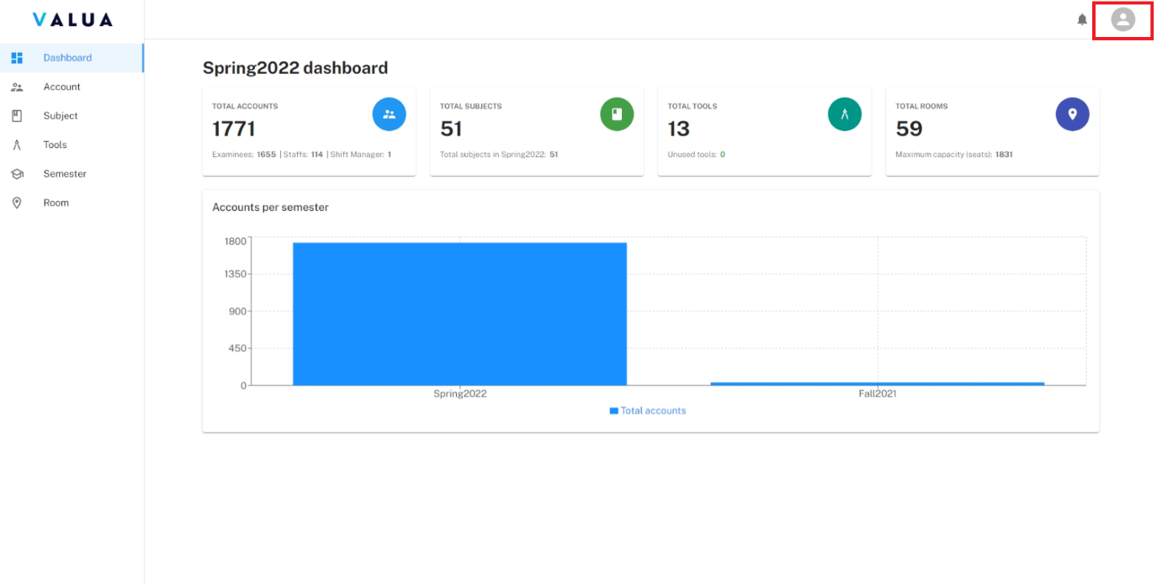

Figure 39: <Web> Logout

* + - Step 2: Select the “Log out” option.

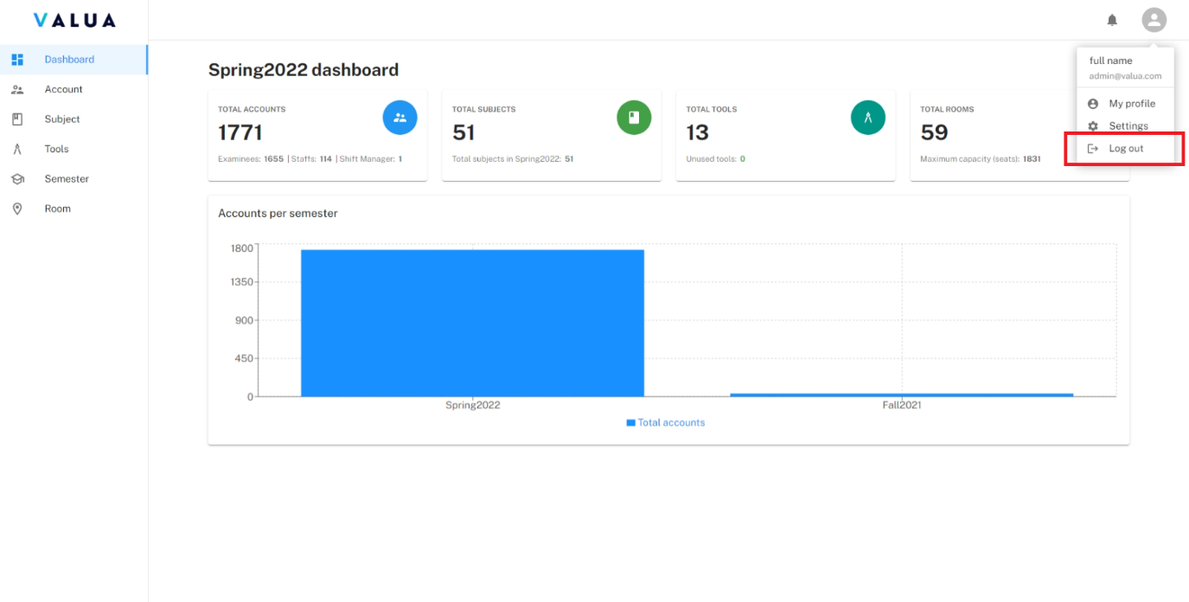

Figure 40: <Web> Logout

###### Manage profile

* **Purpose:** This feature allows Manager or Shift Manager to manage their profile.
* **<Manager, Shift Manager> View profile**:
  + - Step 1: Click the icon at the top right corner.



Figure 41: <Web> View profile (Step 1)

* + - Step 2: Select the “My profile” option.

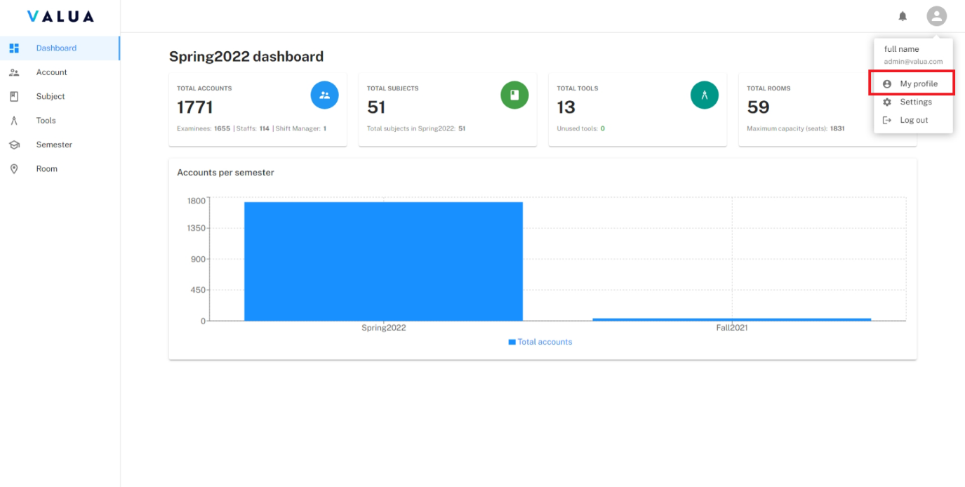

Figure 42: <Web> View profile (Step 2)

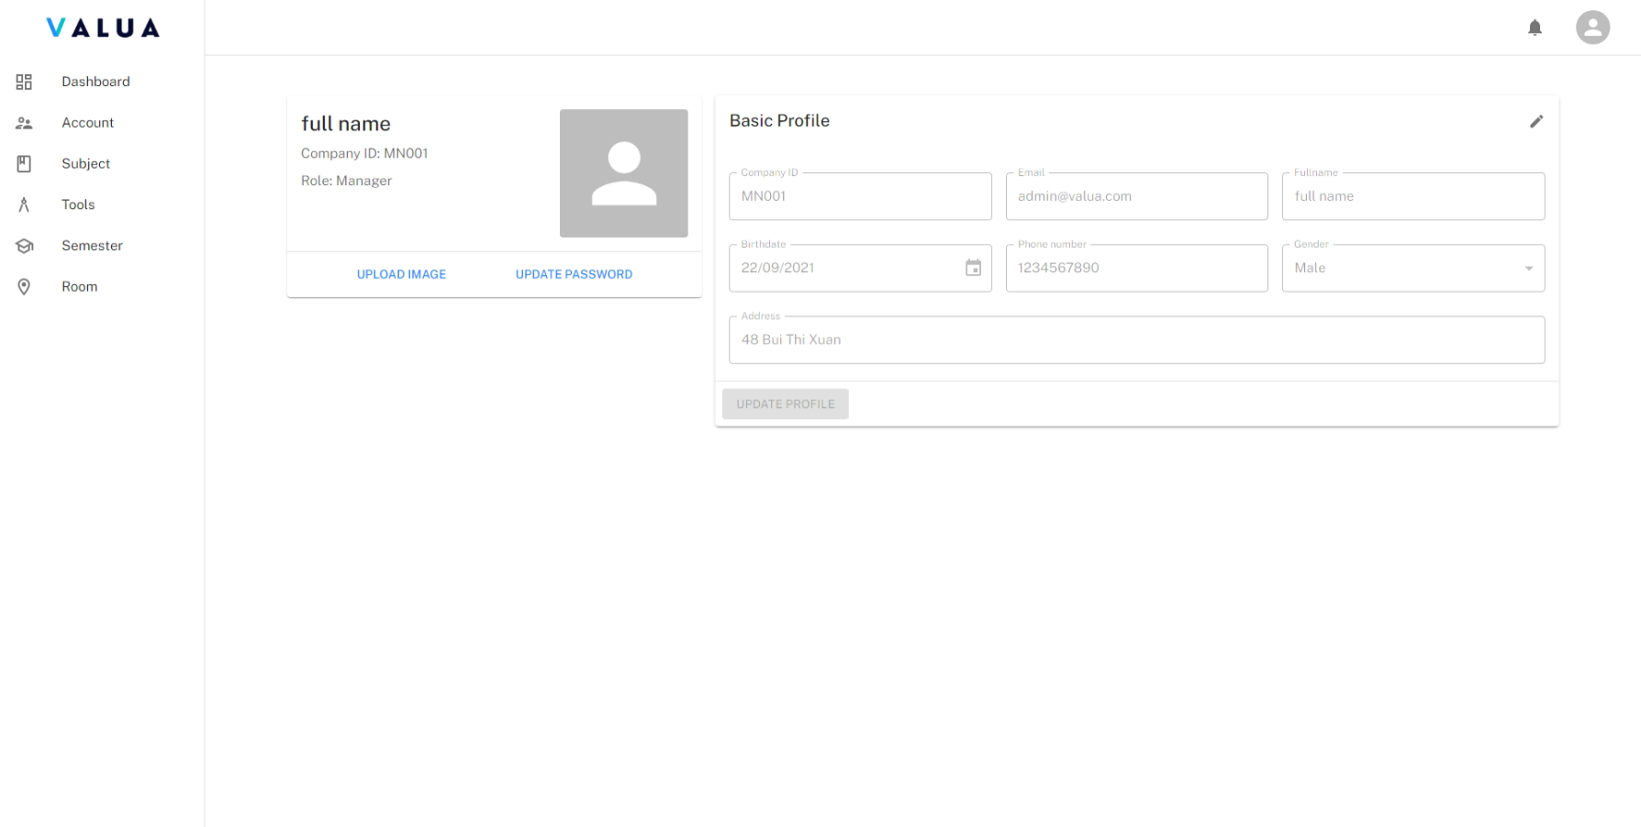

Figure 43: <Web> Profile screen

* **<Manager, Shift Manager> Update profile**:
  + **Update profile information**
    - Step 1: Click the icon edit to enable field for filling information.

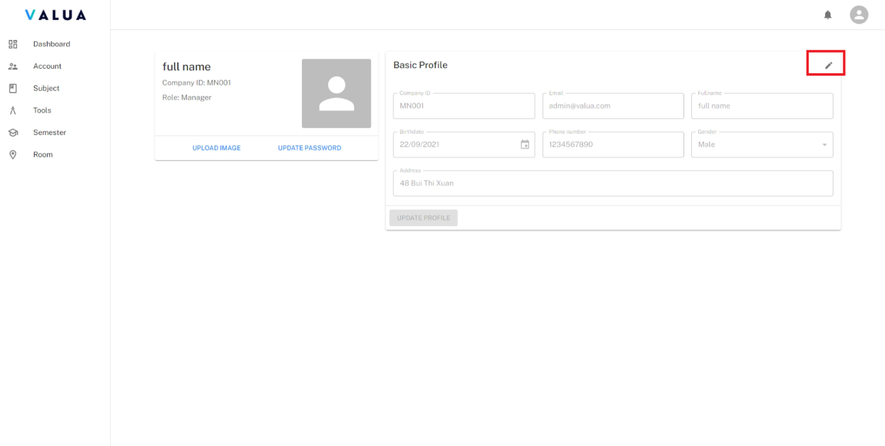

Figure 44: <Web> Update profile information (Step 1)

* + - Step 2: Choose the image and click “Open” button.

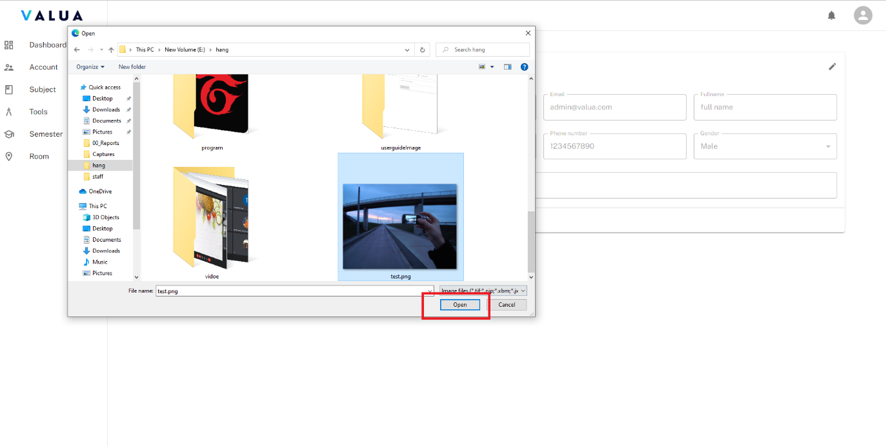

Figure 45: <Web> Update avatar image (Step 2)

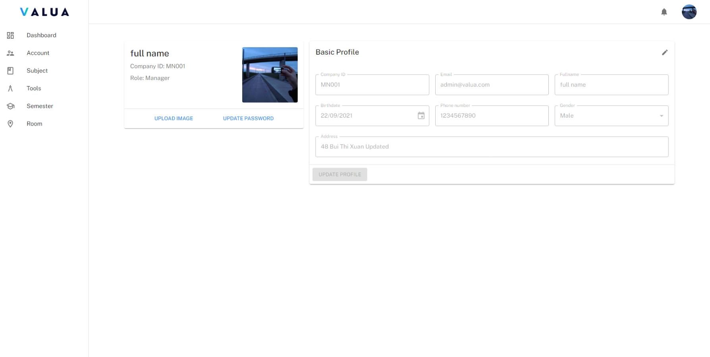

Figure 46: <Web> Update avatar image (Result)

* **<Manager, Shift Manager> Change password**:
  + **Update profile information**
    - Step 1: Click the “UPDATE PASSWORD” button.

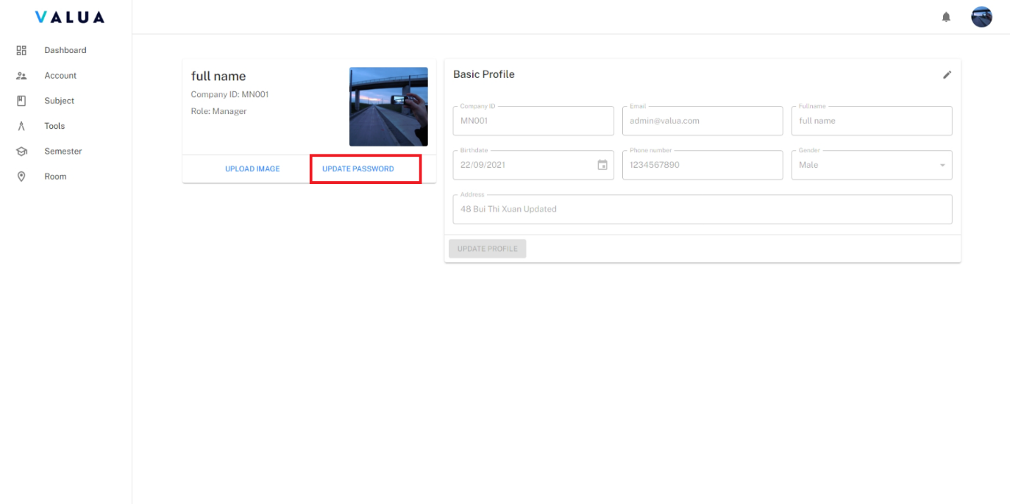

Figure 47: <Web> Change password (Step 1)

* + - Step 2: Enter current password and new password.
    - Step 3: Click the “UPDATE” button

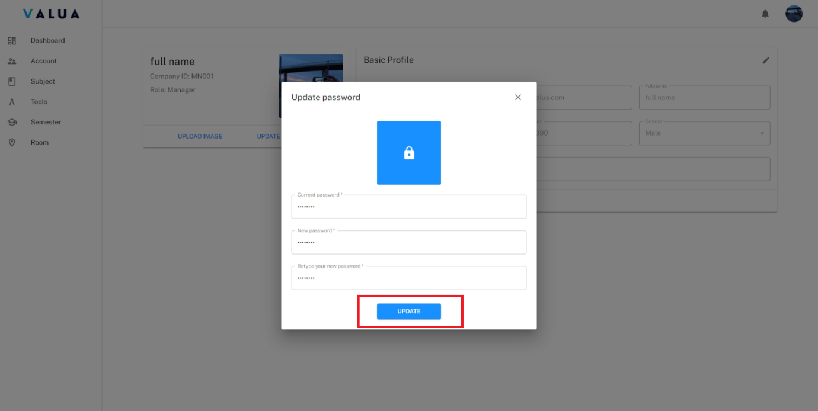

Figure 48: <Web> Change password (Step 2)

###### View notification list

* **Purpose:** This feature allows Manager or Shift Manager to view the notifications.
* **<Manager, Shift Manager> View notification list**:
  + - Step 1: Click the bell icon at the top right corner.

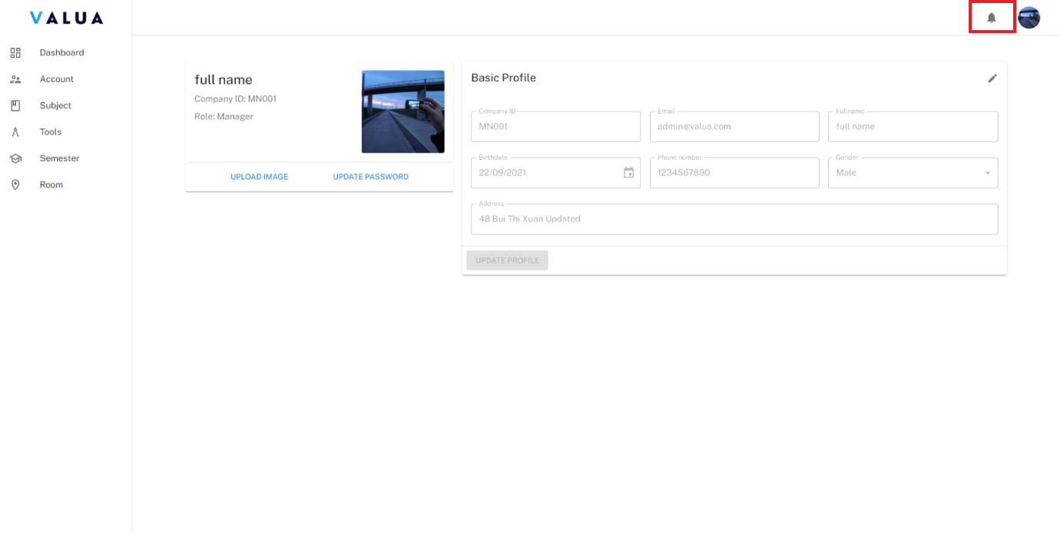

Figure 49: <Web> View notification list

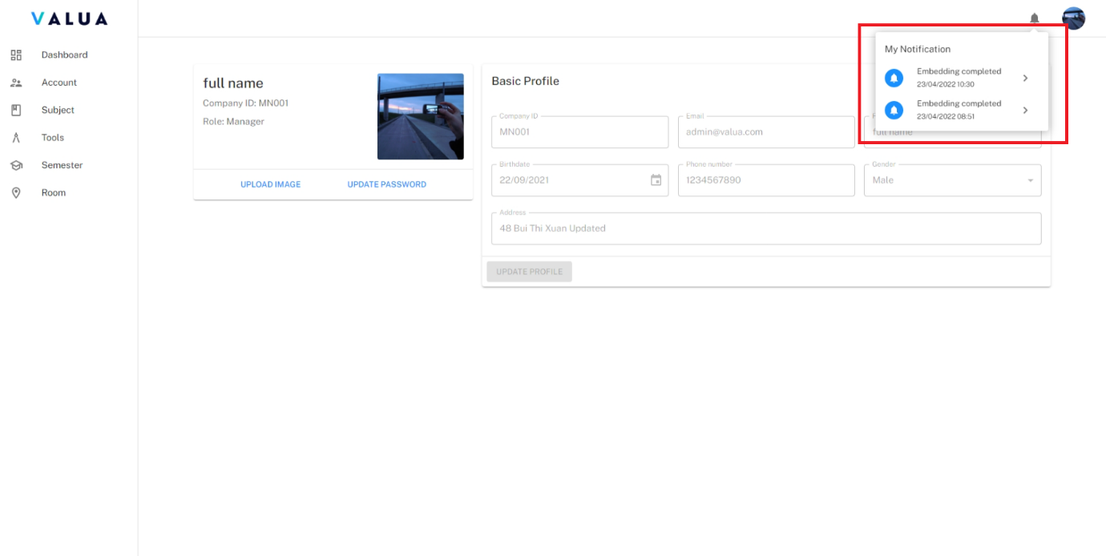

Figure 50: <Web> View notification list (Result)

###### Manage configuration

* **Purpose:** This feature allows Manager or Shift Manager to view and update the configuration of VaLua System.
* **<Manager, Shift Manager> View configuration**:
  + - Step 1: Click the icon at the top right corner and select the “Setting” option.

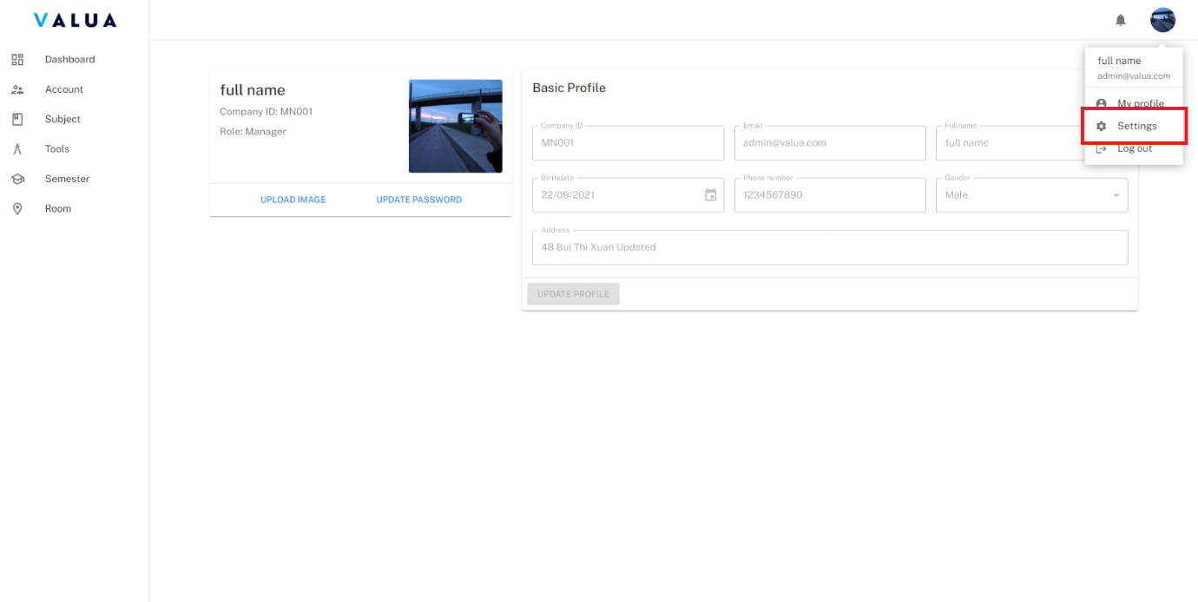

Figure 51: <Web> View configuration

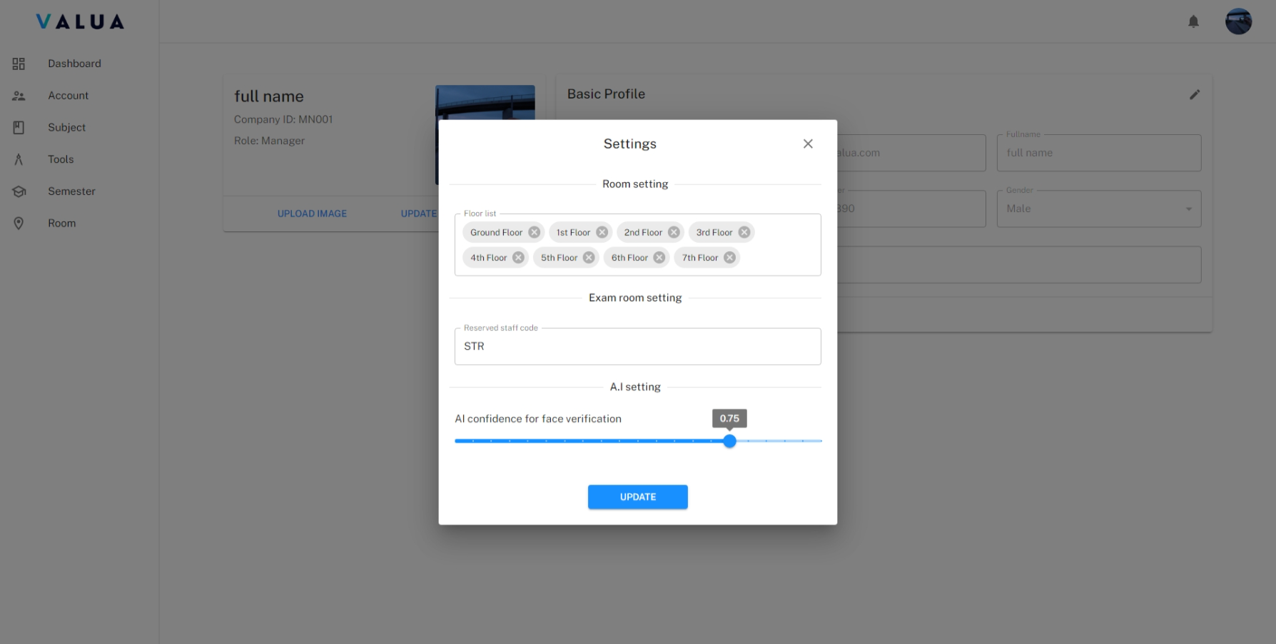

Figure 52: <Web> Configuration dialog - Manager

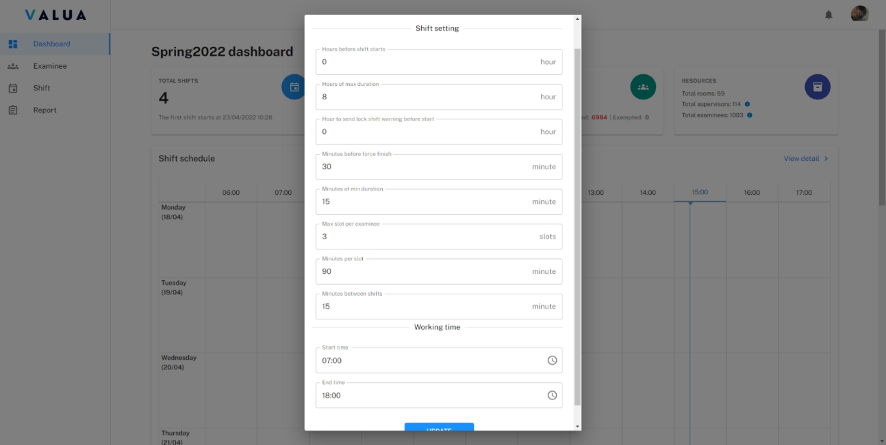

Figure 53: <Web> Configuration dialog - Shift manager

* **<Manager, Shift Manager> Update configuration:**
  + - Step 1: On configuration dialog, fills updated configuration.
    - Step 2: Click “UPDATE” button.

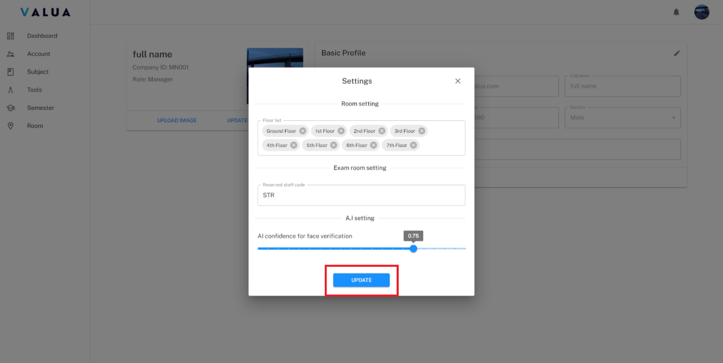

Figure 54: <Web> Update configuration (Step 2)

###### Manage account

* **Purpose:** This feature allows Manager to manage accounts of VaLua System.
* **<Manager> View account list**:
  + - Step 1: Click the “Account” tab.

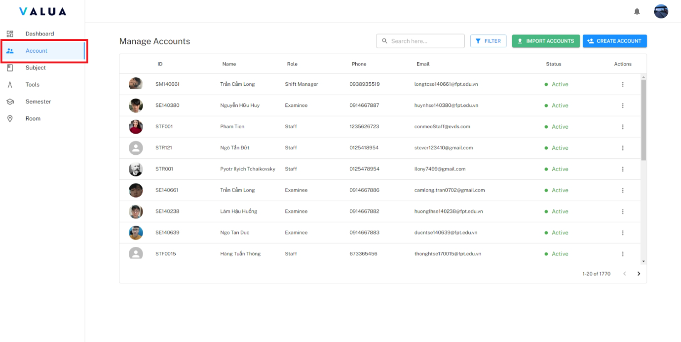

Figure 55: <Web> View account list

* + - Manager can search account by email, company id or full name (1).
    - Manager can be filtered by both status and role (2).

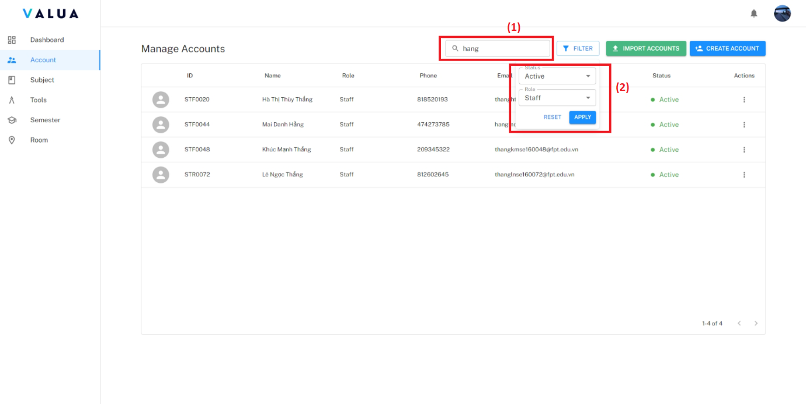

Figure 56: <Web> Search account

* **<Manager> View account detail**:
  + - Step 1: Click the “Account” tab (1).
    - Step 2: Click the “Action” ellipsis of specific account row. (2)

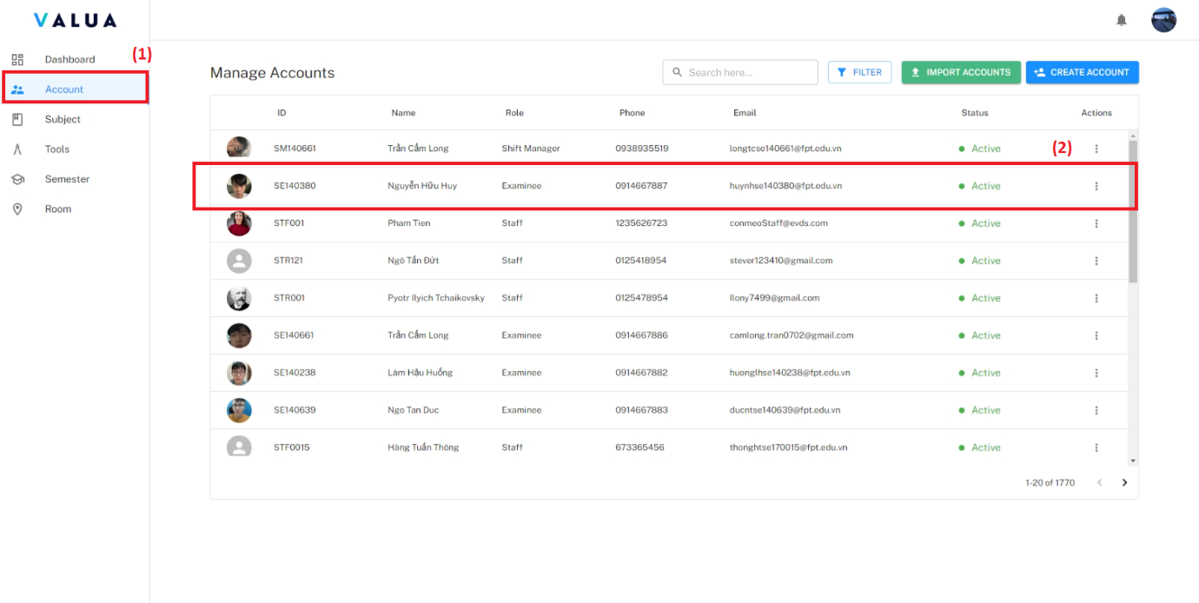

Figure 57: <Web> View account detail (Step 1,2)

* + - Step 3: Click the “View detail” option.

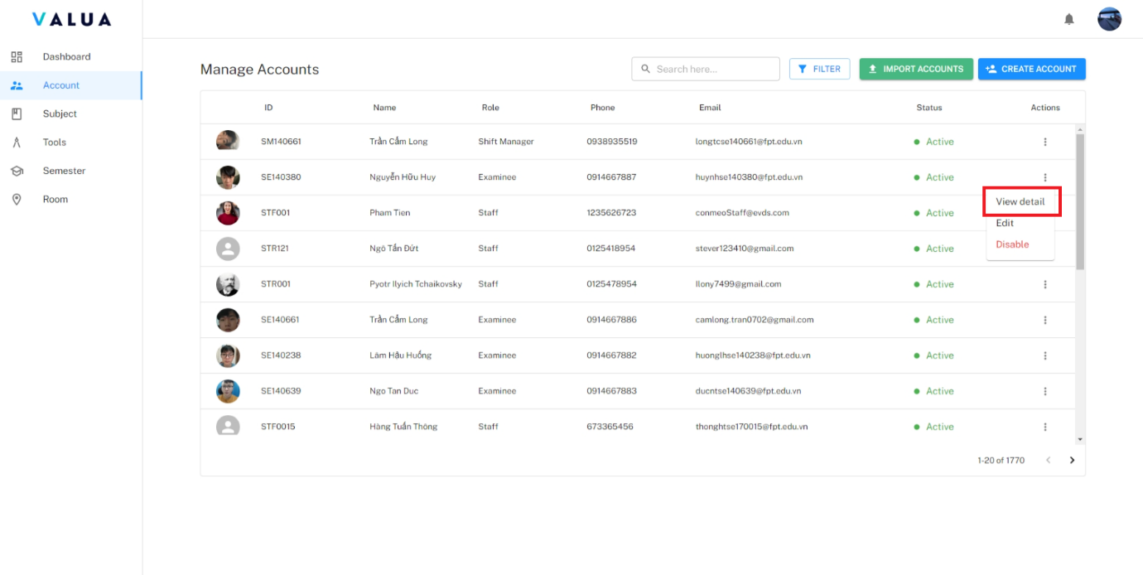

Figure 58: <Web> View account detail (Step 3)

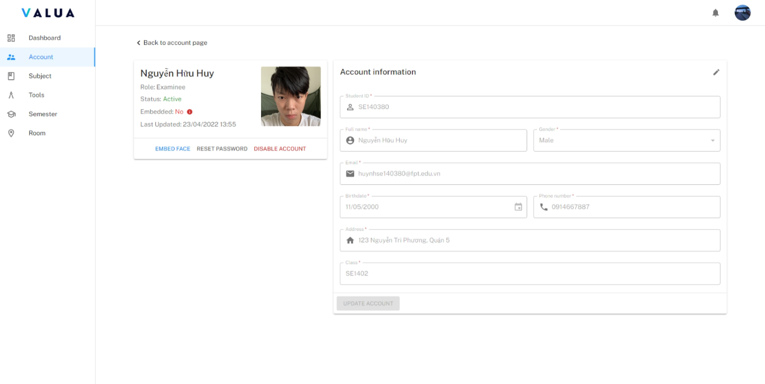

Figure 59: <Web> Account detail screen

* **<Manager> Create account**:
  + **Create an account.**
    - Step 1: Click the “Account” tab (1) and click the “CREATE ACCOUNT” button (2).

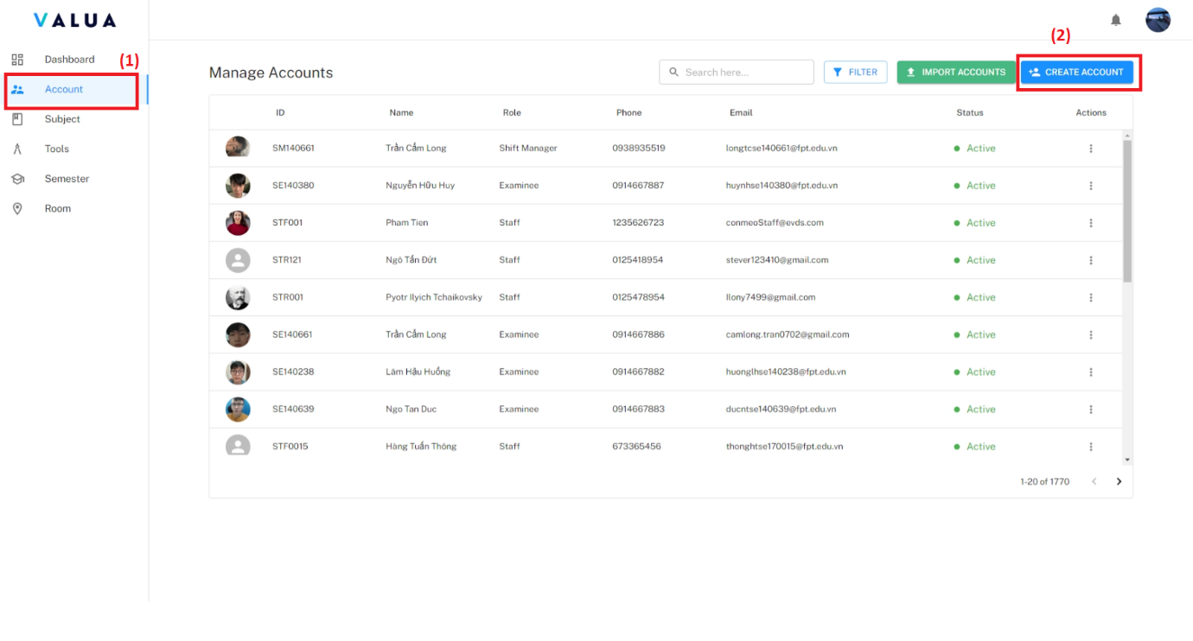

Figure 60: <Web> Create an account (Step 1)

* + - Step 2: Choose account role.

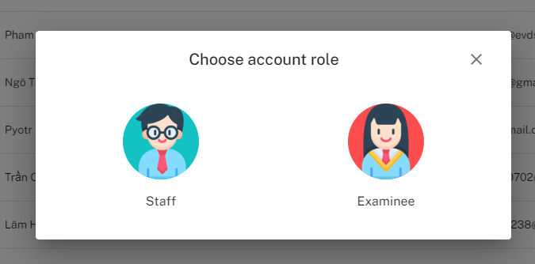

Figure 61: <Web> Create an account (Step 2)

* + - Step 3: Fill required information and click “CREATE” button.

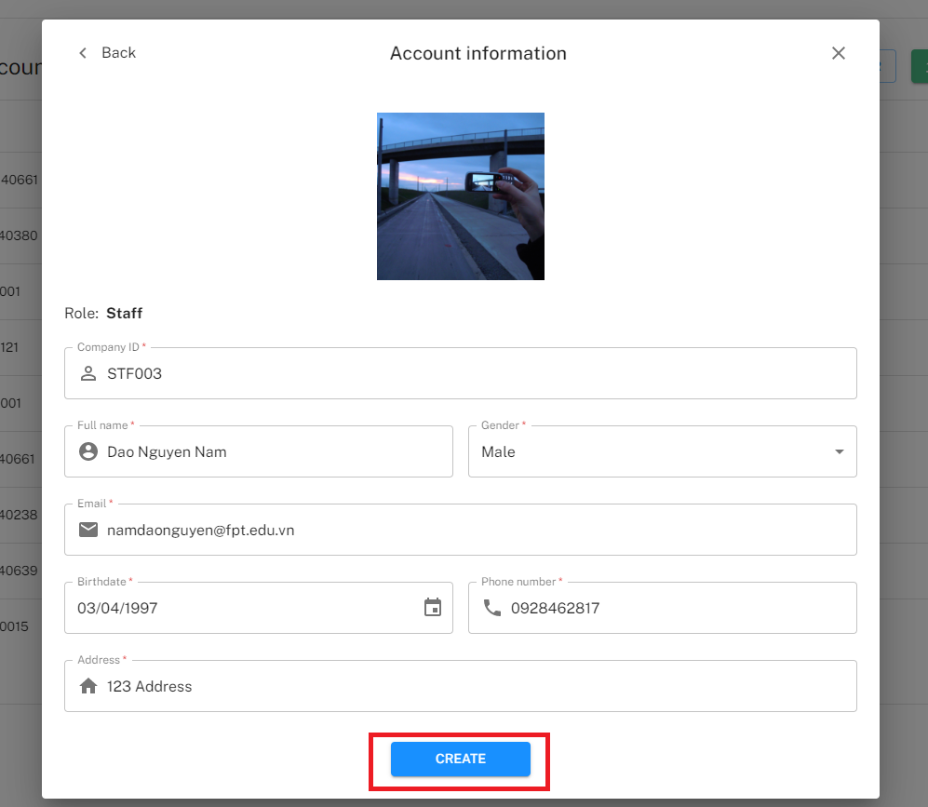

Figure 62: <Web> Create an account - Role staff (Step 3)

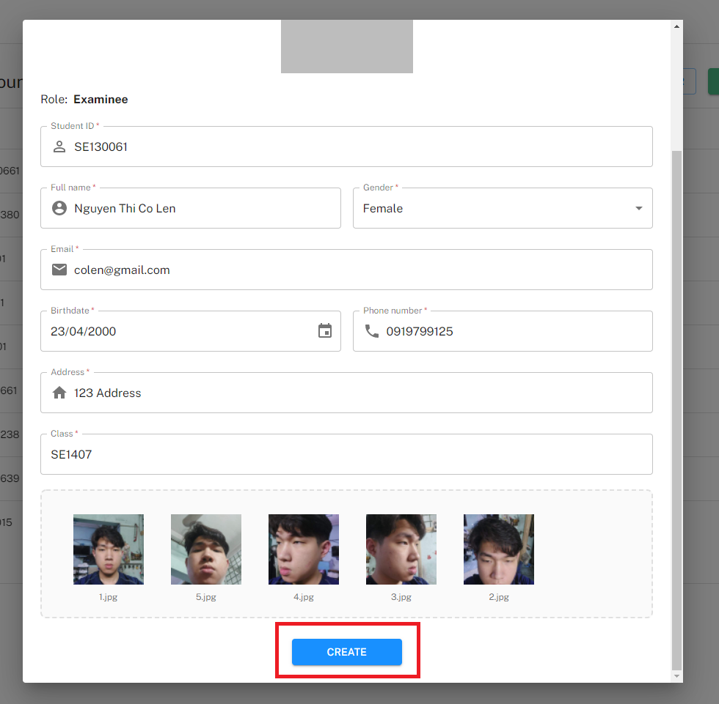

Figure 63: <Web> Create an account - Role examinee (Step 3)

* + **Import account.**
    - Step 1: Click the “Account” tab (1) and click the “IMPORT ACCOUNTS” button (2).

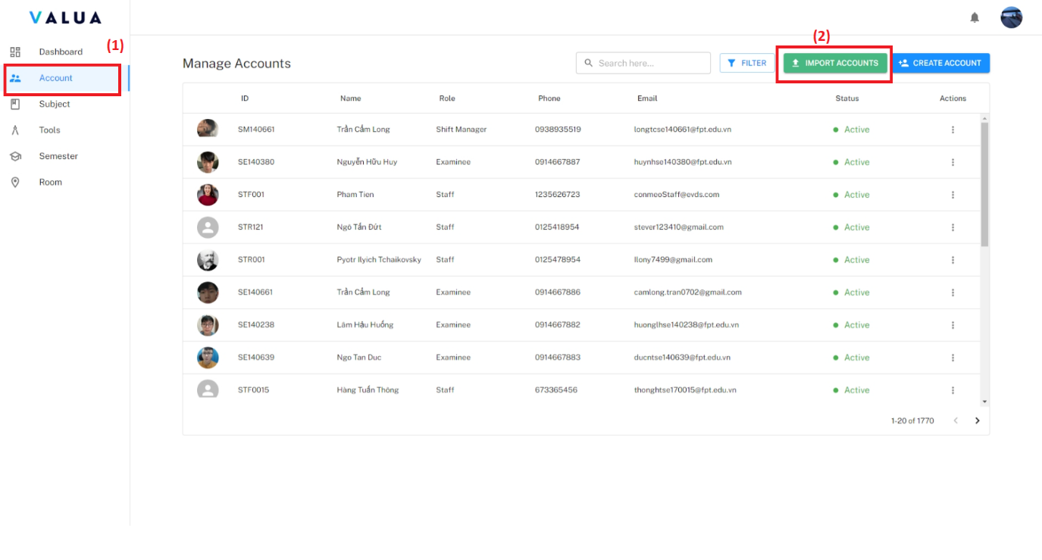

Figure 64: <Web> Import account (Step 1)

* + - Step 2: Click the “UPLOAD FILES” then choose the file with fille name format <role_name>_<folder_image>.

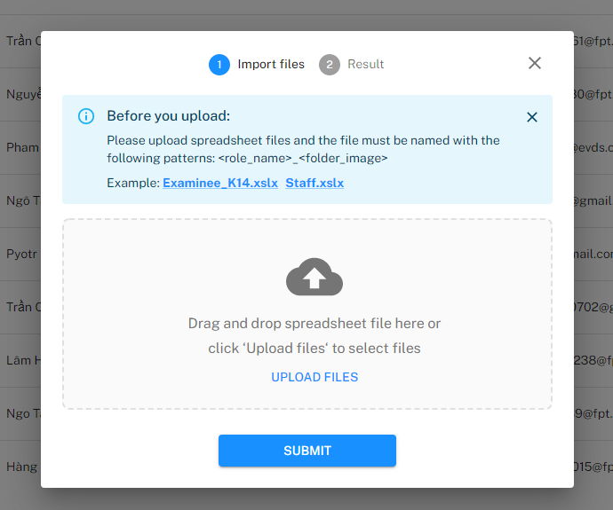

Figure 65: <Web> Import accounts (Step 2)

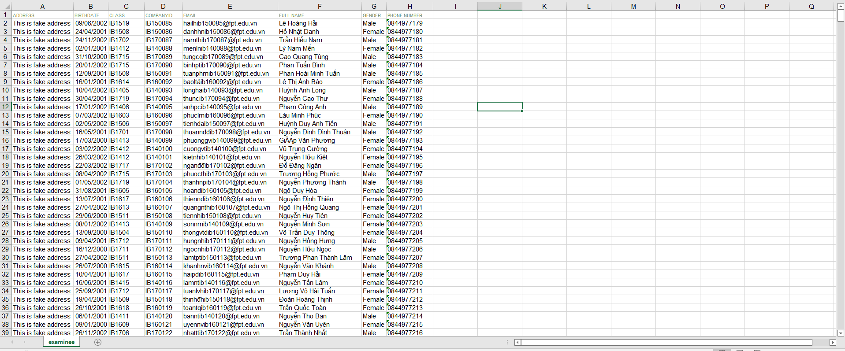

Figure 66: <Web> Examinee information excel example

* + - Step 3: Click the “SUBMIT” button. Manager can download the error file to view errors.

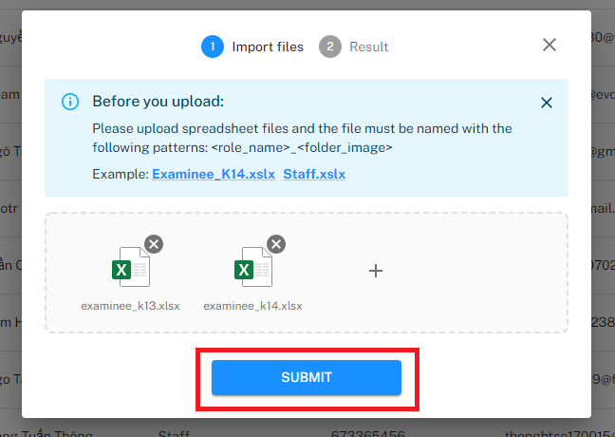

Figure 67: <Web> Import accounts (Step 3)

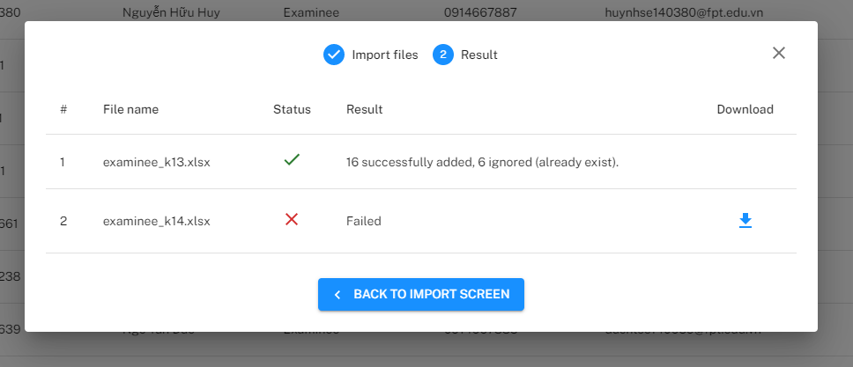

Figure 68: <Web> Import account result

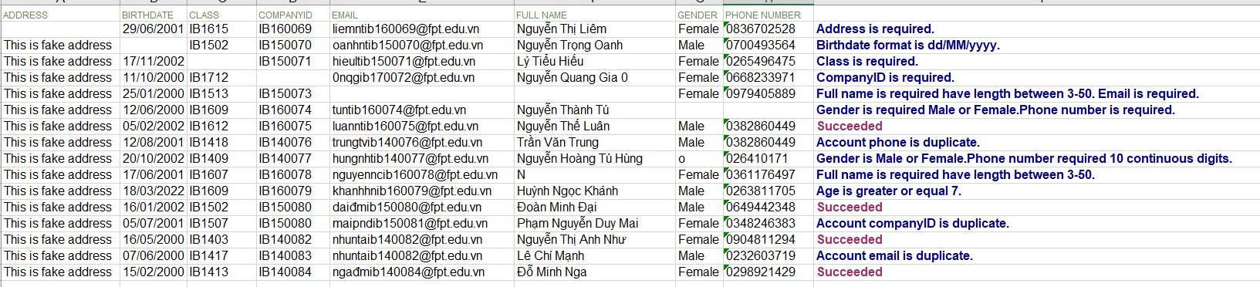

Figure 69: <Web> Example of error file

* + **<Manager> Update account.**
    - Step 1: Click the “Account” tab (1) and click the “Action” ellipsis of specific account row (2).
    - Step 2: Click the “Edit” option (3).

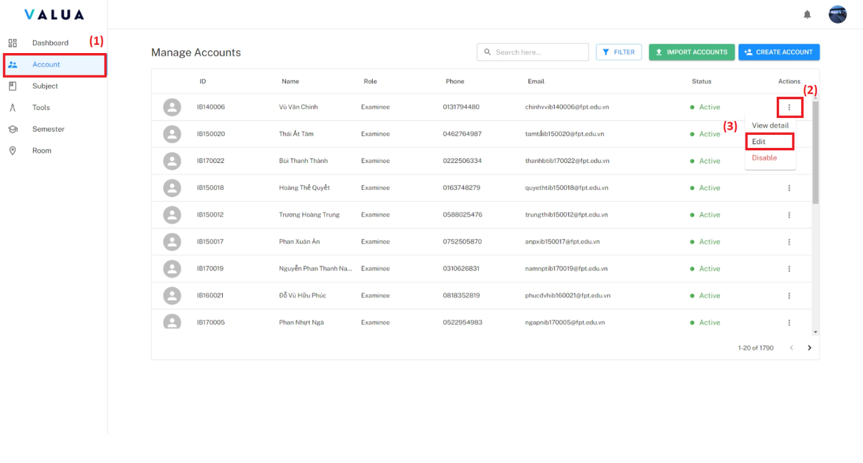

Figure 70: <Web> Update account (Step 1,2)

* + - Step 3: Fill changed information and click “UPDATE ACCOUNT” button.

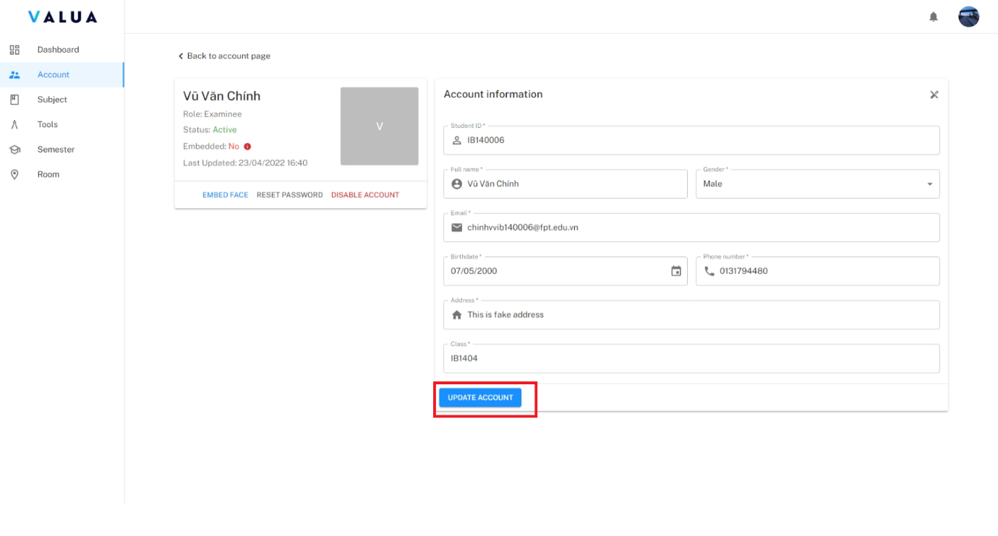

Figure 71: <Web> Update account (Step 3)

* **<Manager> Disable account**:
  + **Disable on account screen:**
    - Step 1: Click the “Account” tab (1) and click the “Action” ellipsis of specific account row (2).
    - Step 2: Click the “Disable” option (3).
    - Step 3: Click “Confirm” button.

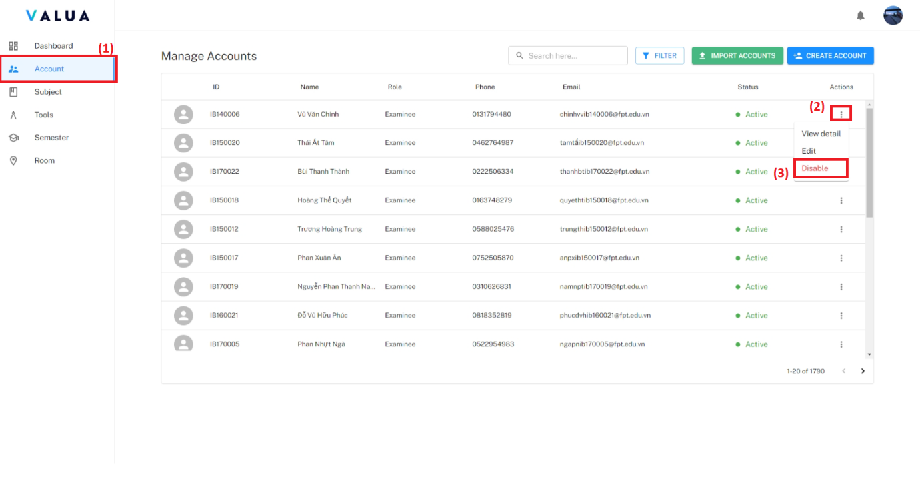

Figure 72: <Web> Disable account on account screen (Step 1,2)

* + **Disable on account detail screen:**
    - Click on the “DISABLE ACCOUNT” button then click “Confirm button”.

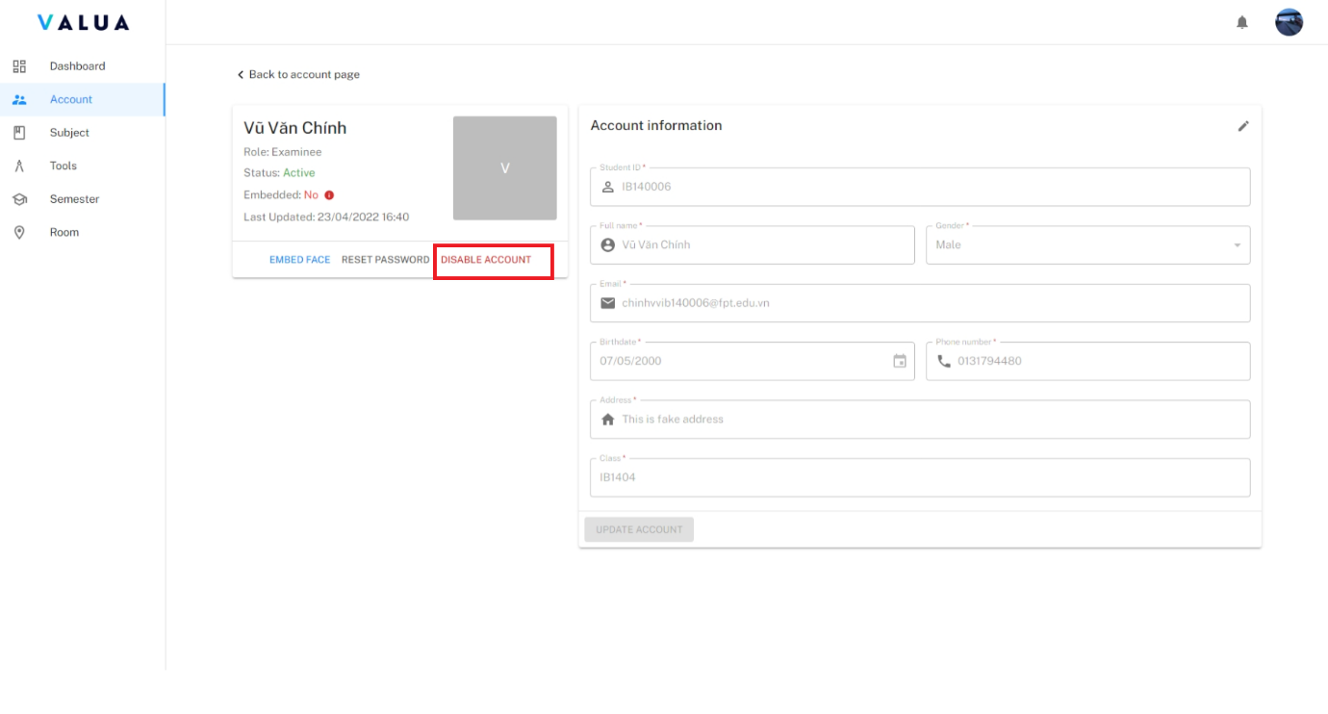

Figure 73: <Web> Disable account on account detail screen

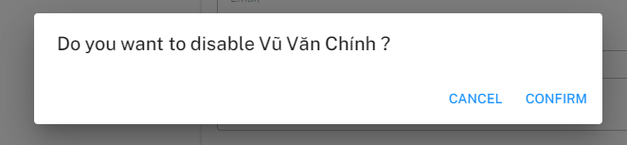

Figure 74: <Web> Confirm dialog for disable account

* **<Manager> Reset password**:
  + - Step 1: On account detail screen, click “RESET PASSWORD” button

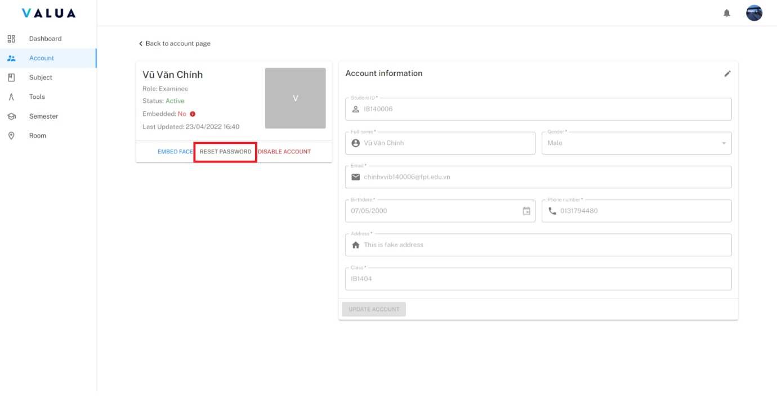

Figure 75: <Web> Reset password (Step 1)

* + - Step 2: Click “Confirm” button.

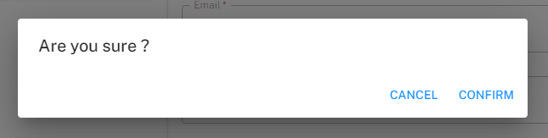

Figure 76: <Web> Confirm dialog for reset password (Step 2)

* **<Manager> Embed face vector file**:
  + - Step 1: On the account detail screen, click the “EMBED FACE” button.

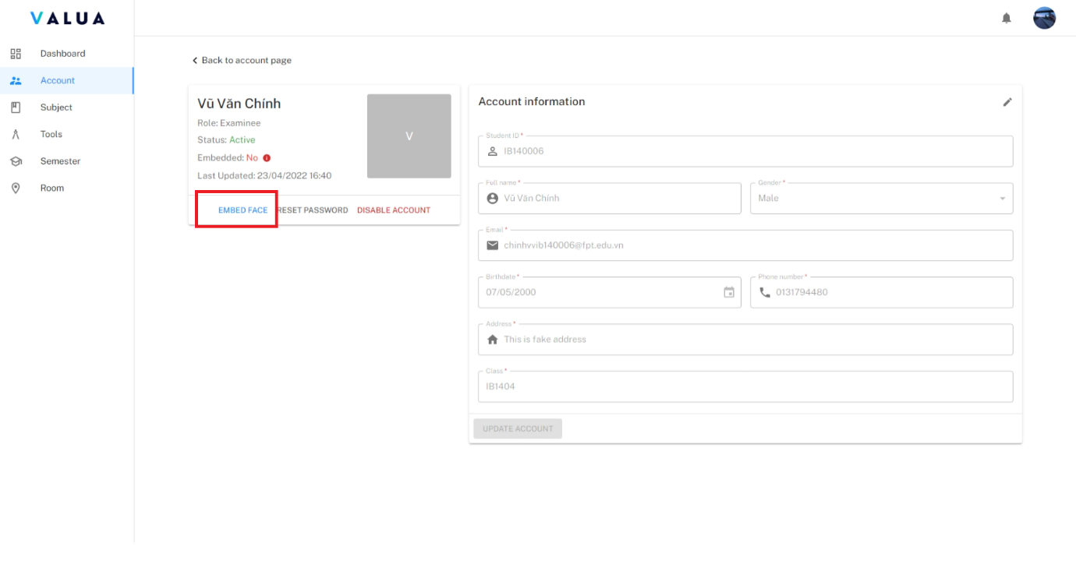

Figure 77: <Web> Embed face (Step 1)

* + - Step 2: Choose 5 images of examinee’s face with different angles.

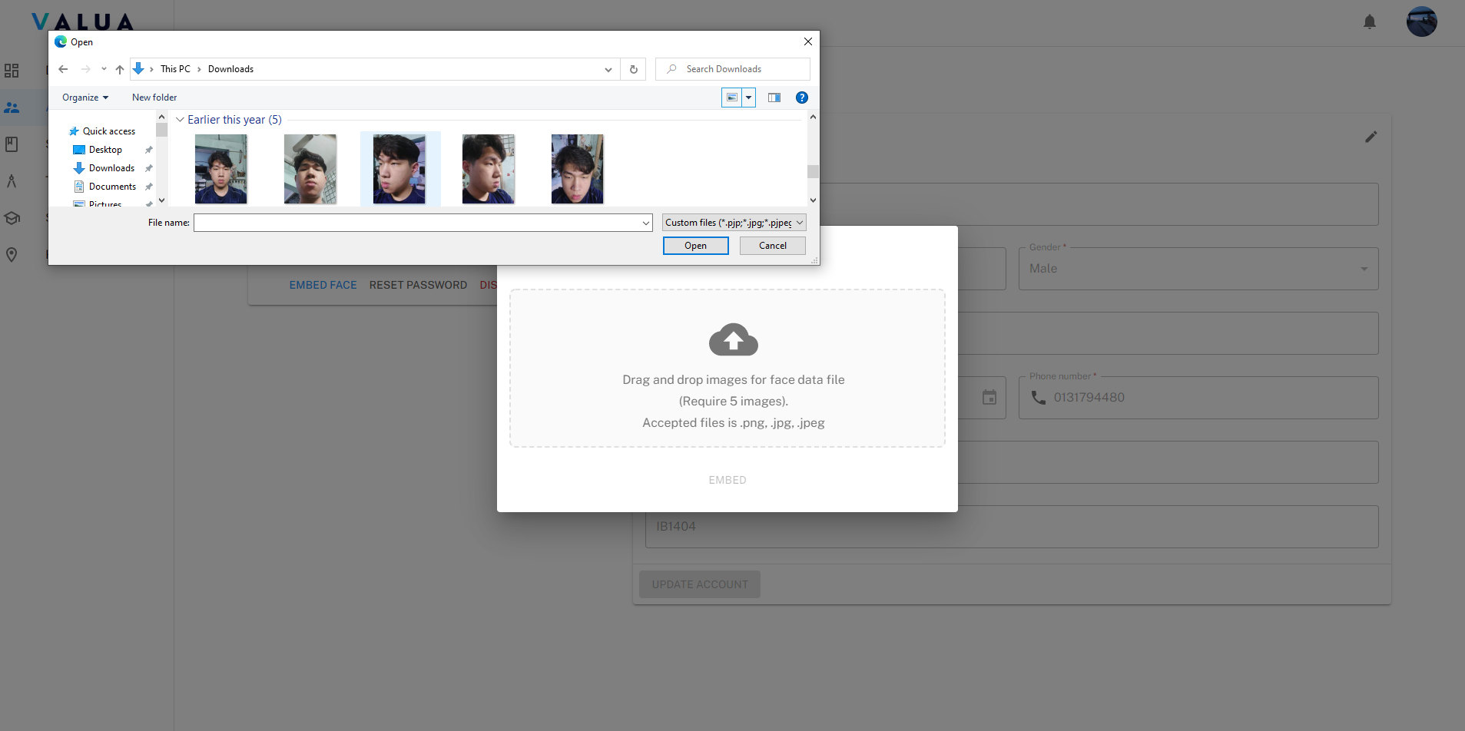

Figure 78: <Web> Embed face (Step 2)

* + - Step 3: Click the “EMBED” button.

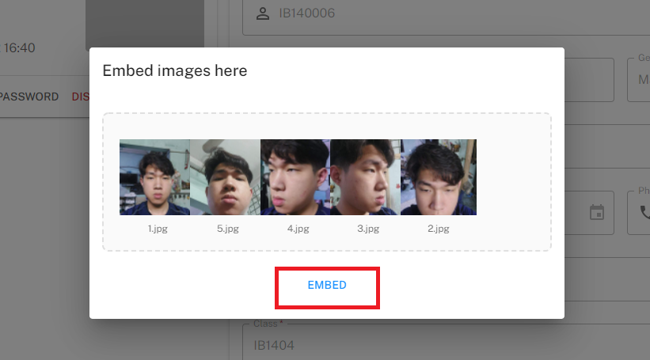

Figure 79: <Web> Embed face (Step 3)

###### Manage tool

* **Purpose:** This feature allows Manager to manage tool of VaLua System.
* **<Manager> View tool list**:
  + - Step 1: Click the “Tool” tab.

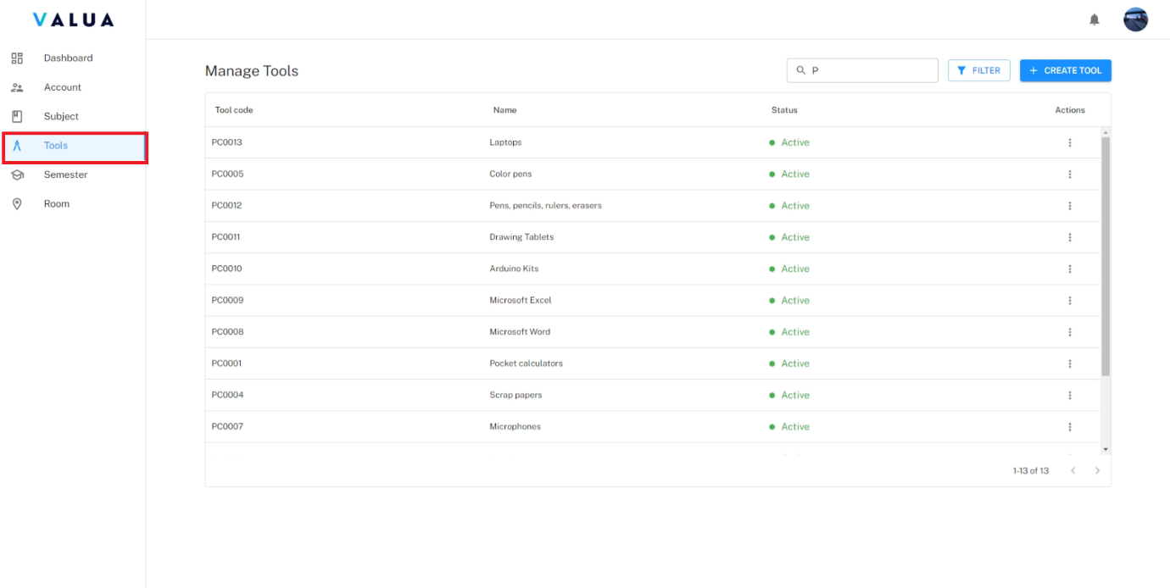

Figure 80: <Web> View tool list

* + - Manager can search tool by tool code or tool name (1)
    - Manager can filter tool by status (2).

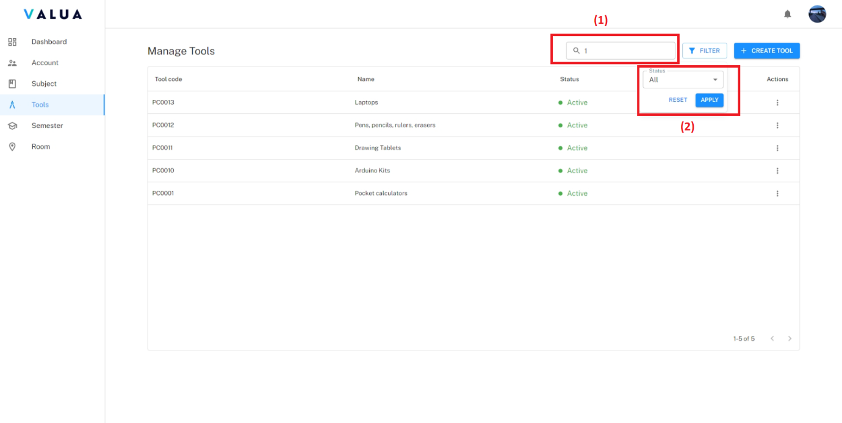

Figure 81: <Web> Search and filter tool

* **<Manager> Create tool**:
  + - Step 1: Click the “Tool” tab.

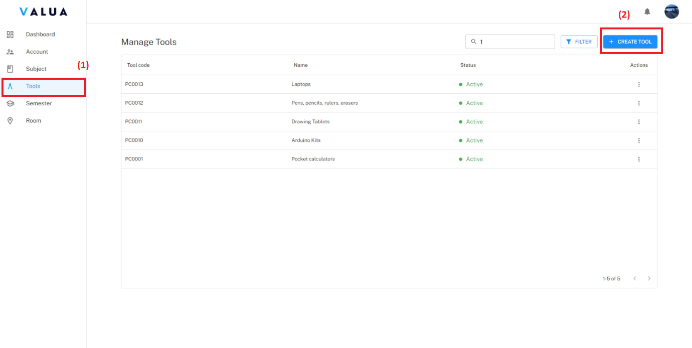

Figure 82: <Web> Create tool (Step 1)

* + - Step 2: Fill required information.
    - Step 3: Click the “CREATE” button.

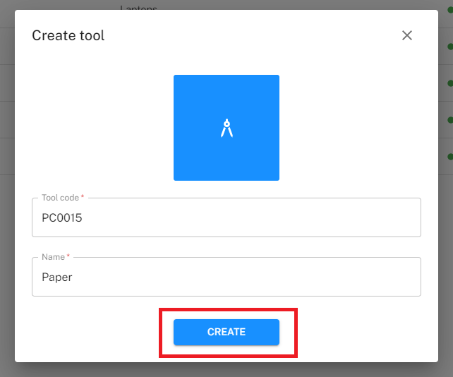

Figure 83: <Web> Create tool (Step 3)

* **<Manager> Update tool**:
  + - Step 1: Click the “Tool” tab (1) and click the “Action” ellipsis of specific tool row (2).
    - Step 2: Click the “Edit” option (3).

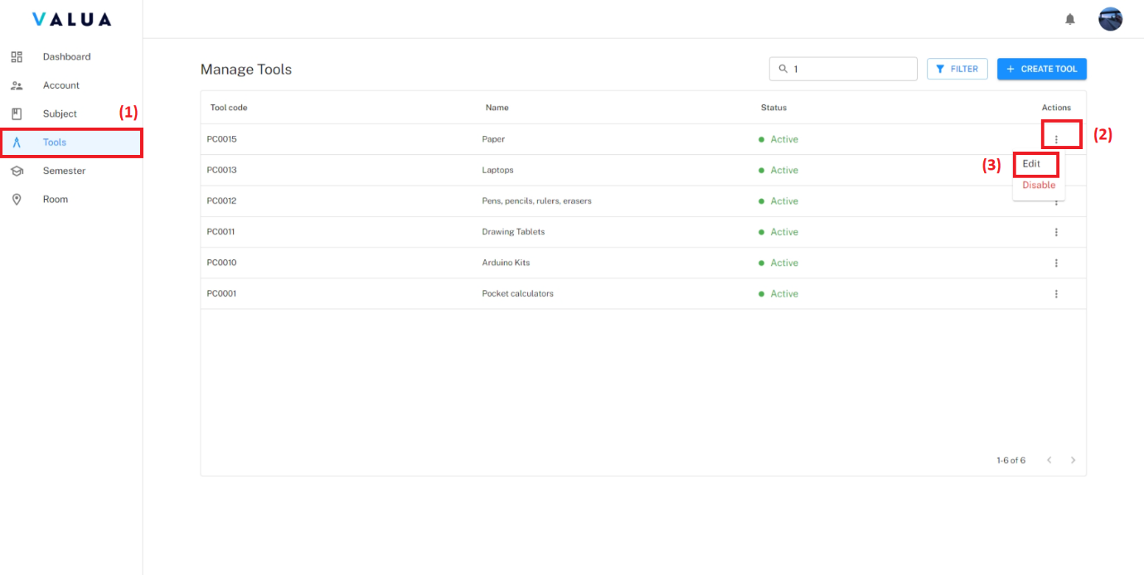

Figure 84: <Web> Update tool (Step 1, 2)

* + - Step 3: Fill changed information.
    - Step 4: Click the “UPDATE” button.

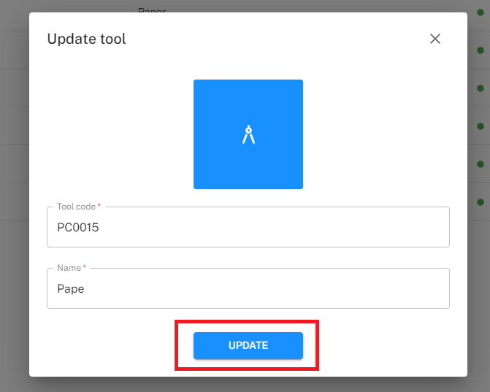

Figure 85: <Web> Update tool (Step 4)

* **Manager> Disable tool**:
  + - Step 1: Click the “Tool” tab (1) and click the “Action” ellipsis of specific tool row (2).
    - Step 2: Click the “Disable” option (3).

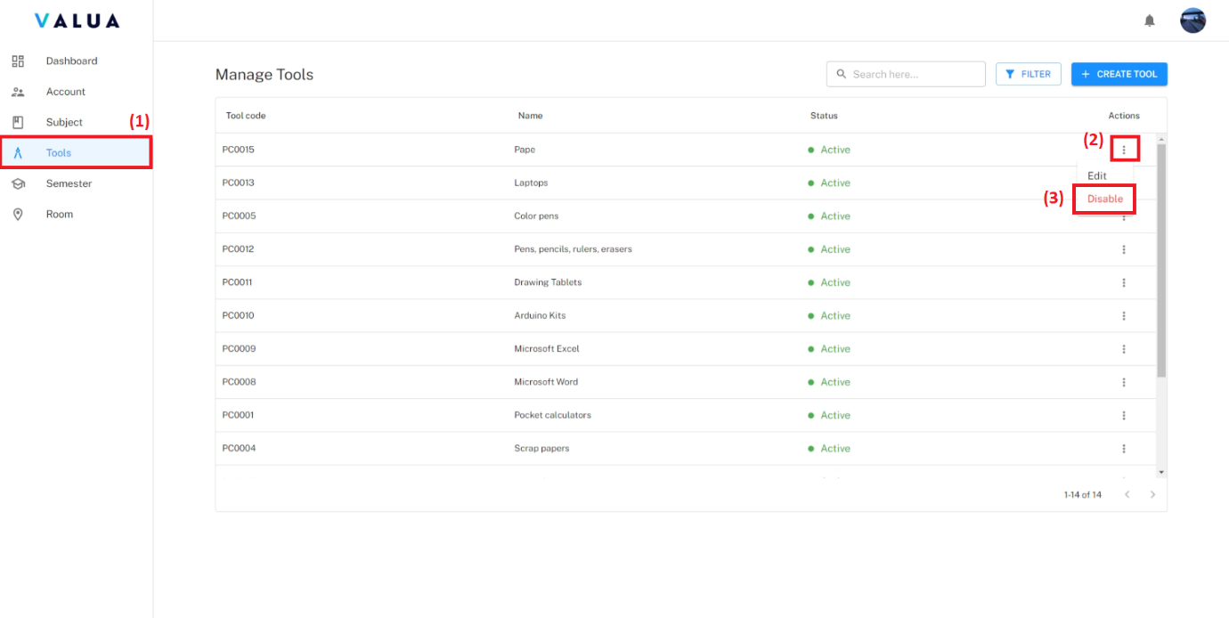

Figure 86: <Web> Disable tool (Step 1, 2))

* + - Step 3: Click the “CONFIRM” button.

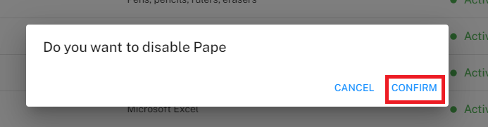

Figure 87: <Web> Disable tool (Step 3)

###### Manage subject

* **Purpose:** This feature allows Manager to manage subjects of VaLua System.
* **<Manager> View subject list**:
  + - Step 1: Click the “Subject” tab.

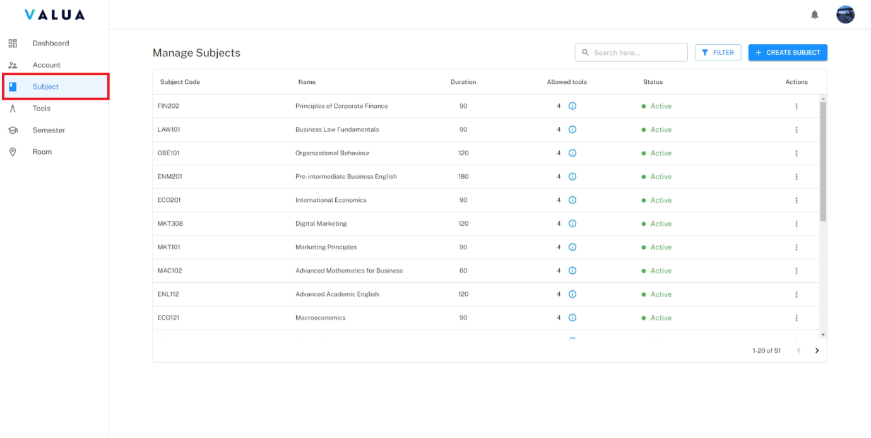

Figure 88: <Web> View subject list

* + - Manager can search subject by subject code or subject name (1).
    - Manager can filter subject by status (2).

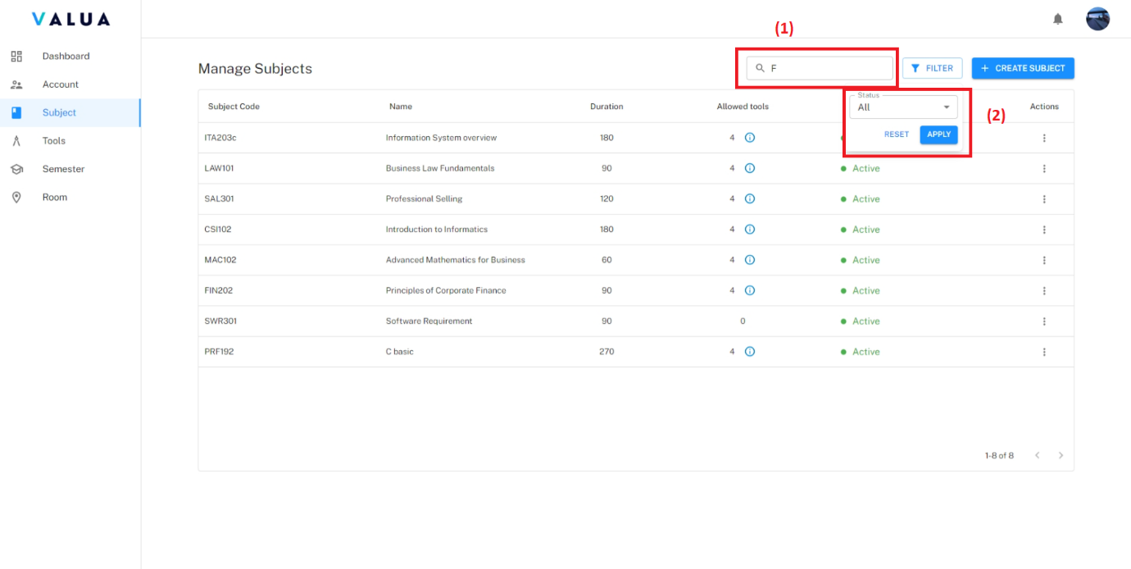

Figure 89: <Web> Search and filter subject

* **<Manager> Create subject**:
  + - Step 1: Click the “Subject” tab (1) and click the “CREATE SUBJECT” button (2).

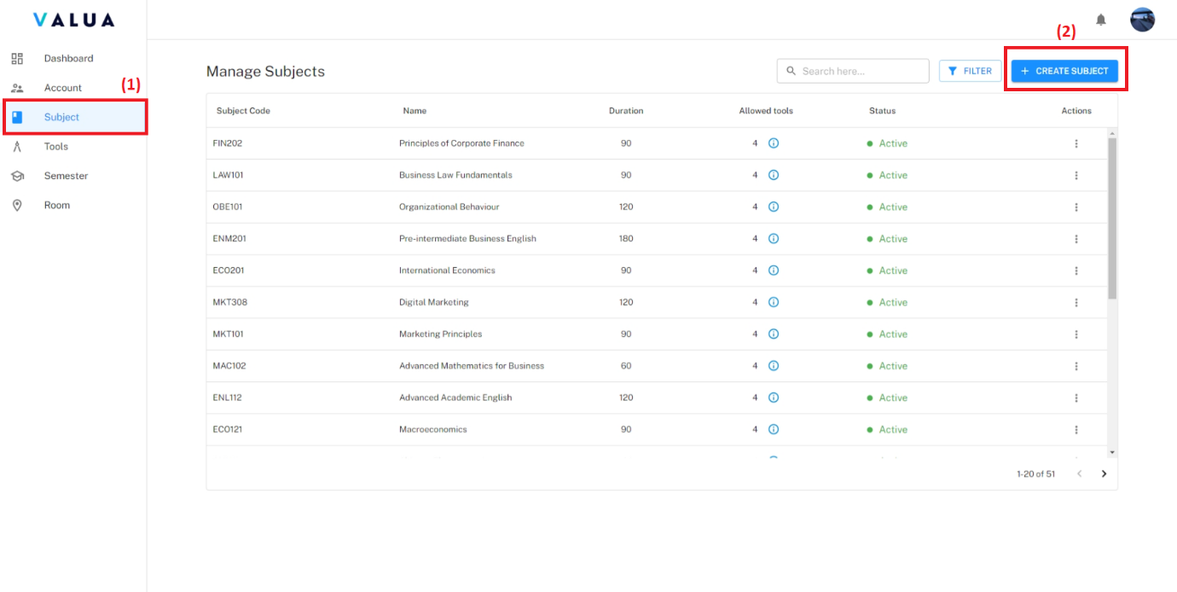

Figure 90: <Web> Create subject (Step 1)

* + - Step 2: Fill required information.
    - Step 3: Click the “CREATE” button

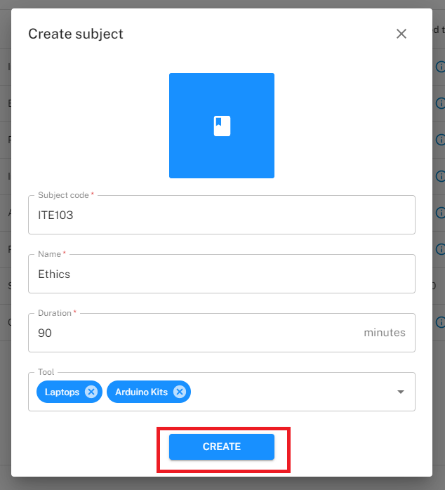

Figure 91: <Web> Create subject (Step 2)

* **<Manager> Update subject**:
  + - Step 1: Click the “Subject” tab (1) and click the “Action” ellipsis of specific subject row (2).
    - Step 2: Click the “Edit” option (3).

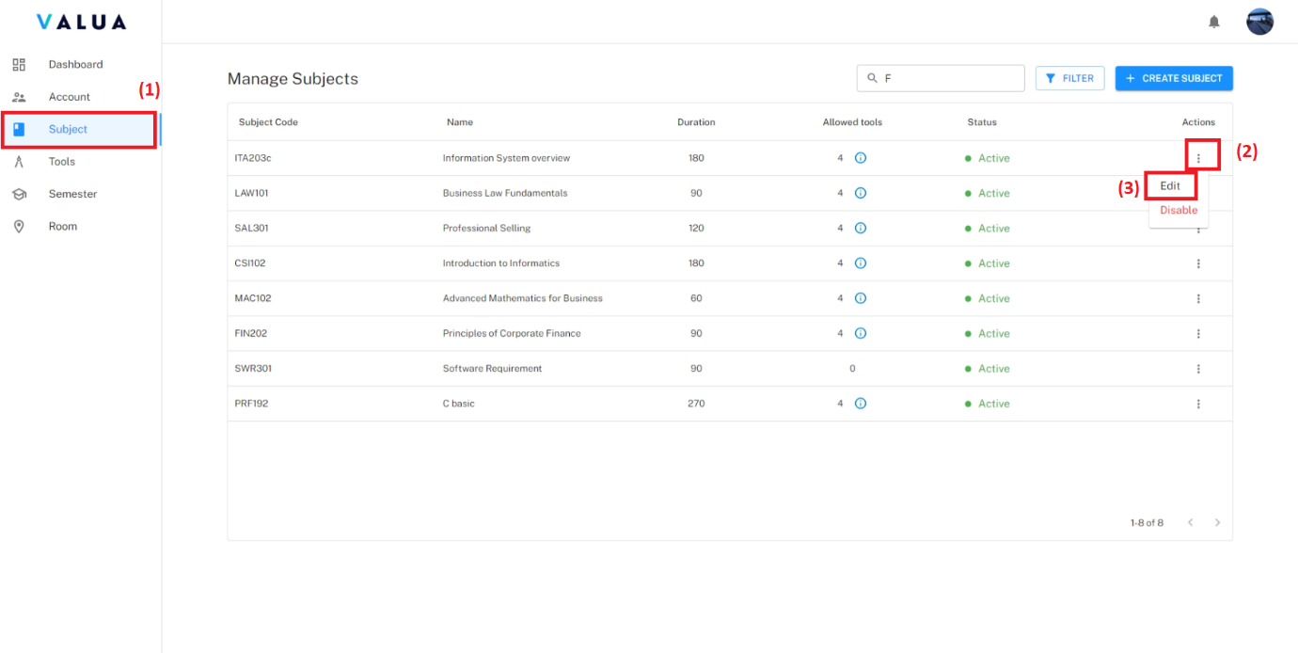

Figure 92: <Web> Update subject (Step 1,2)

* + - Step 3: Fill changed information.
    - Step 4: Click the “UPDATE” button.

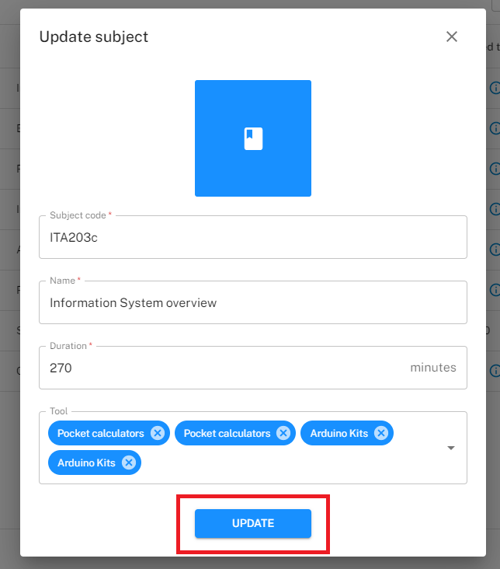

Figure 93: <Web> Update subject (Step 3)

* **<Manager> Disable subject**:
  + - Step 1: Click the “Subject” tab (1) and click the “Action” ellipsis of specific subject row (2).
    - Step 2: Click the “Disable” option (3).

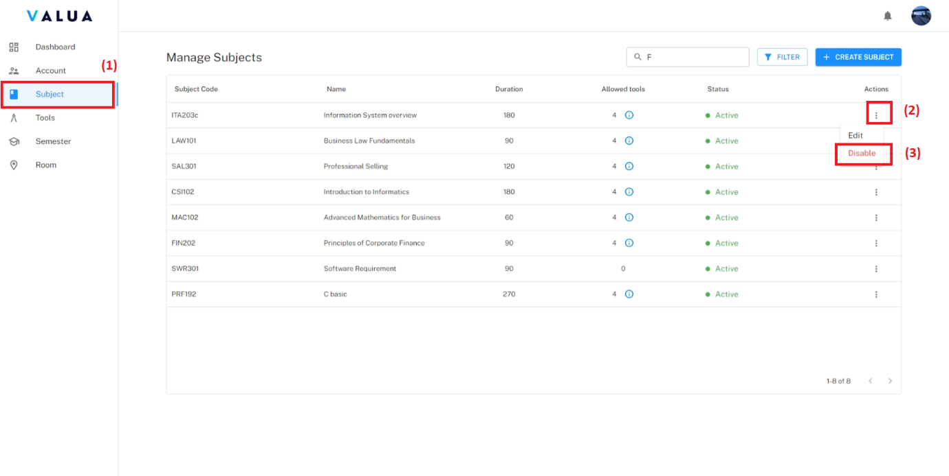

Figure 94: <Web> Disable subject (Step 1,2)

* + - Step 3: Click the “CONFIRM” button.

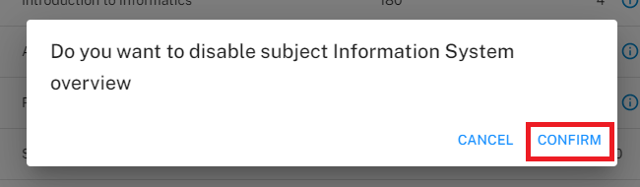

Figure 95: <Web> Disable subject (Step 3)

* **<Manager> Add tool subject**:
  + - Step 1: Click the “Subject” tab (1) and click the “Action” ellipsis of specific subject row (2).
    - Step 2: Click the “Edit” option (3).



Figure 96: <Web> Add tool to subject (Step 1,2)

* + - Step 3: Click icon then choose specific tool.

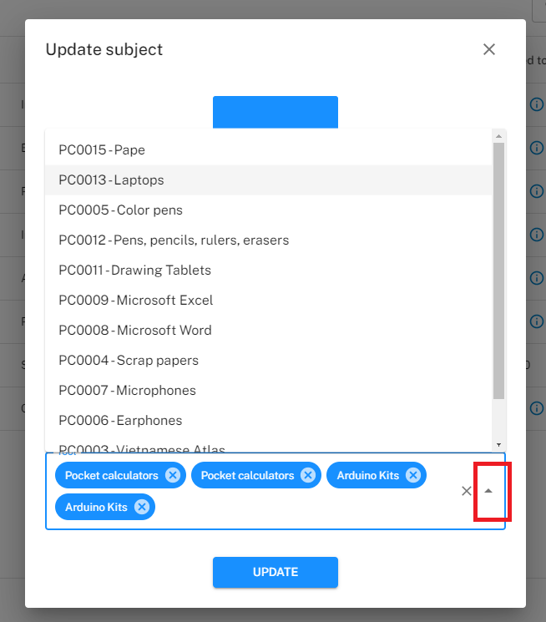

Figure 97: <Web> Add tool to subject (Step 3)

* + - Step 4: Click the “UPDATE” button.



Figure 98: <Web> Add tool to subject (Step 4)

* **<Manager> Remove tool subject**:
  + - Step 1: Click the “Subject” tab (1) and click the “Action” ellipsis of specific subject row (2).
    - Step 2: Click the “Edit” option (3).

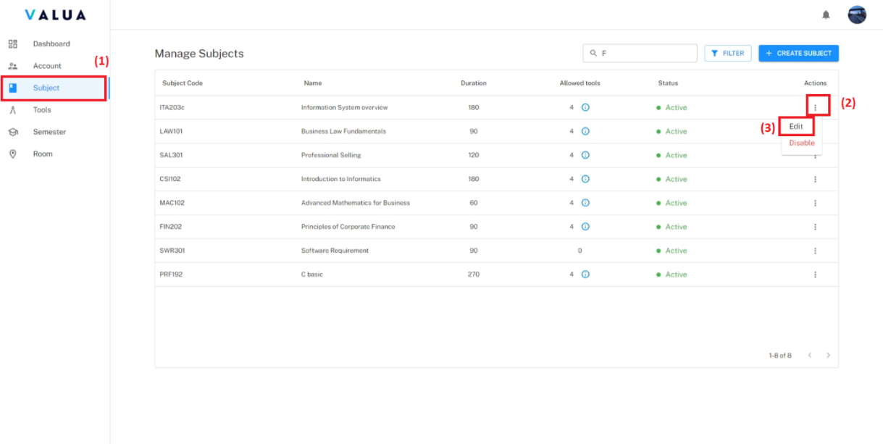

Figure 99: <Web> Remove tool from subject (Step 1,2)

* + - Step 3: Click icon “X” of specific tool (1) to remove tool or “X” (2) to remove all tool.

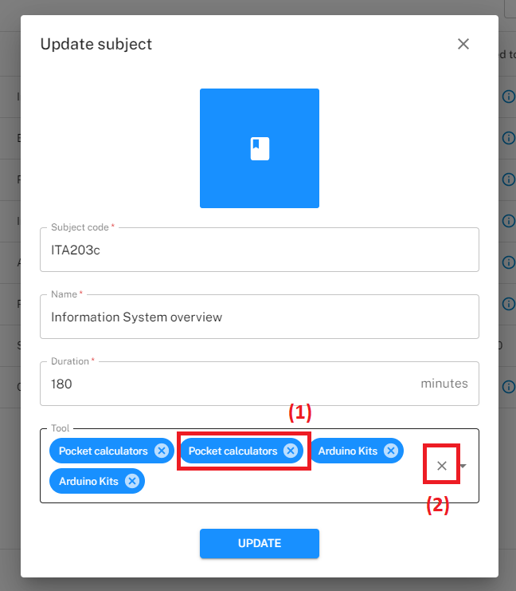

Figure 100: <Web> Remove tool from subject (Step 3)

* + - Step 4: Click the “UPDATE” button.



Figure 101: <Web> Remove to from subject (Step 4)

###### Manage semester

* **Purpose:** This feature allows Manager to manage semesters of VaLua System.
* **<Manager> View semester list**:
  + - Step 1: Click the “Semester” tab.

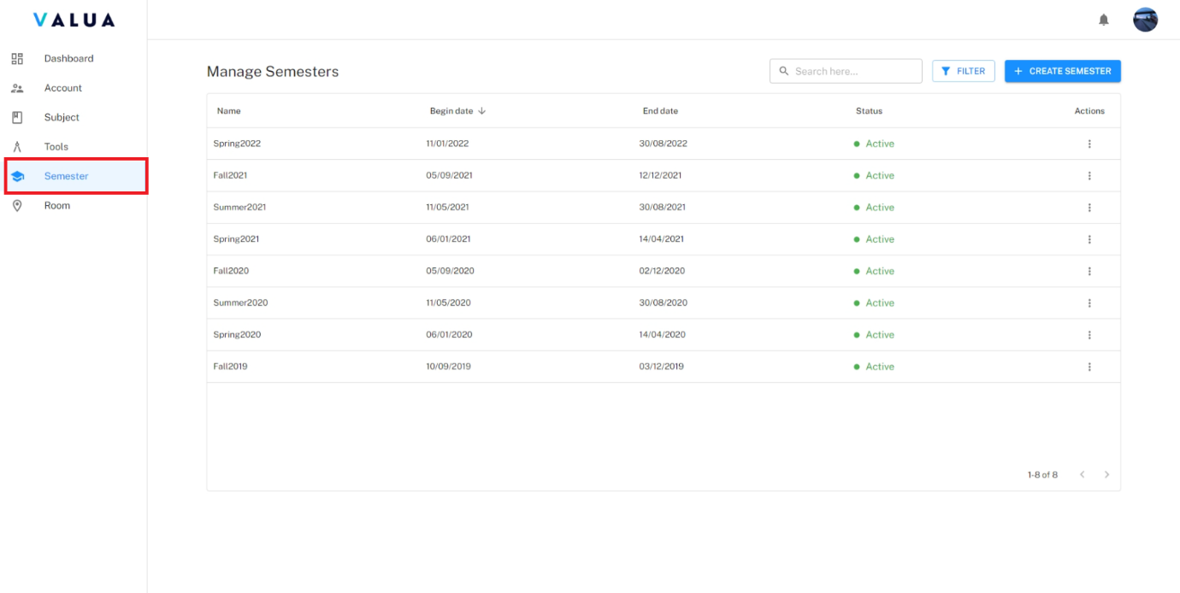

Figure 102: <Web> View semester list

* + - Manager can search semester by semester name (1)
    - Manager can filter semester by status, from begin date to end date (2)
    - Manager can sort semester by begin date or end date (3)

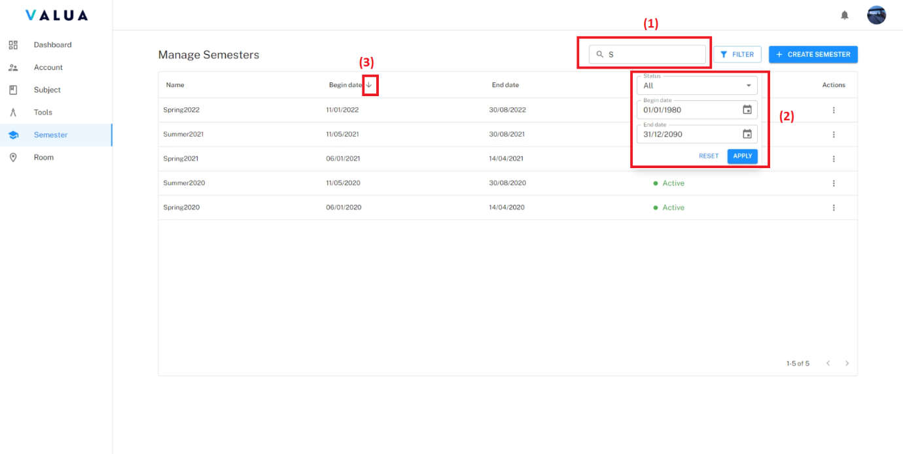

Figure 103: <Web> Search, filter and sort semester

* **<Manager> Create semester**:
  + - Step 1: Click the “Semester” tab (1) and click the “CREATE SEMESTER” button (2).

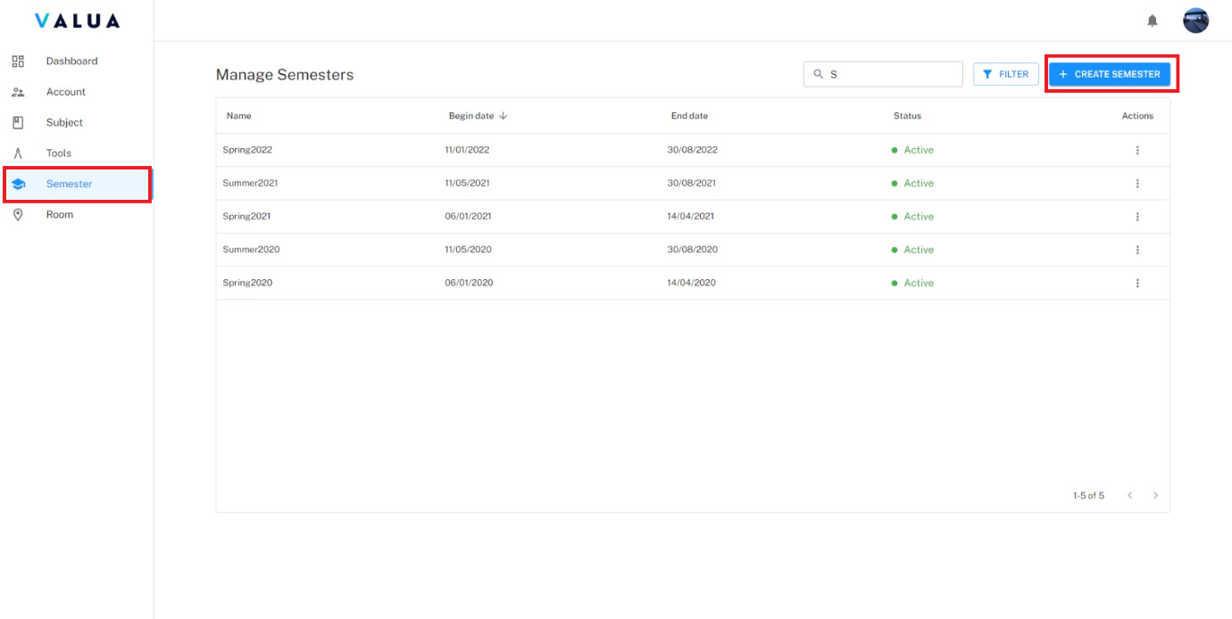

Figure 104: <Web> Create semester (Step 1)

* + - Step 2: Fill required information.
    - Step 3: Click the “CREATE” button.

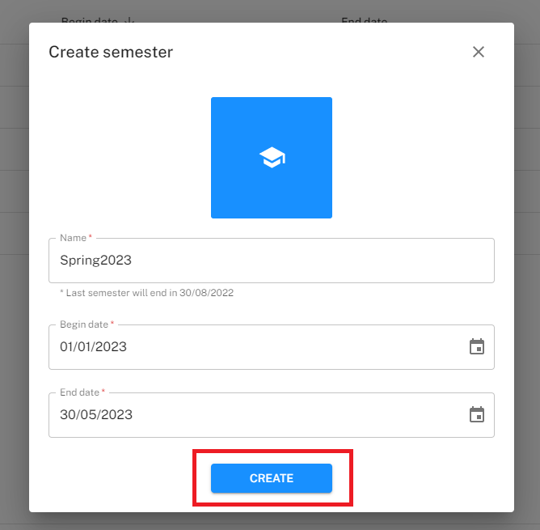

Figure 105: <Web> Create semester (Step 3)

* **<Manager> View semester detail**:
  + - Step 1 Click the “Semester” tab (1) and click the “Action” ellipsis of specific semester row (2).
    - Step 2: Click the “View detail” option (3).

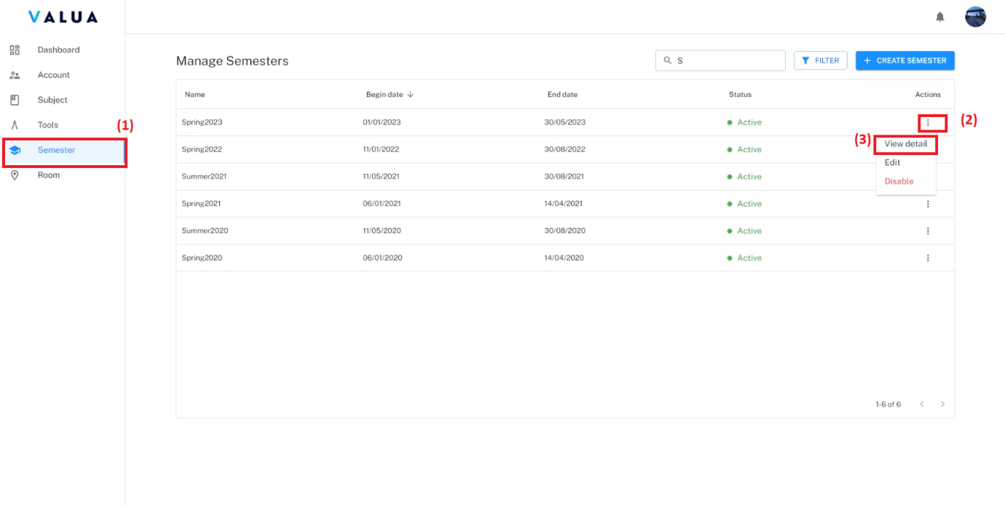

Figure 106: <Web> Semester detail screen (Step 1,2)

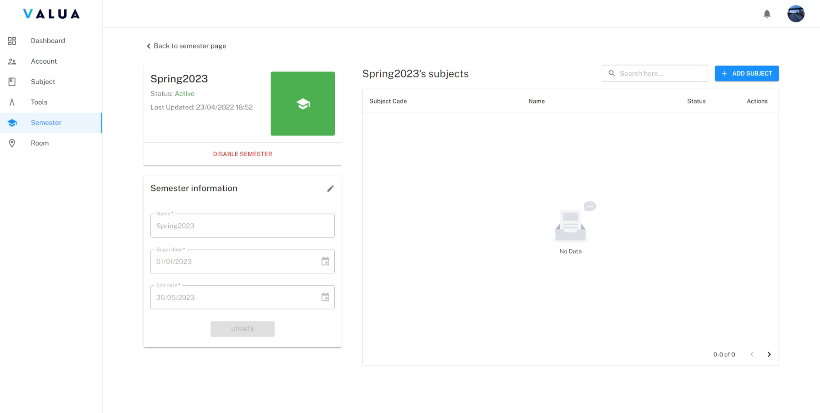

Figure 107: <Web> Semester detail screen

* **<Manager> Update semester**:
  + - Step 1 Click the “Semester” tab (1) and click the “Action” ellipsis of specific semester row (2)
    - Step 2: Click the “View Edit” option (3).

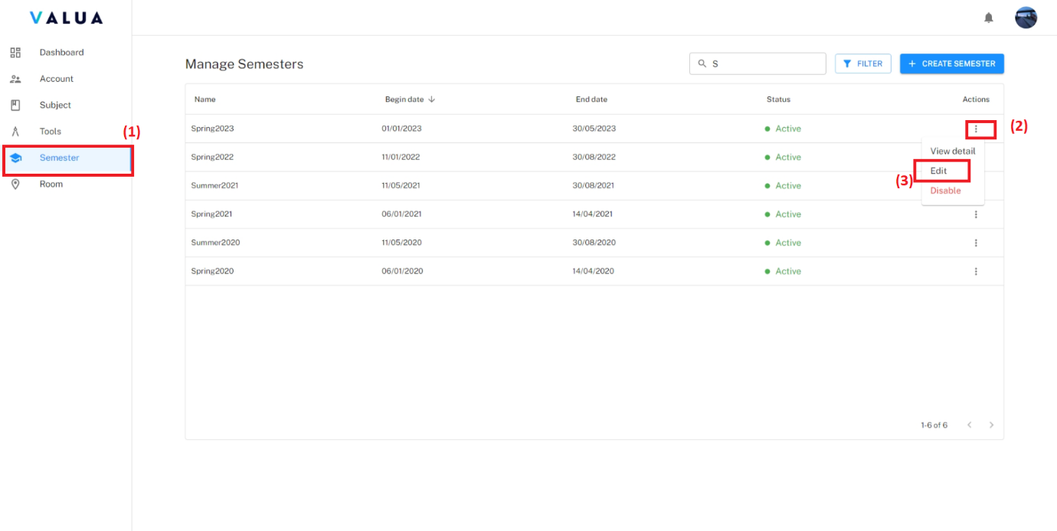

Figure 108: <Web> Update semester (Step 1,2)

* + - Step 3: Fill changed information.
    - Step 4: Click the “UPDATE” button.

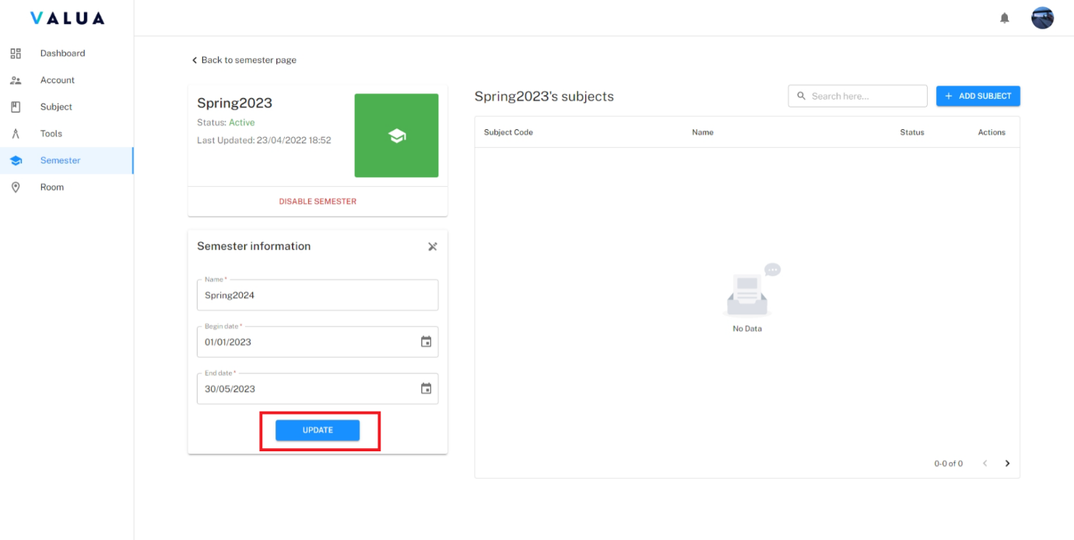

Figure 109: <Web> Update semester (Step 4)

* **<Manager> Disable semester**
  + **Disable semester on semester screen:**
    - Step 1: Click the “Semester” tab (1) and click the “Action” ellipsis of specific semester row (2).
    - Step 2: Click the “Disable” option (3).
    - Step 3: Click “Confirm” button.

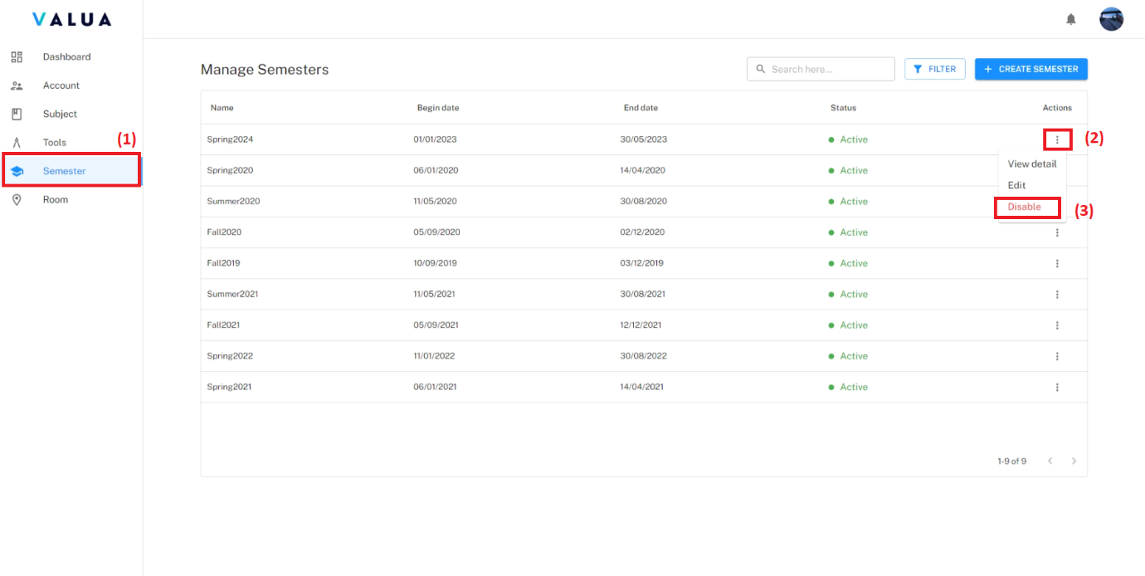

Figure 110: <Web> DIsable semester on semester screen (Step 1,2)

* + **Disable semester on semester detail screen:**
    - Step 1: Click on the “DISABLE SEMESTER” button then click “Confirm button”.

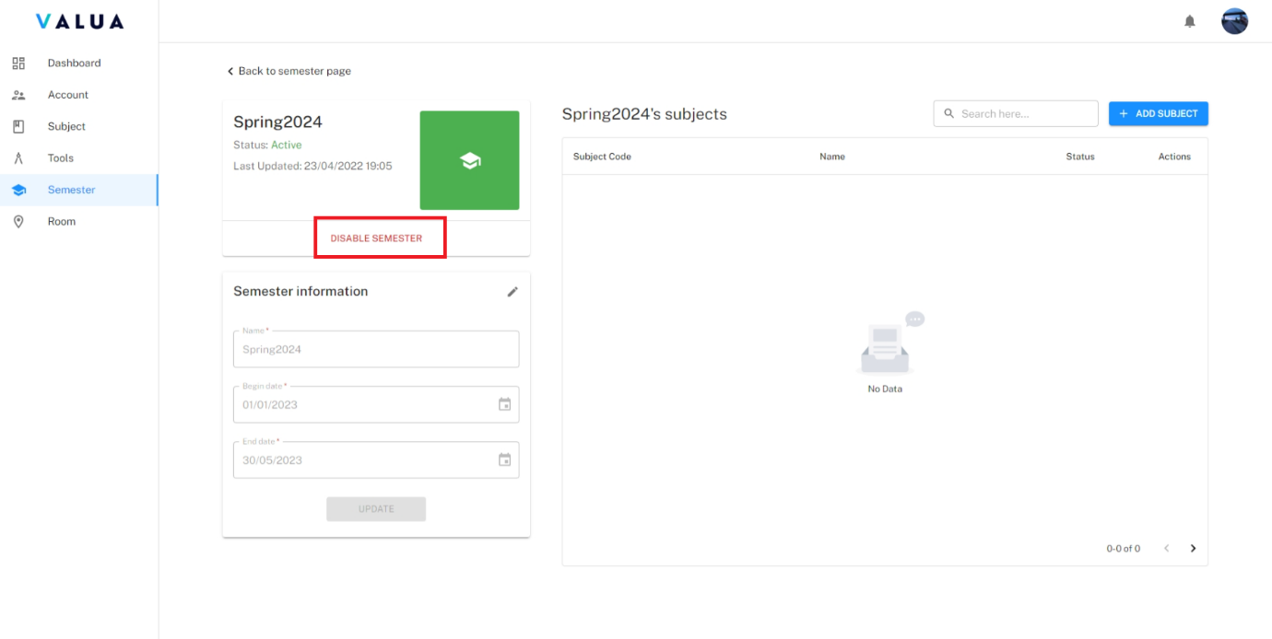

Figure 111: <Web> DIsable semester on semester detail screen

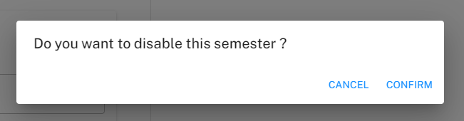

Figure 112: <Web> Confirm dialog for disable semester

* **<Manager> Add subject to semester**:
  + - Step 1: On semester screen detail, click the “ADD SUBJECT” button.

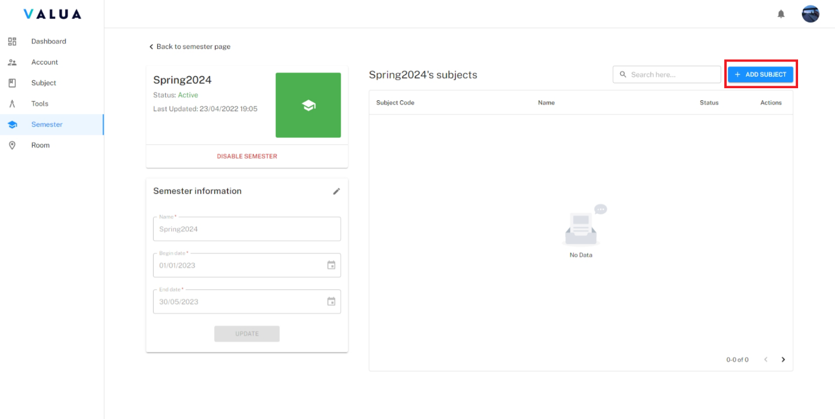

Figure 113: <Web> Add subject to semester (Step 1)

* + - Step 2: Select subjects want to add.

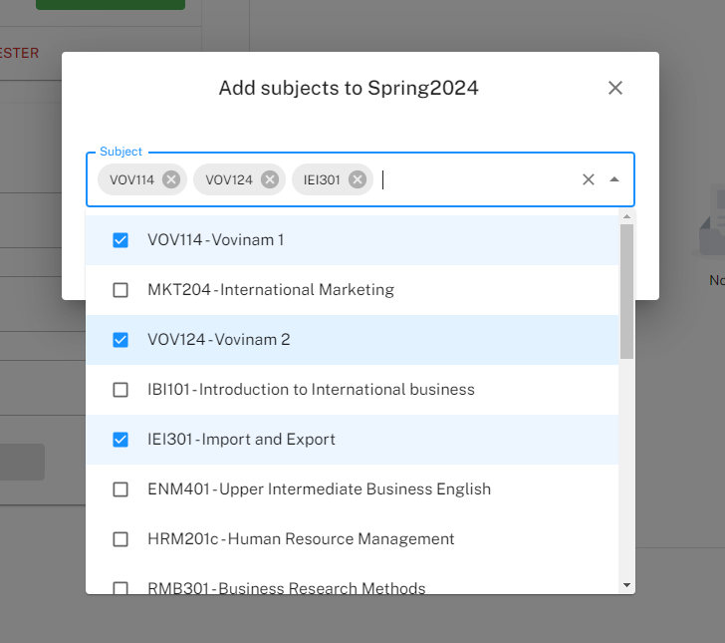

Figure 114: <Web> Add subject to semester (Step 2)

* + - Step 3: Click the “ADD” button.

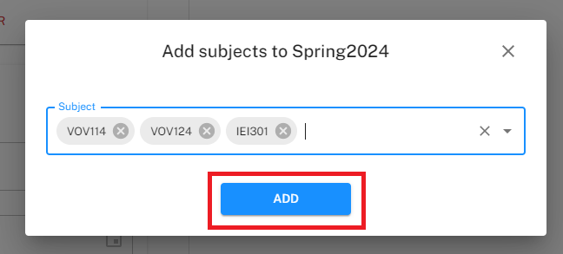

Figure 115: <Web> Add subject to semester (Step 3)

* **<Manager> Remove subject from semester**:
  + - Step 1: On semester screen detail, select icon “Delete” of specific subject row to remove subject from semester.

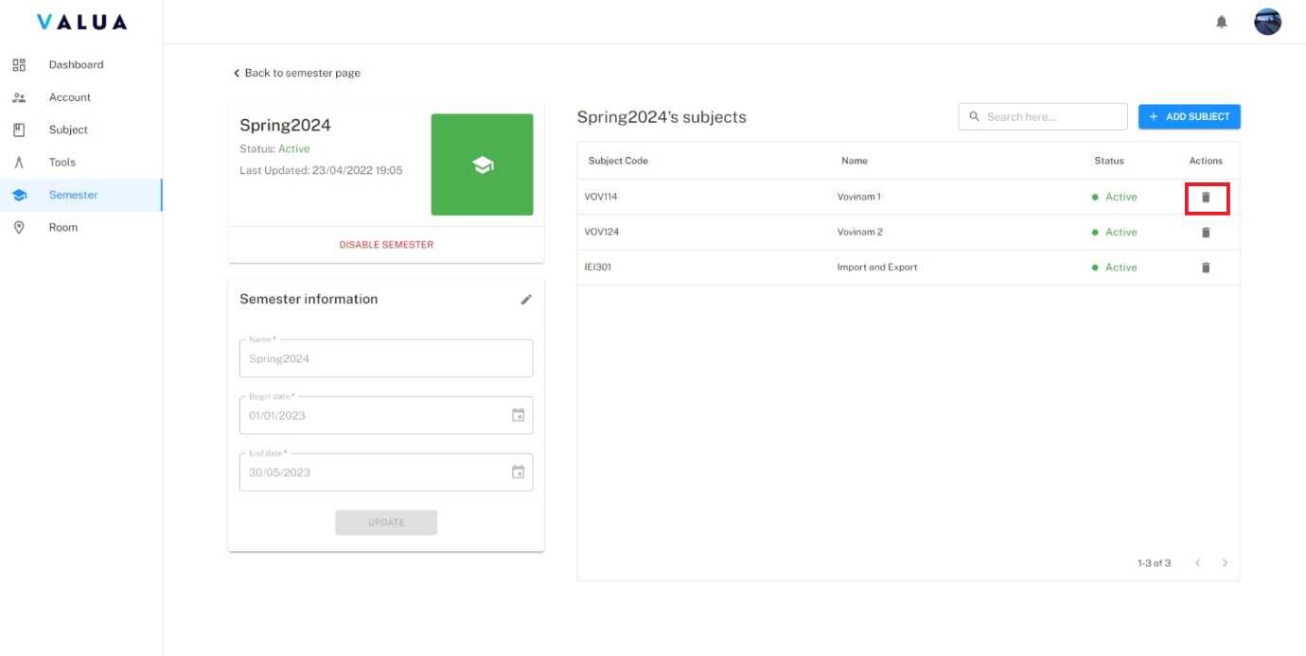

Figure 116: <Web> Remove subject from semester (Step 1)

* + - Step 2: Click the “CONFIRM” button.

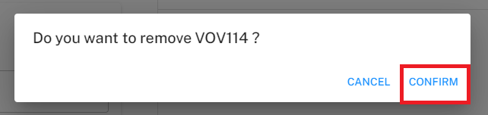

Figure 117: <Web> Remove subject from semester (Step 2)

###### Manage room

* **Purpose:** This feature allows Manager to manage rooms of VaLua System.
* **<Manager> View room list**:
  + - Click the “Room” tab.

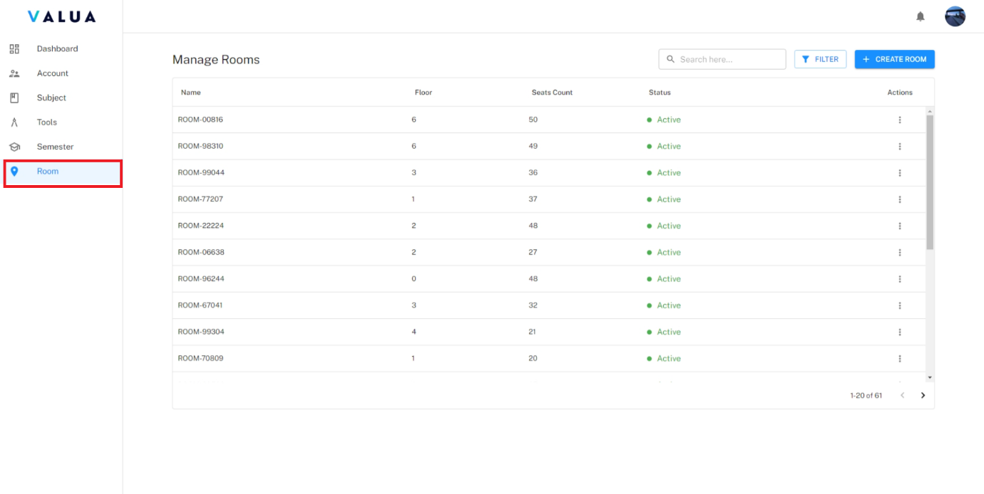

Figure 118: <Web> View room list

* + - Manager can search room by room name (1)
    - Manager can filter room by status (2)

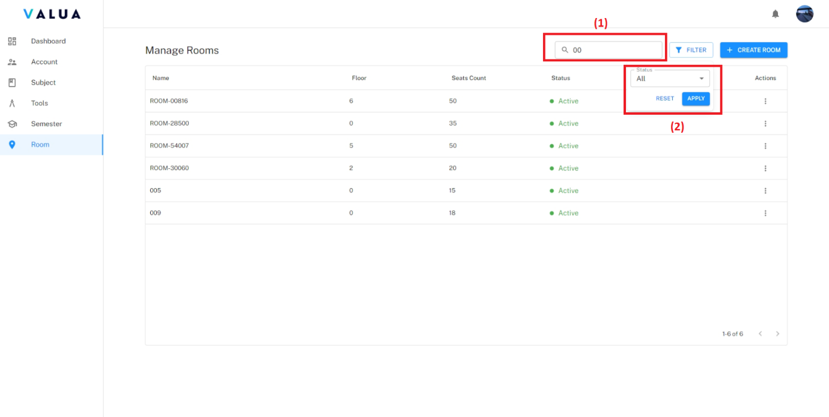

Figure 119: <Web> Search and filter room

* **<Manager> Create room**:
  + - Step 1: Click the “Room” tab (1) and click the “CREATE ROOM” button (2).

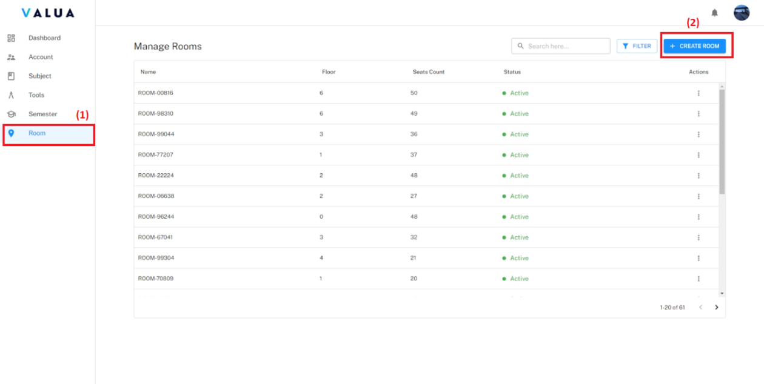

Figure 120: <Web> Create room (Step 1)

* + - Step 2: Fill required information.
    - Step 3: Click the “CREATE” button.

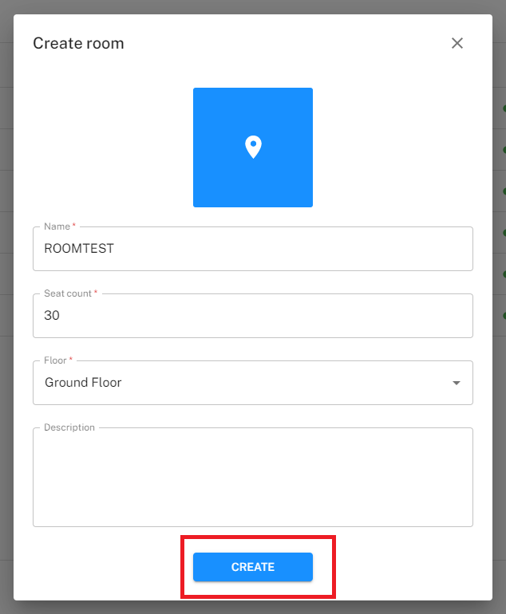

Figure 121: <Web> Create room (Step 3)

* **<Manager> View room detail**:
  + - Step 1: Click the “Room” tab (1) and click the “Action” ellipsis of specific room row (2).
    - Step 2: Click the “View detail” option (3).

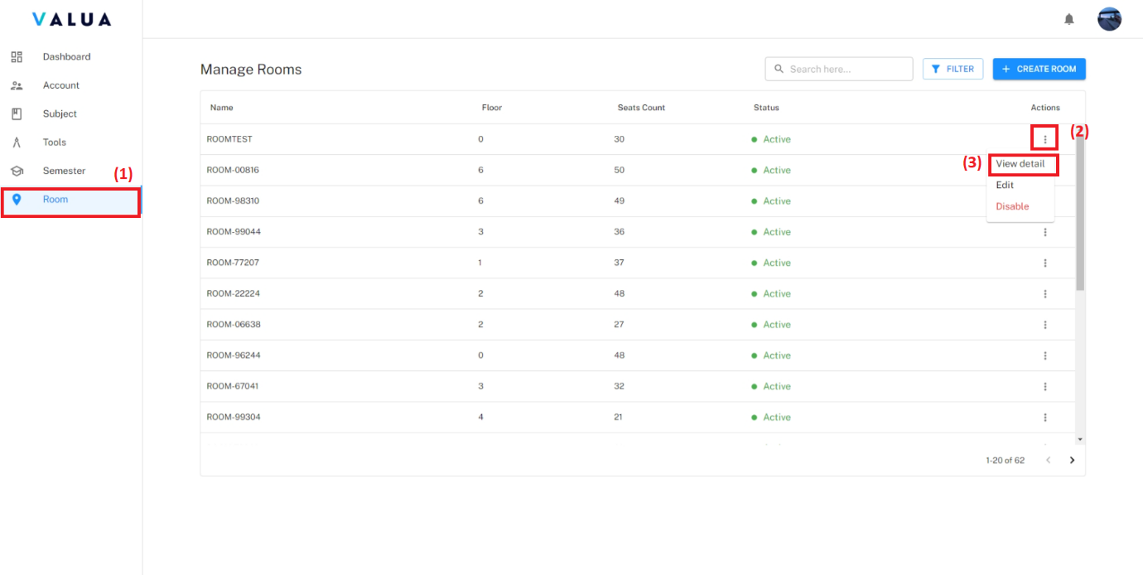

Figure 122: <Web> View detail room (Step 1,2)

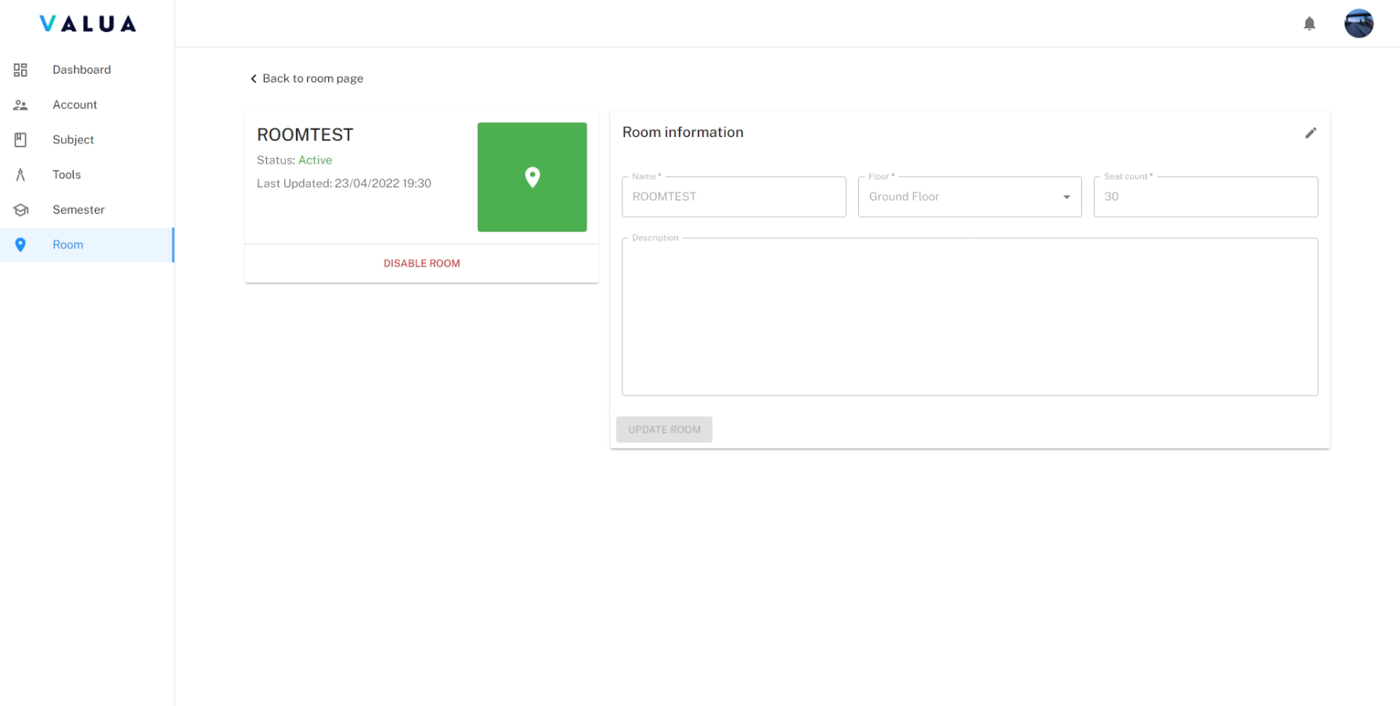

Figure 123: <Web> Room detail screen

* **<Manager> Update room**:
  + - Step 1: Click the “Room” tab (1) and click the “Action” ellipsis of specific room row (2).
    - Step 2: Click the “Edit” option (3).

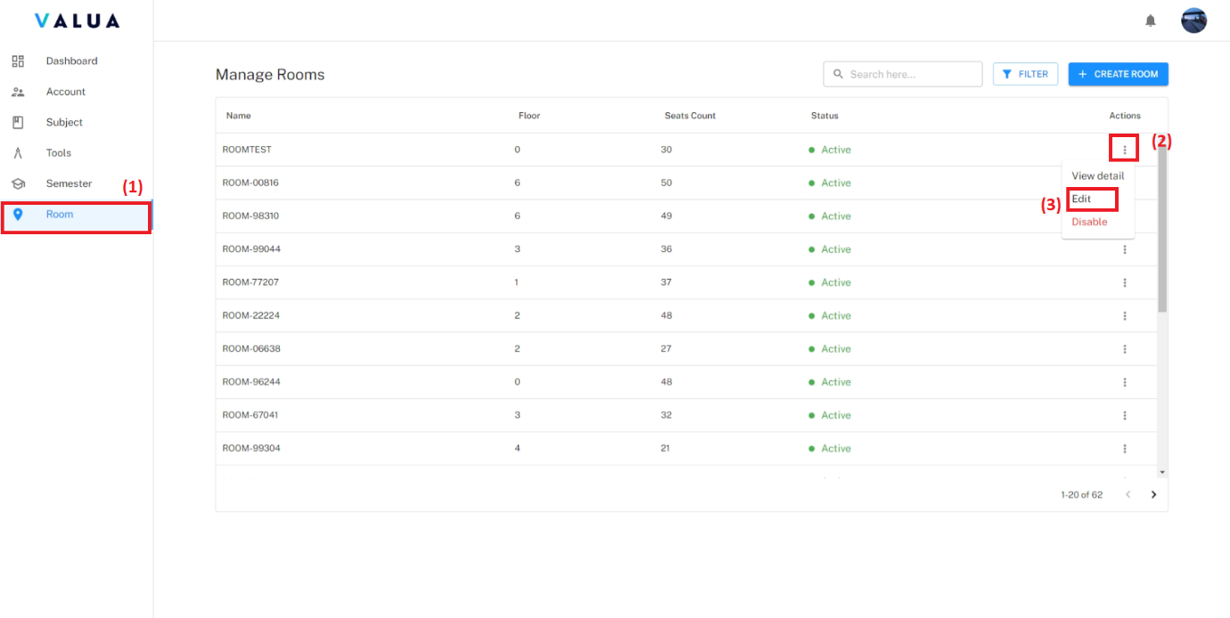

Figure 124: <Web> Update room (Step 1,2)

* + - Step 3: Fill changed information.
    - Step 4: Click the “UPDATE” button.

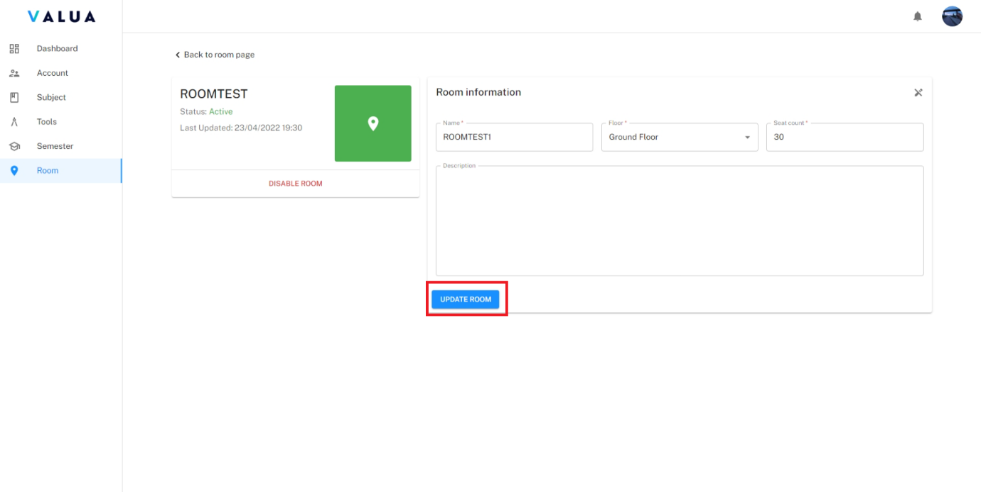

Figure 125: <Web> Update room (Step 4)

* **<Manager> Disable room**:
  + **Disable room on room screen:**
    - Step 1: Click the “Room” tab (1) and click the “Action” ellipsis of specific room row (2).
    - Step 2: Click the “Disable” option (3).
    - Step 3: Click “Confirm” button.

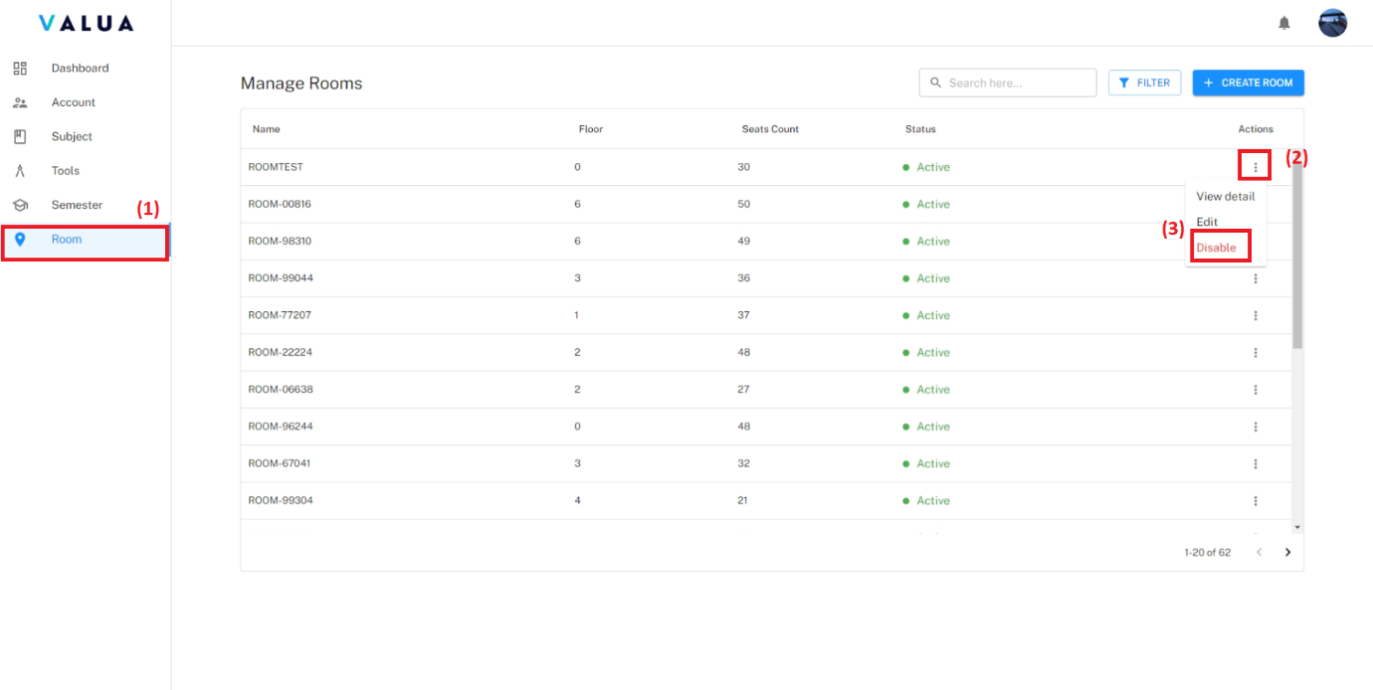

Figure 126: <Web> Disable room on room screen (Step 1,2)

* + **Disable room on room detail screen:**
    - Click on the “DISABLE ROOM” button then click “CONFIRM” button.

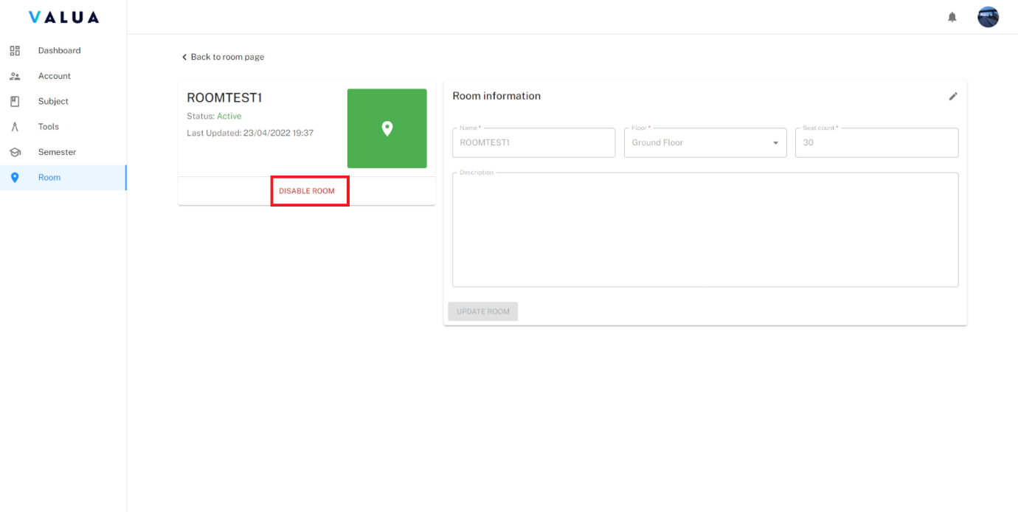

Figure 127: <Web> Disable room in room detail screen

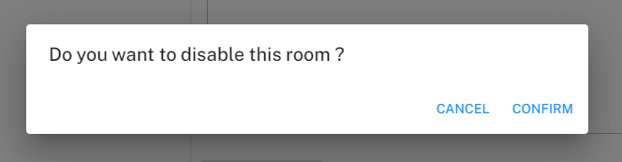

Figure 128: <Web> Confirm dialog for disable room

###### Manage examinee

* Purpose: This feature allows Shift Manager to manage examinee of subject of VaLua System.
* Function:
* **<Shift Manager> View subject assignments list:**
  + Click the “Examinee” tab.

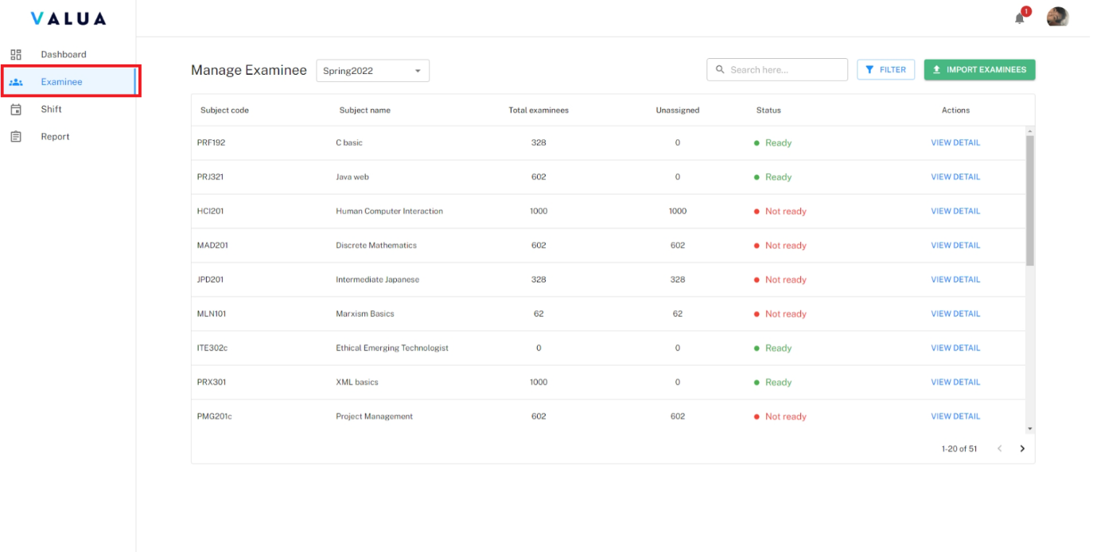

Figure 129. <Web> View subject assignments list

* Shift Manager can search by subject code, name (2) or filter subject assignments by semester (1) or status (3).

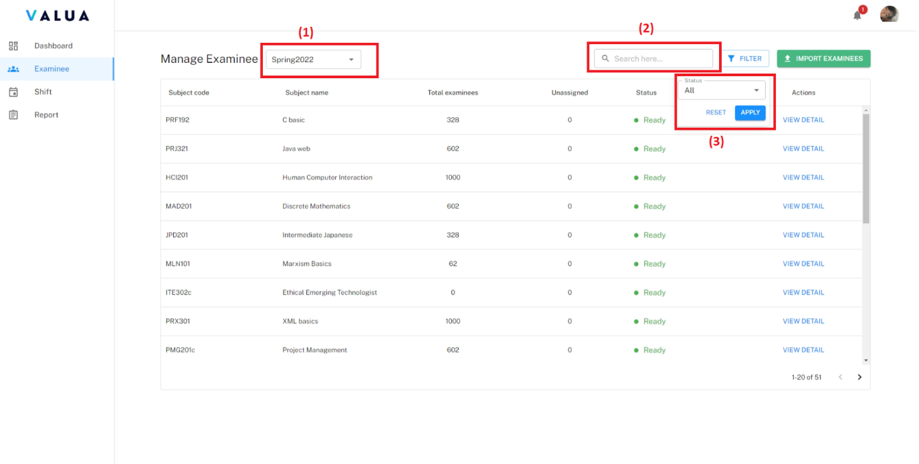

Figure 130. <Web> Search and filter subject assignments

* **<Shift Manager> Import examinees:**
* Step 1: Click the “Examinee” tab (1) and click the “IMPORT EXAMINEES” button (2).

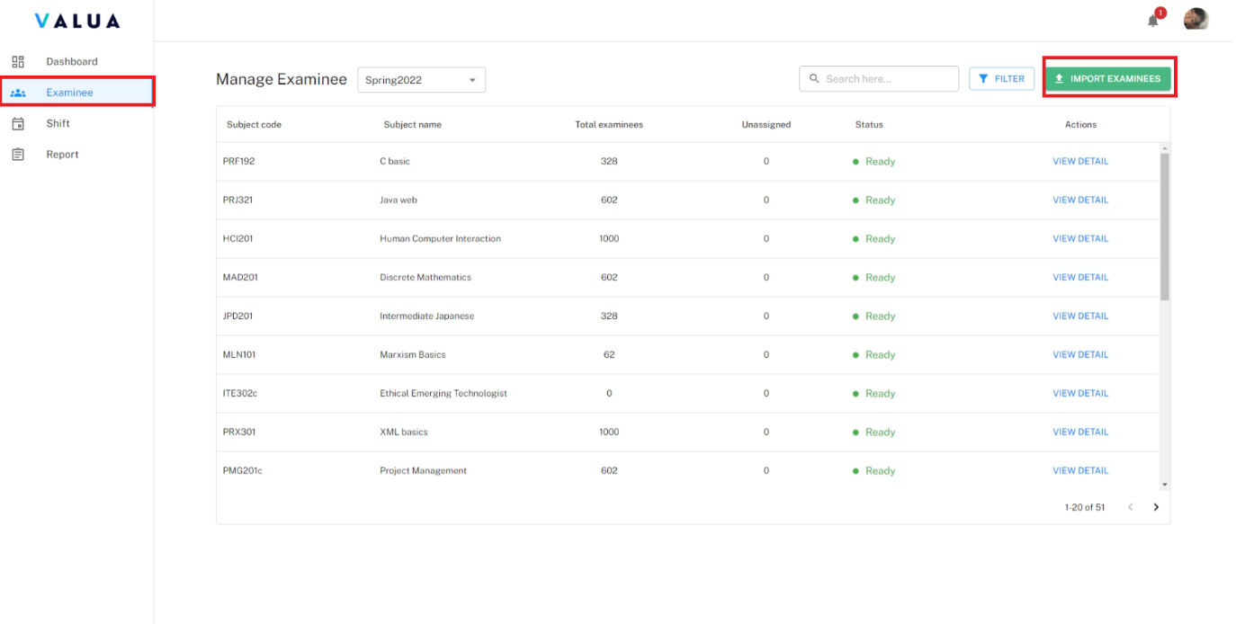

Figure 131. <Web> Import examinees (Step 1)

* Step 2: Select file excel to import with format name “<semester name>_ <subject code>_<campus>”.

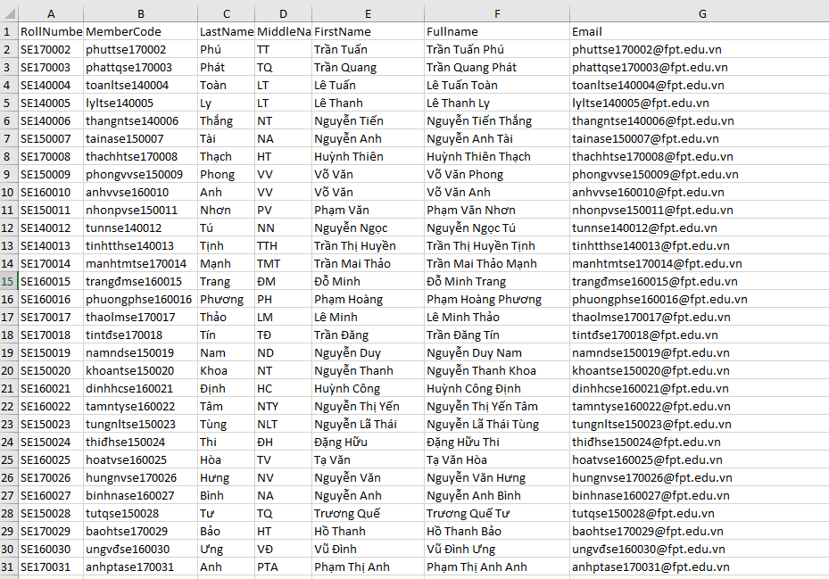

Figure 132. <Web> Import examinees - Format in file excel example.

* Step 3: Click the “SUBMIT” button.

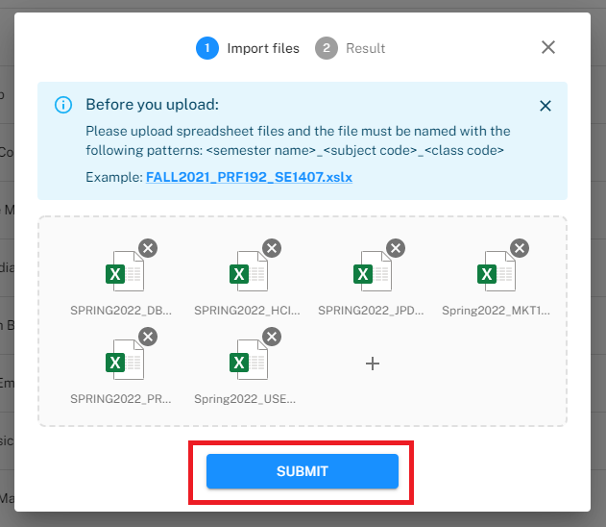

Figure 133. <Web> Import examinees (Step 3)

* Shift Manager can view which file is imported success or failed. If a file is failed because of its content, Shift Manager can download the error file.

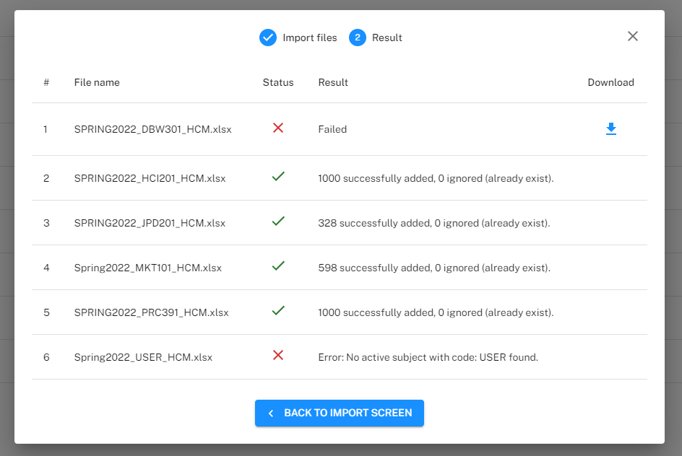

Figure 134. <Web> Import examinees – Result

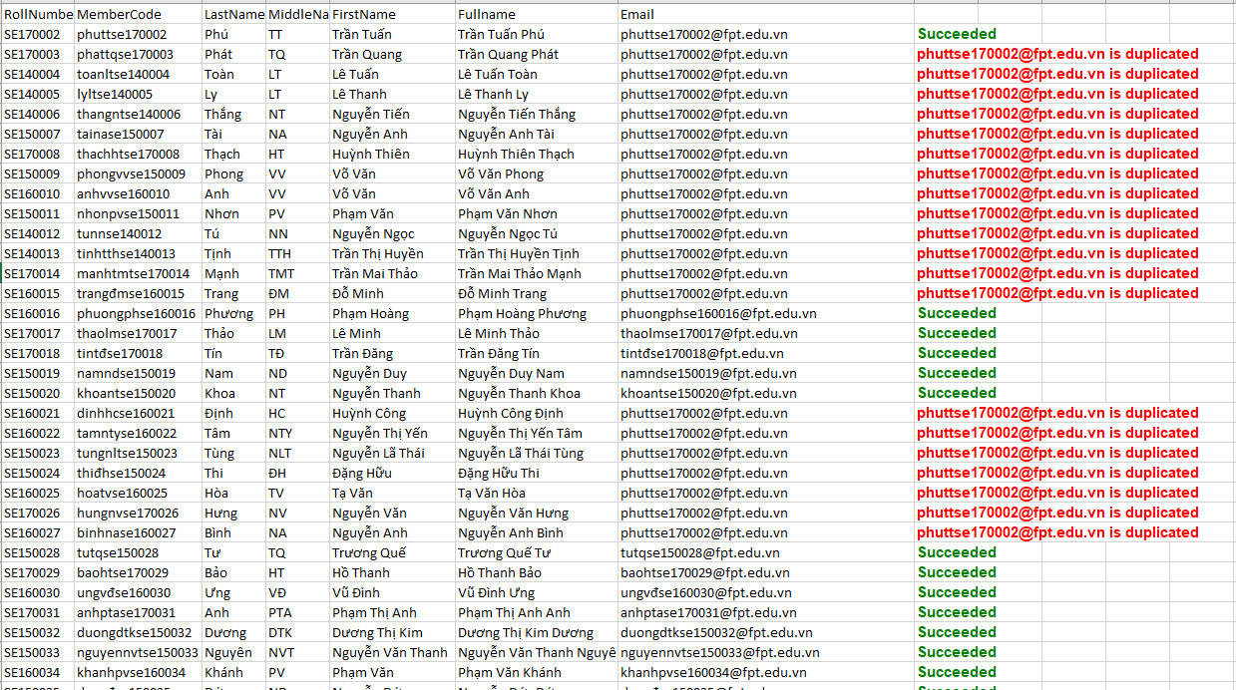

Figure 135. <Web> Import examinees - Error file example

* **<Manager> View subject assignment detail:**
* Click the “EXAMINEE” tab (1) and click the “VIEW DETAIL” button of specific subject assignment row (2).

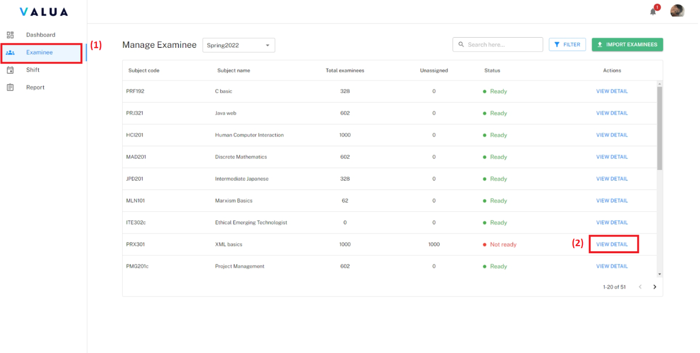

Figure 136. <Web> View subject assignment detail

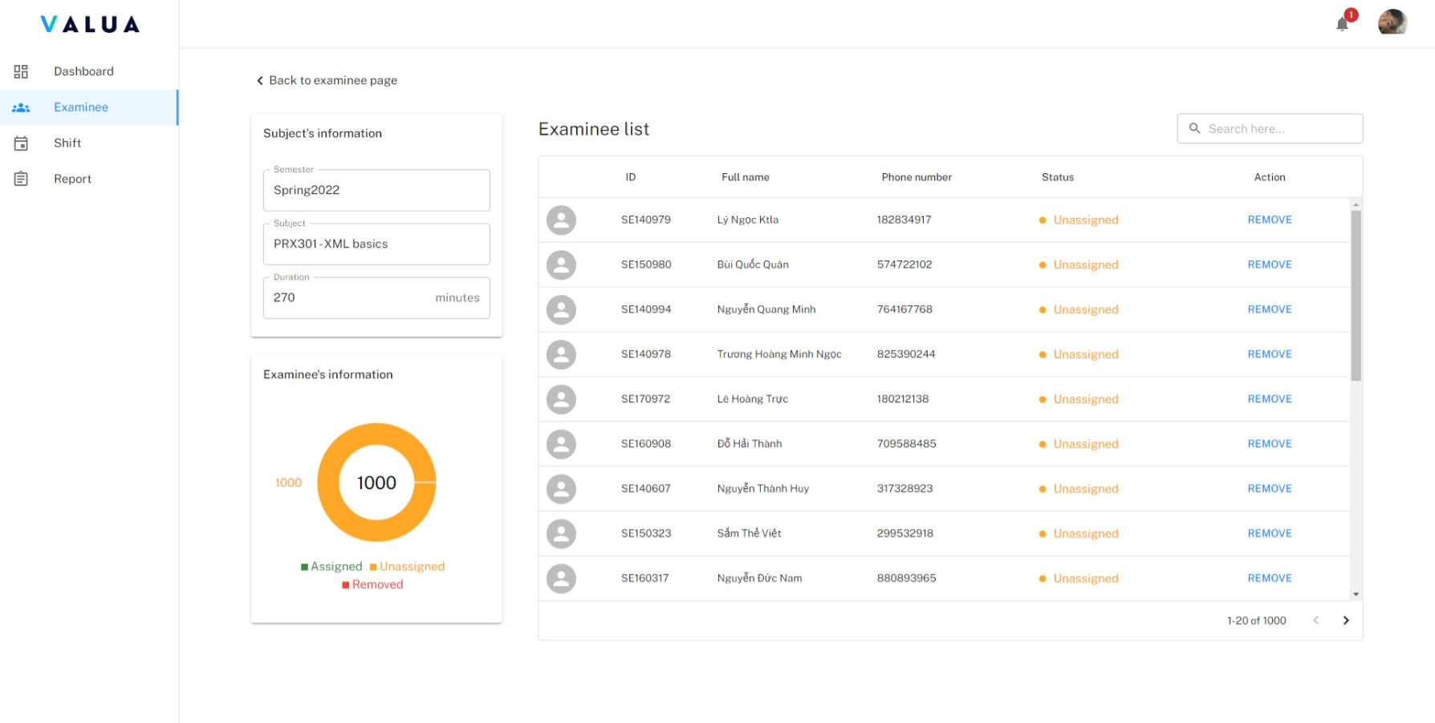

Figure 137. <Web> Subject assignment detail screen

* **<Shift Manager> Remove examinee from semester’s subject:**
* Step 1: On the subject assignment detail screen, click “REMOVE” button of specific examinee row.

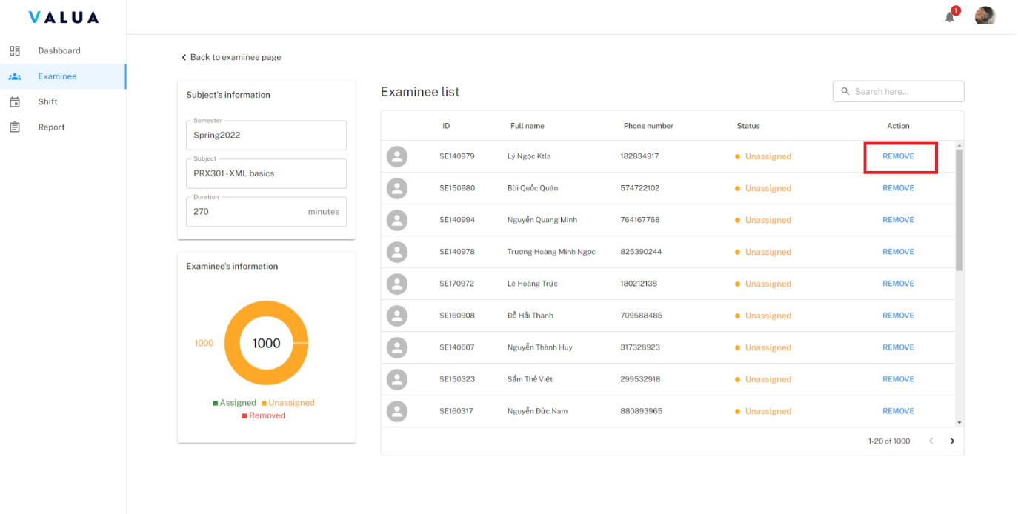

Figure 138. <Web> Remove examinee from semester's subject (Step 1)

* Step 2: Fill reason why remove the examinee.
* Step 3: Click the “CONFIRM” button.

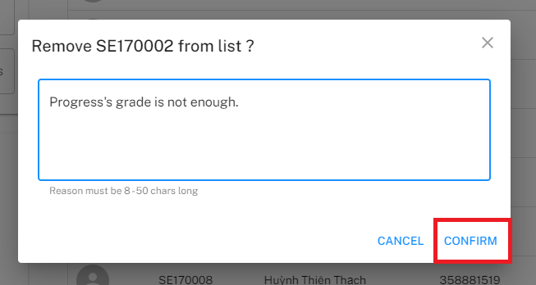

Figure 139. <Web> Remove examinee from semester's subject (Step 3)

###### Manage shift

* Purpose: This feature allows Shift Manager to manage shift in VaLua System.
* Function:
* **<Shift Manager> View shift list:**
  + Click the “Shift” tab.

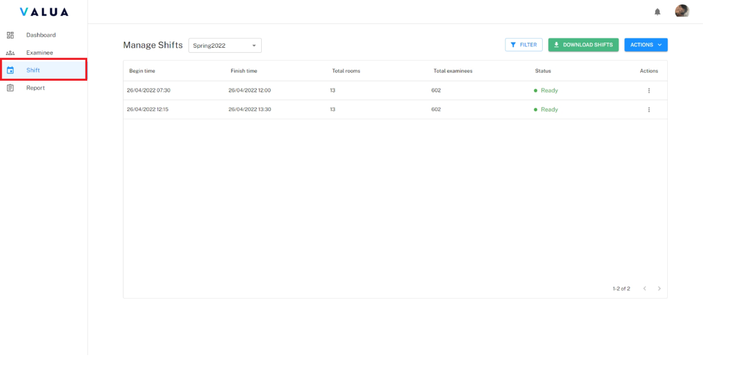

Figure 140. <Web> View shift list

* Shift Manager can filter shift by semester or status.

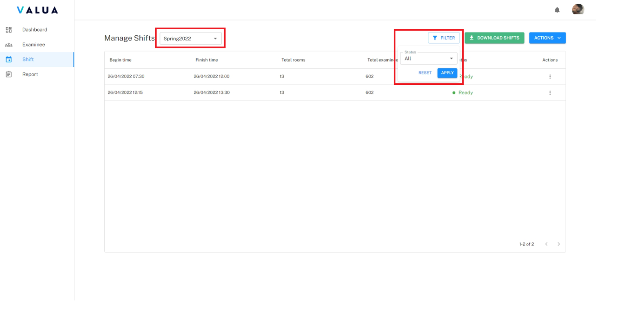

Figure 141. <Web> Filter shift

* **<Shift Manager> Auto assign shifts:**
* Step 1: Click “Shift” tab (1) then click “ACTION” drop down list button (2).
* Step 2: Click “Auto assign shifts” option (3).

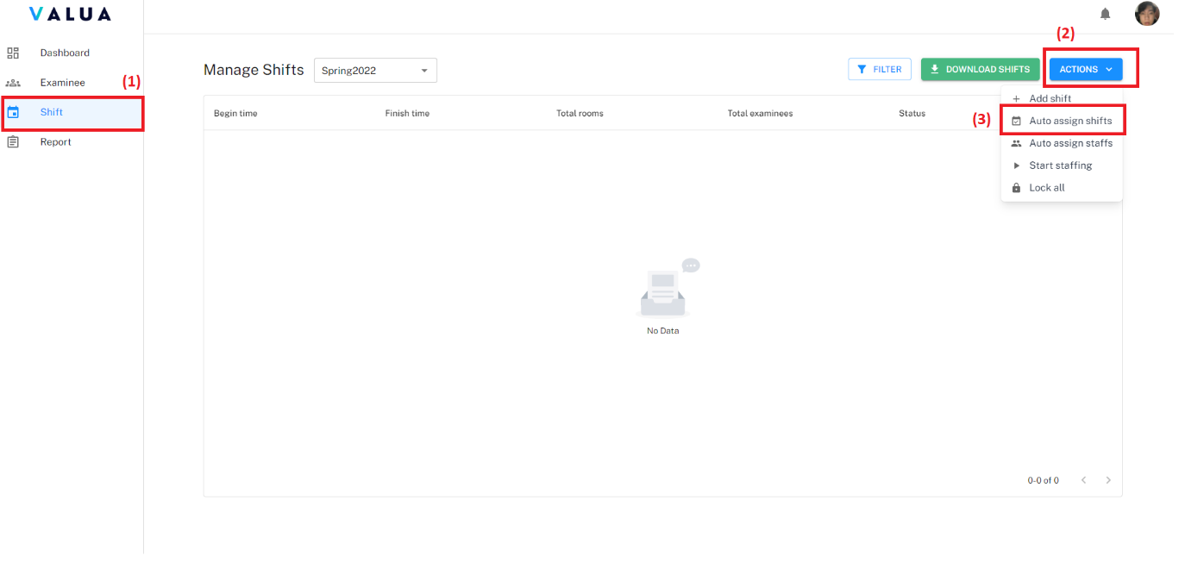

Figure 142. <Web> Auto assign shifts (Step 1, 2)

* Step 3: Fill required information.
* Step 4: Click “CREATE” button.

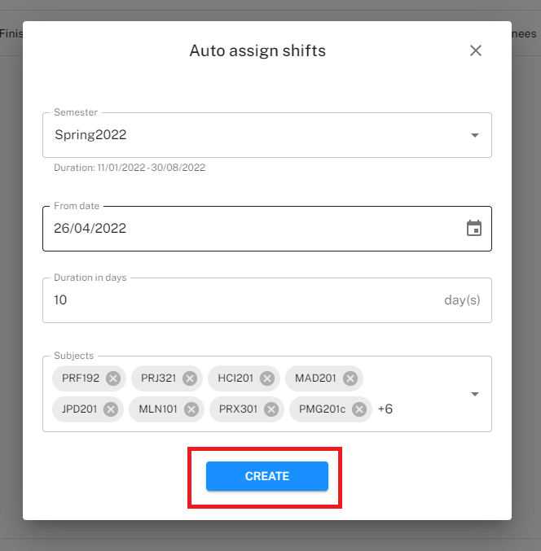

Figure 143. <Web> Auto assign shifts (Step 4)

* **<Shift Manager> View shift detail:**
* Step 1: Click the “Shift” tab (1) and click the “Action” ellipsis of specific shift row (2).
* Step 2: Click the “View detail” option (3).

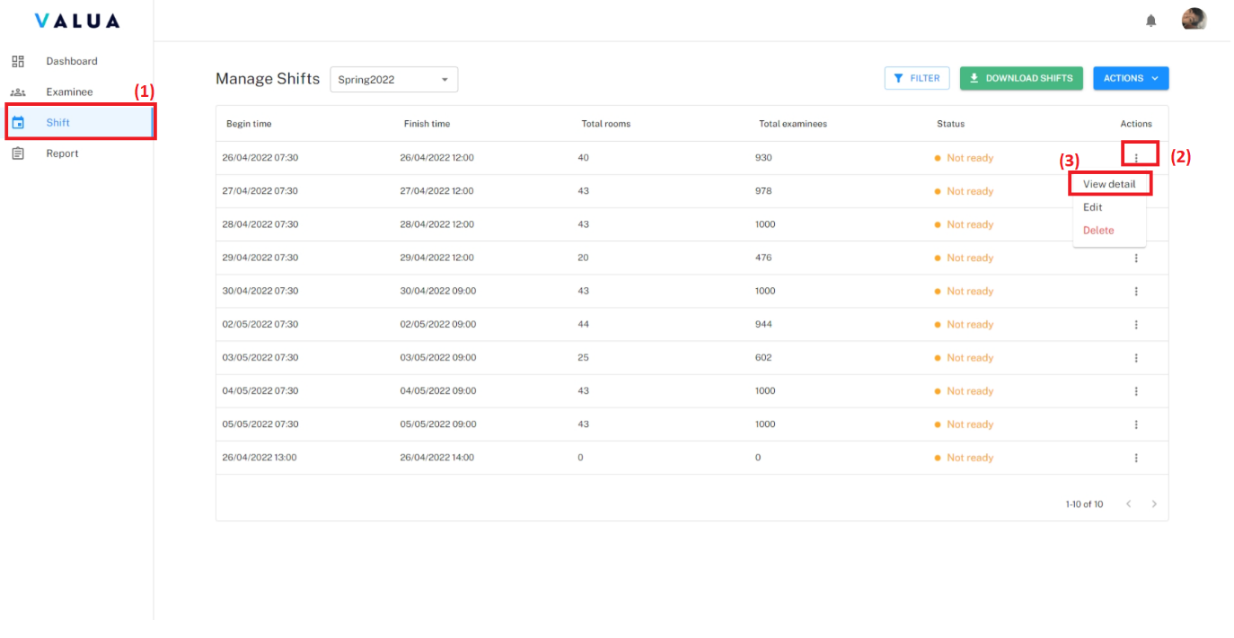

Figure 144. <Web> View shift detail (Step 1, 2)

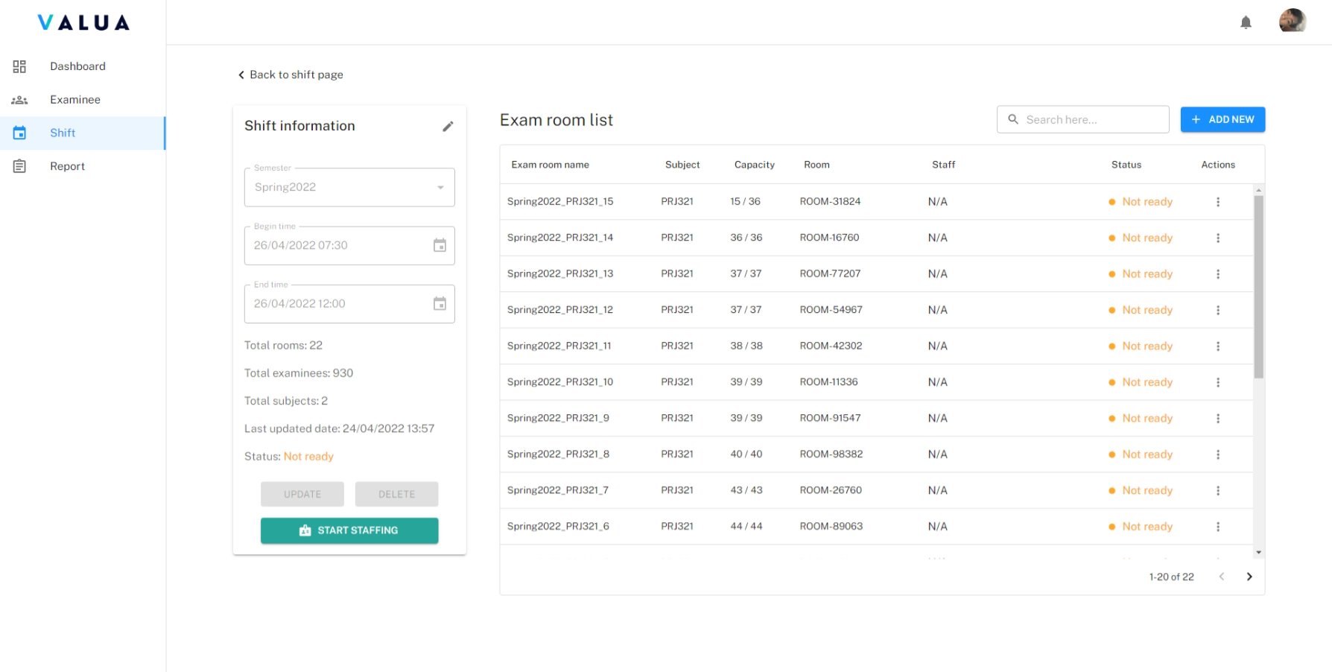

Figure 145. <Web> Shift detail screen

* **<Shift Manager> Create shift:**
* Step 1: Click “Shift” tab (1) then click “ACTION” drop down list button (2).
* Step 2: Click “Add shift” option (3).

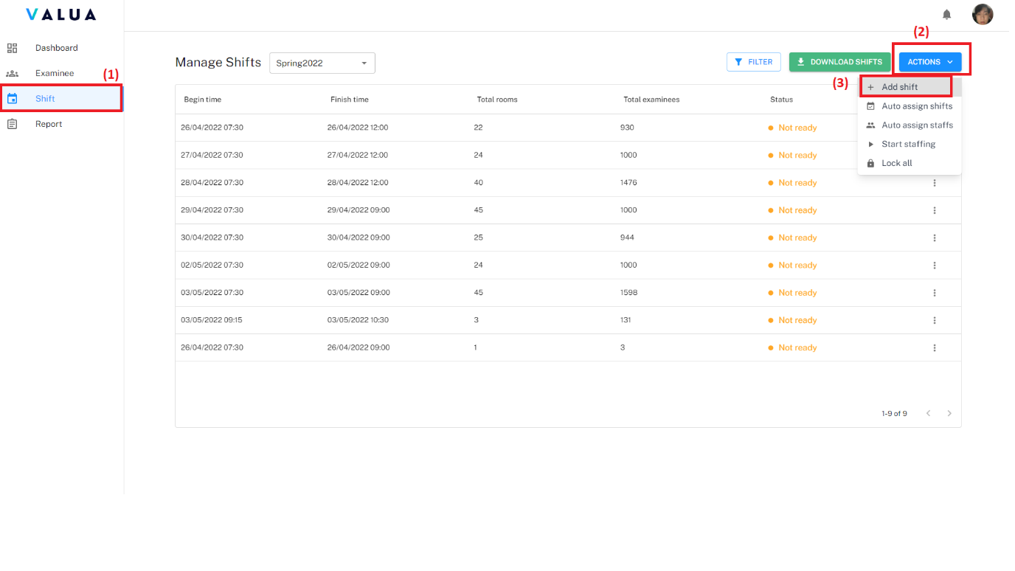

Figure 146. <Web> Create shift (Step 1, 2)

* Step 3: Click on available slot in the calendar (1) or fill required information.
* Step 4: Click the “CREATE” button (2). The created shift is initially without any exam room.

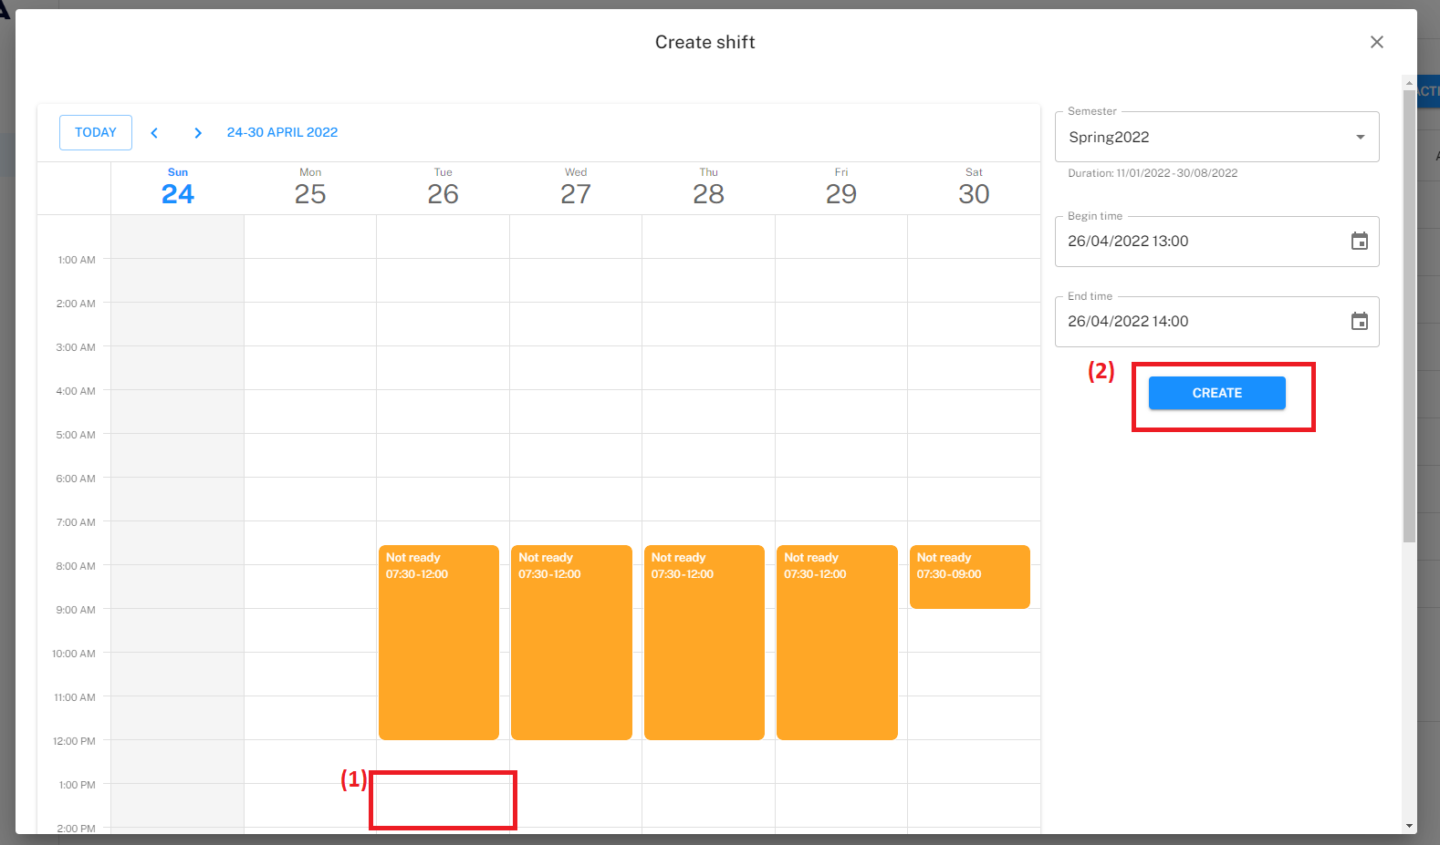

Figure 147. <Web> Create shift (Step 3, 4)

* **<Shift Manager> Update shift:**
* Step 1: Click the “Shift” tab (1) and click the “Action” ellipsis of specific shift row (2).
* Step 2: Click the “Edit” option (3).

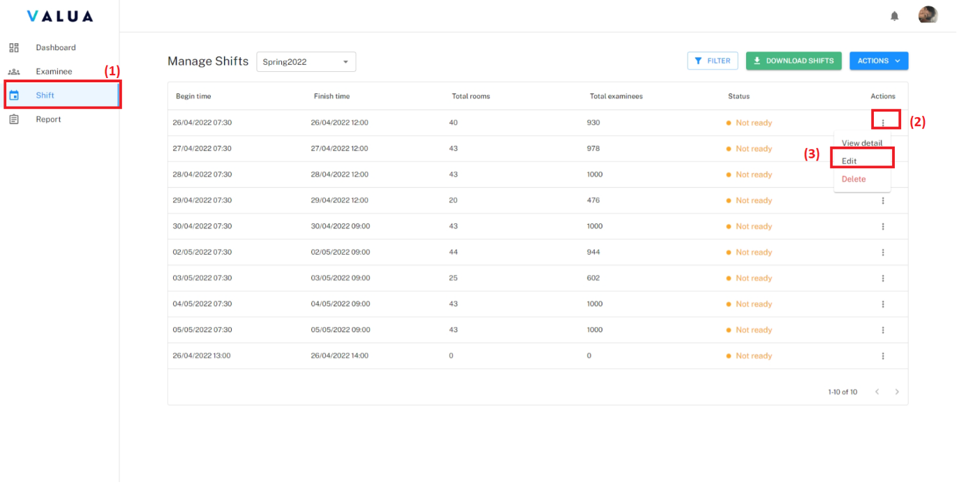

Figure 148. <Web> Update shift (Step 1, 2)

* Step 3: Fill changed information and click “UPDATE” button.

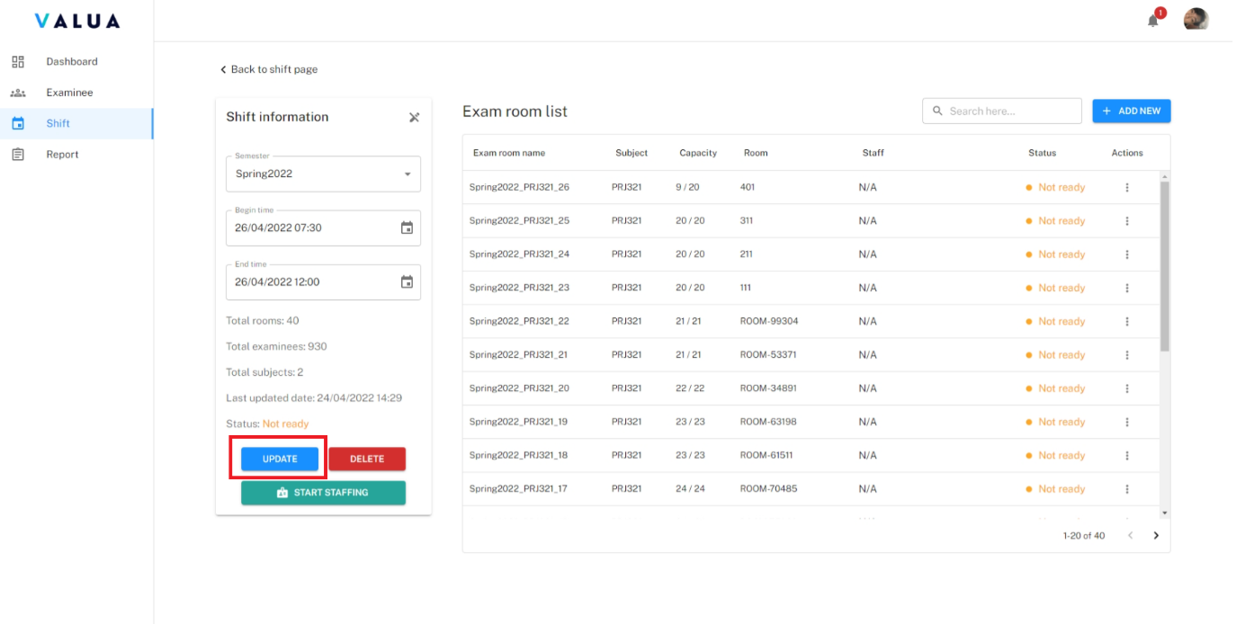

Figure 149. <Web> Update shift (Step 3)

* **<Shift Manager> Delete shift:**
* Delete shift on shift screen:
* Step 1: Click on the “Shift” tab (1) and click on the “Action” ellipsis of specific shift row (2).
* Step 2: Click on the “Delete” option (3).
* Step 3: Click on the “CONFIRM” button.

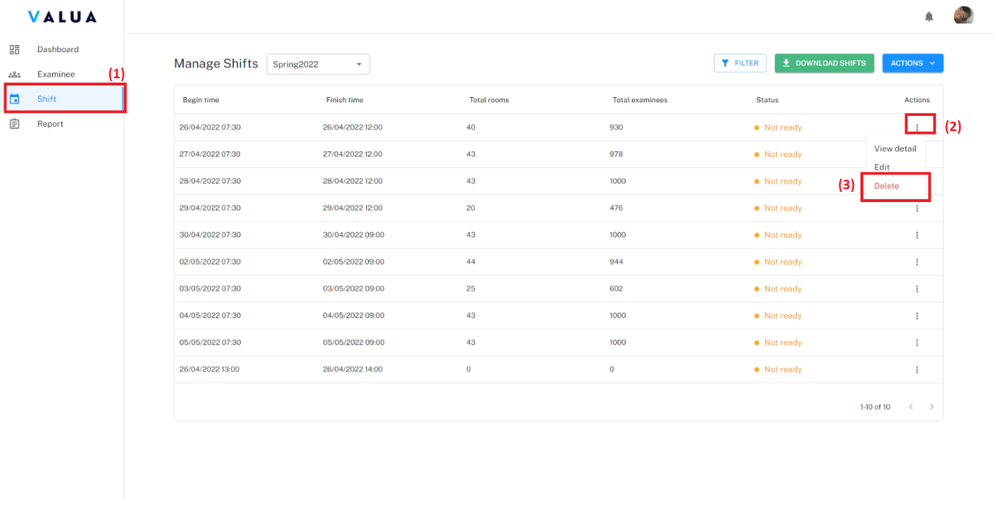

Figure 150. <Web> Delete shift on shift screen (Step 1, 2)

* Delete shift on shift detail screen:
* Step 1: Click on the edit icon (1).
* Step 2: Click on the “DELETE” button (2).
* Step 3: Click on the “CONFIRM” button.

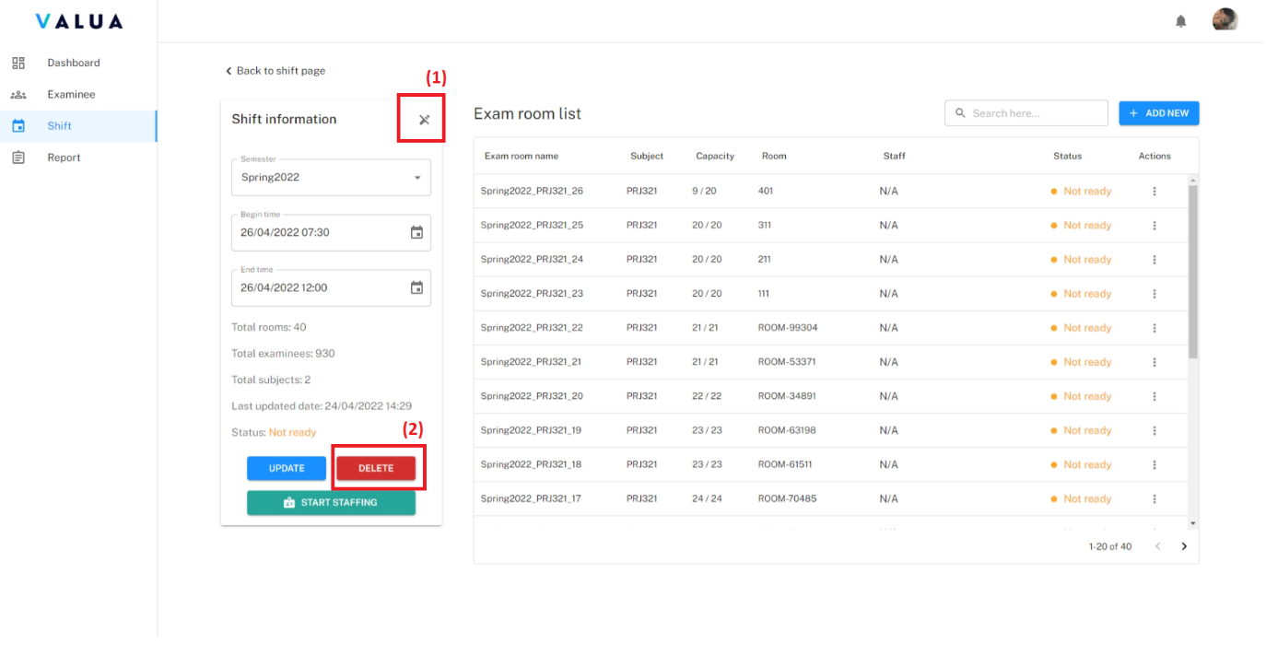

Figure 151. <Web> Delete shift on shift detail screen (Step 1, 2)

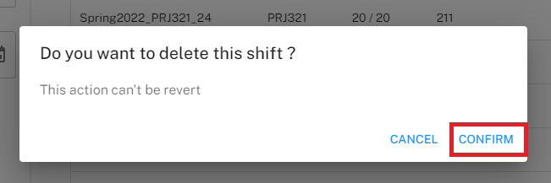

Figure 152. <Web> Delete shift (Step 3)

* **<Shift Manager> Start shift registration:**
  + Start shift registration on shift screen:
    - Step 1: Click on the “Shift” tab (1) and click on the “ACTION” list drop down button (2).
    - Step 2: Click on the “Start staffing” option (3).

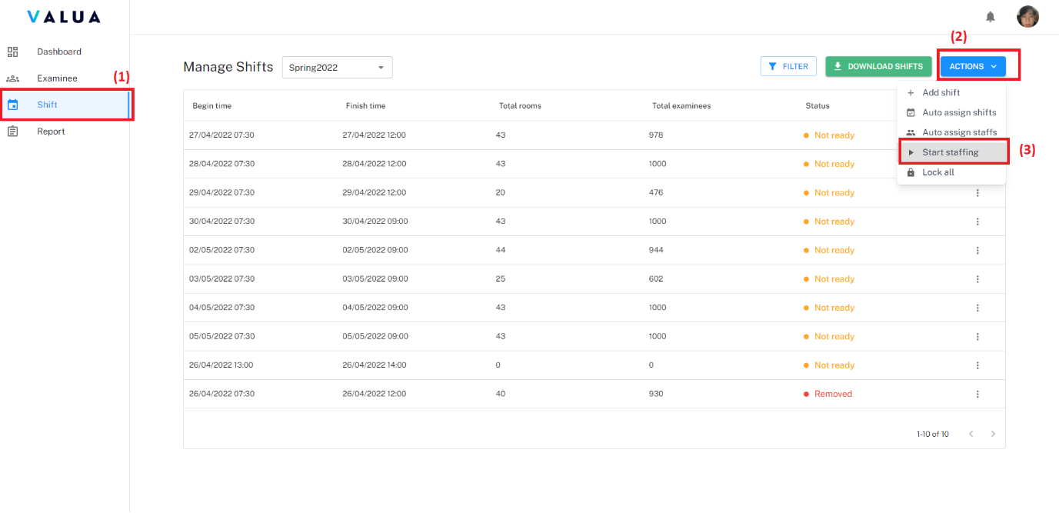

Figure 153. <Web> Start shift registration on shift screen (Step 1, 2)

* + - Step 3: Select shifts to start staffing.
    - Step 4: Click “START” button.

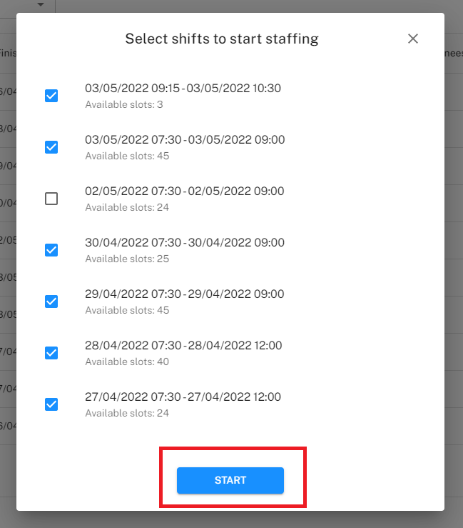

Figure 154. <Web> Start shift registration on shift screen (Step 4)

* + - Start shift registration on shift detail screen:
      * On “Not ready” shift detail screen, click “START STAFFING” button.

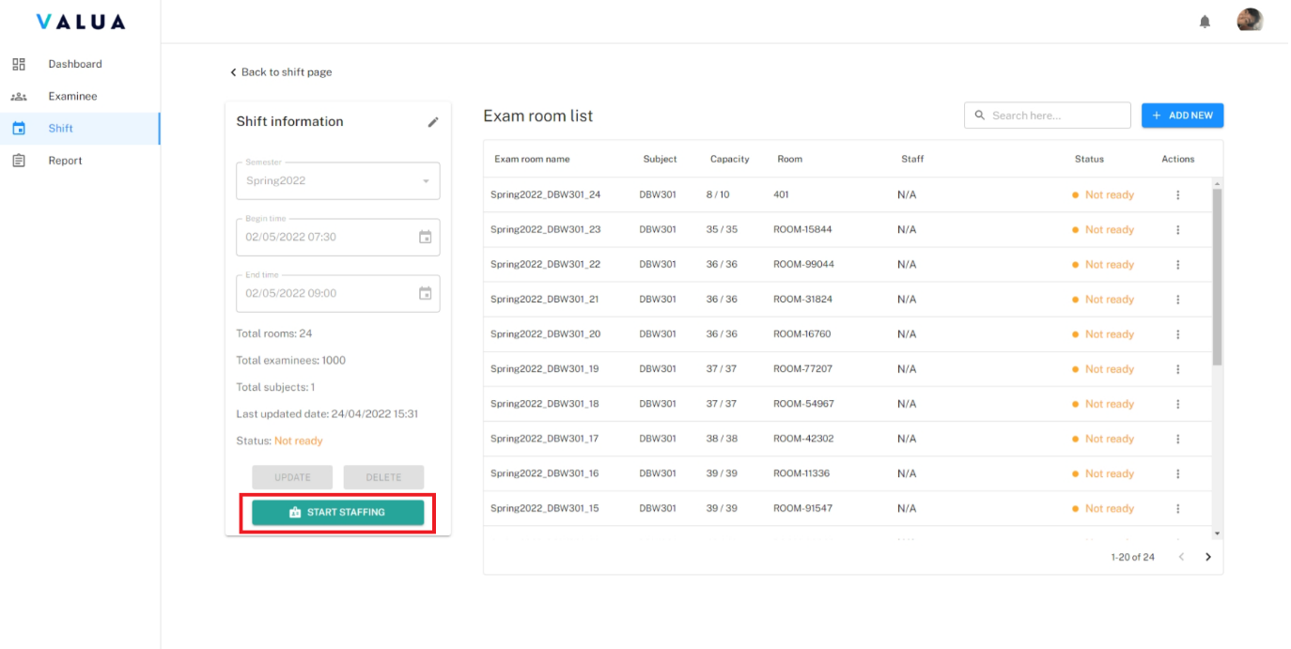

Figure 155. <Web> Start shift registration on shift detail screen

* **<Shift Manager> Lock shift:**
  + Lock shift on shift screen:
    - Step 1: Click on the “Shift” tab (1) and click on the “ACTION” list drop down button (2).
    - Step 2: Click on the “Lock all” option (3).

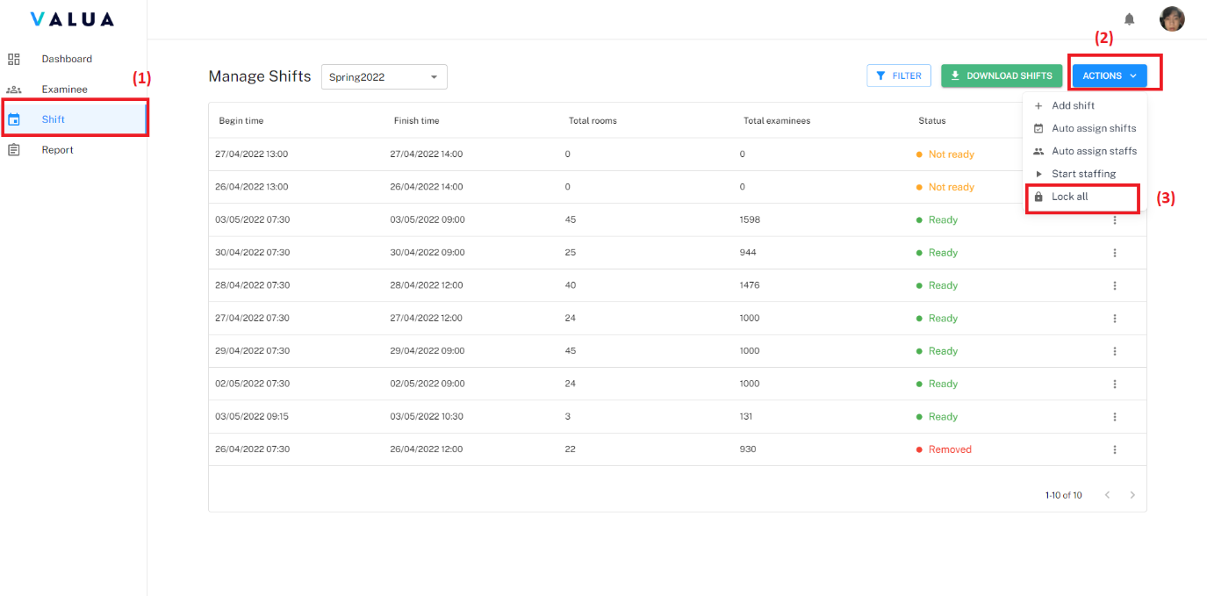

Figure 156. <Web> Start shift registration on shift screen (Step 1, 2)

* Step 3: Select shifts to lock.
* Step 4: Click “LOCK SHIFTS” button.

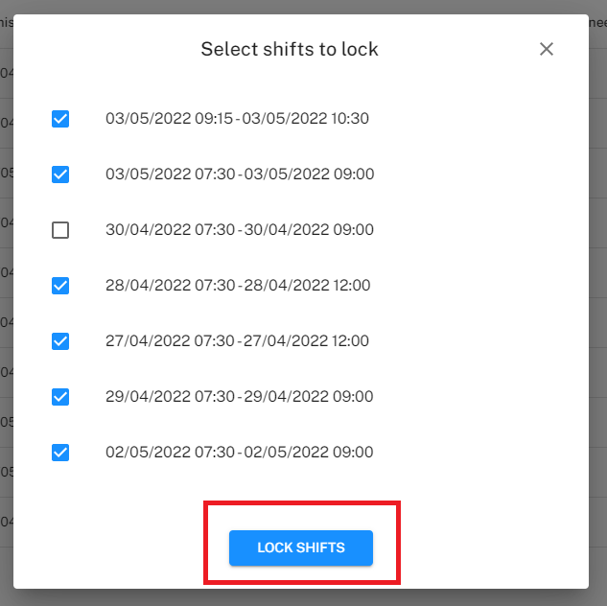

Figure 157. <Web> Start shift registration on shift screen (Step 4)

* Start shift registration on shift detail screen:
  + On “Ready” shift detail screen, click “LOCK SHIFT” button.

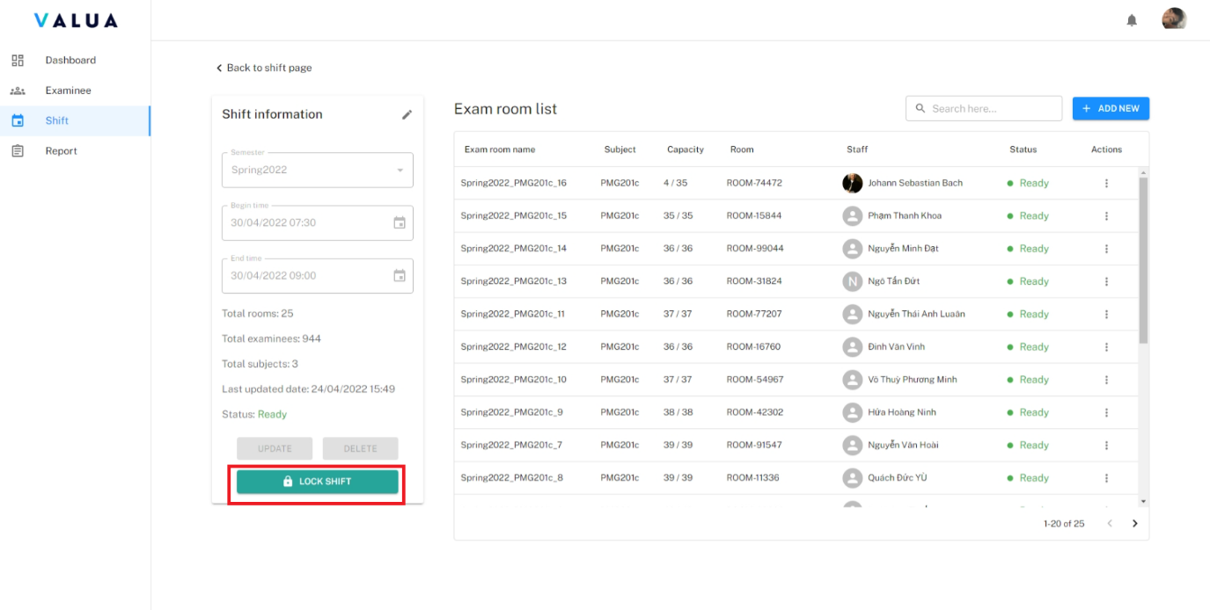

Figure 158. <Web> Start shift registration on shift detail screen

* **<Shift Manager> Export shifts:**
  + Click “Shift” tab (1) then click “ACTION” drop down list button (2).

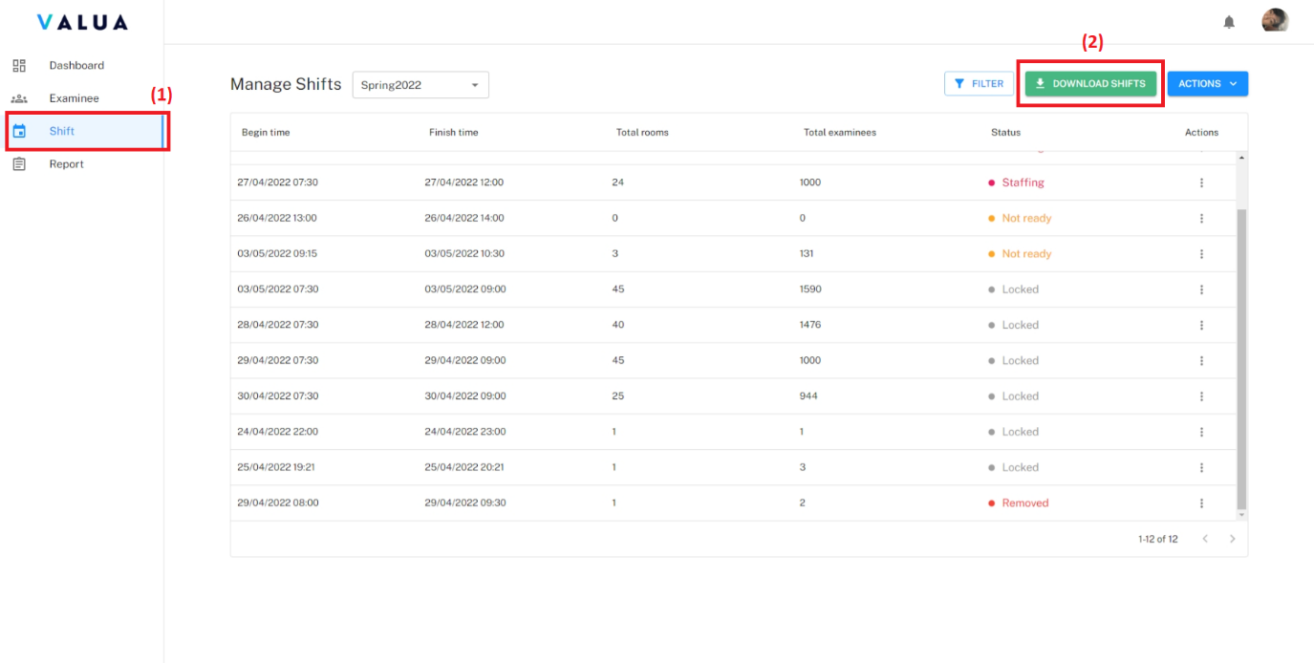

Figure 159. <Web> Export shifts

* + File contains information about locked shift, each sheet name in file excel is shift time, content of each sheet is exam room.

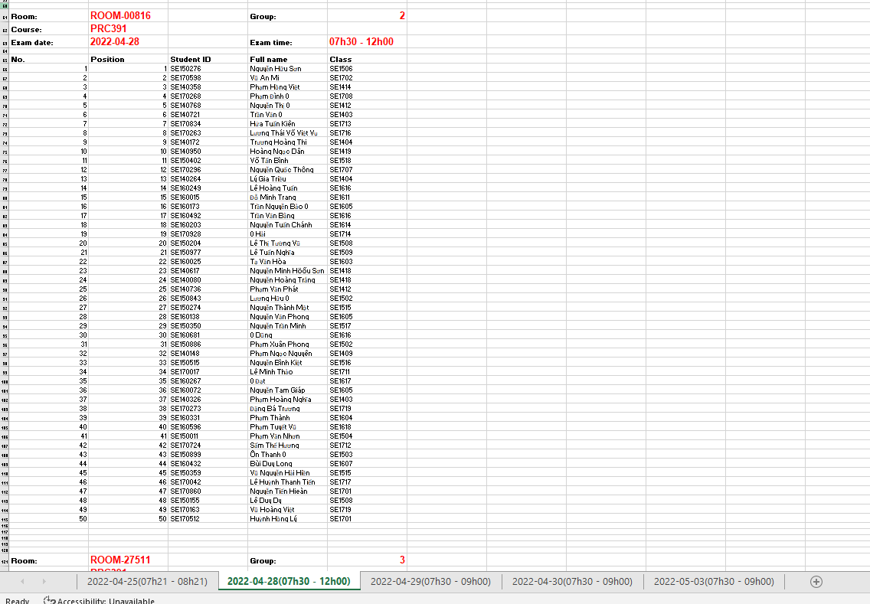

Figure 160. Content of file excel about shift

###### Manage exam room

* Purpose: This feature allows Shift Manager to manage exam rooms in VaLua System.
* Function:
  + **<Shift Manager> Create exam room:**
  + Step 1: On the shift detail screen, click on the “ADD NEW” button.

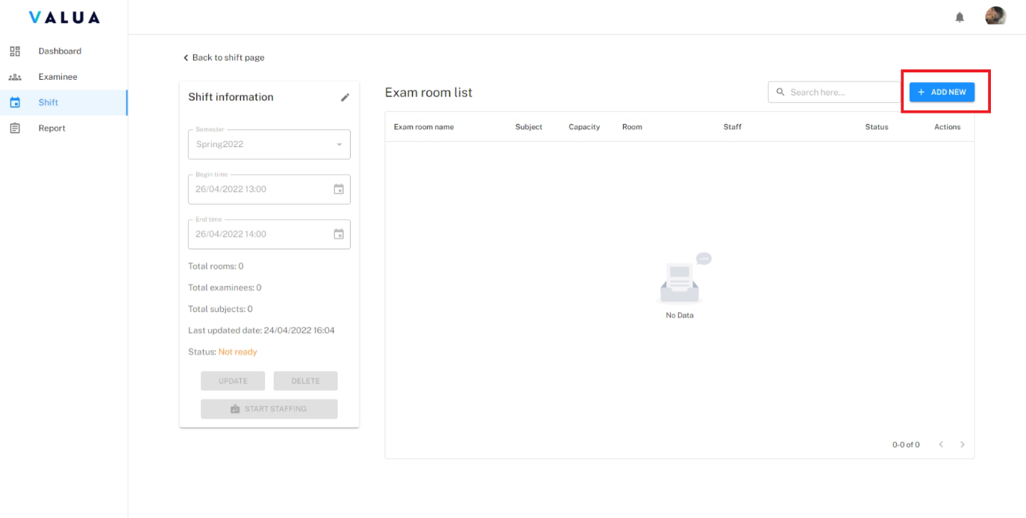

Figure 161. <Web> Create exam room (Step 1)

* + Step 2: Choose the subject to create exam room.
  + Step 3: Click on the “ASSIGN EXAMINEE” button.

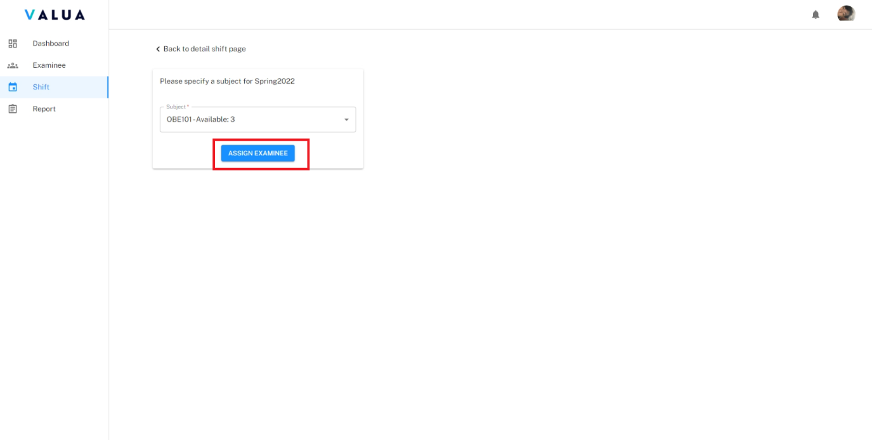

Figure 162. <Web> Create exam room (Step 3)

* Step 4: Select the exam room row to see examinee list.

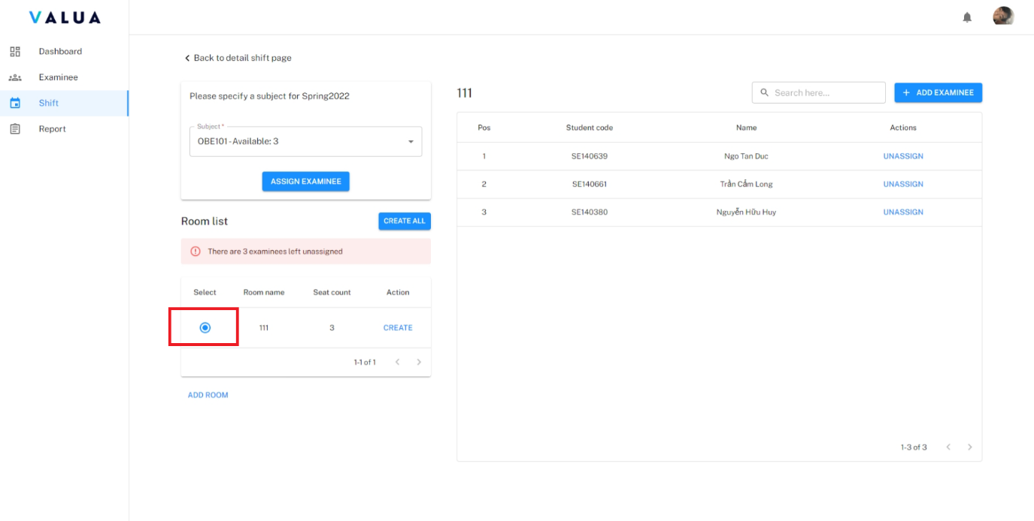

Figure 163. <Web> Create exam room (Step 4)

* Shift Manager can manually select other empty room (2) to create new exam room or occupied room (3) to create a compound room by clicking on the “ADD ROOM” button (1), select room.

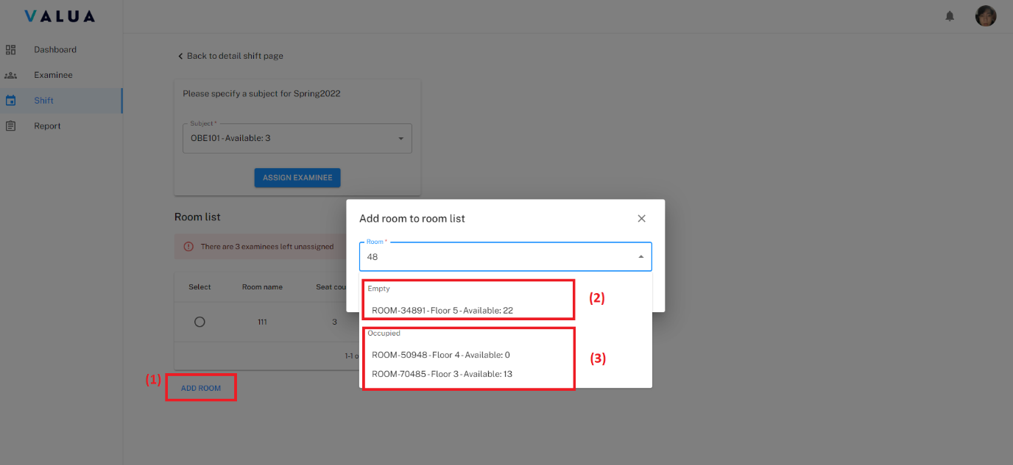

Figure 164. <Web> Create exam room - Create empty or occupied room 1

* Click on the “ADD” button.

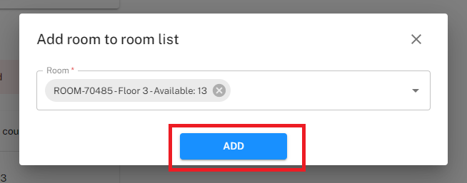

Figure 165. <Web> Create exam room - Create empty or occupied room 2

* Shift Manager can move examinee to the selected room. Click the “UNASSIGN” action for specific examinee want to move.

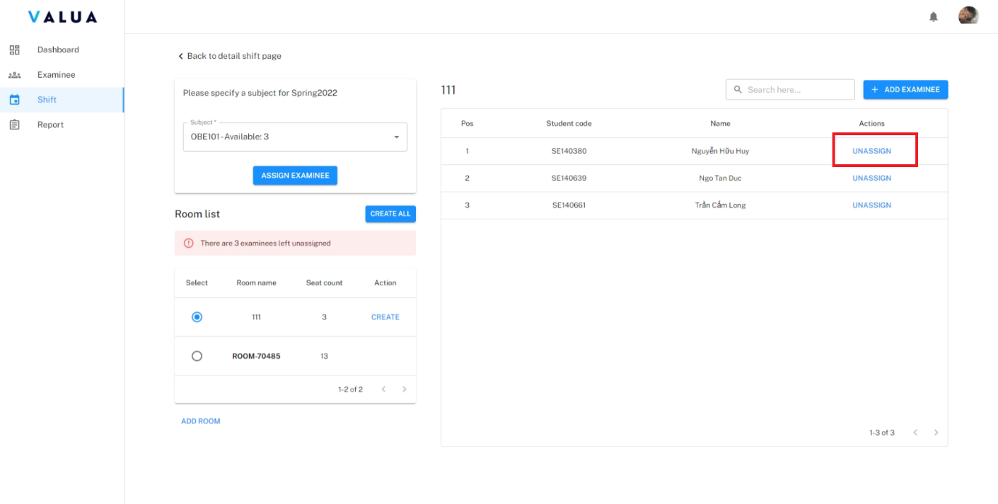

Figure 166. <Web> Create exam room - Move examinee 1

* Select exam room (1), click on button “ADD EXAMINEE” (2), choose examinee to move (3), click move icon (4).

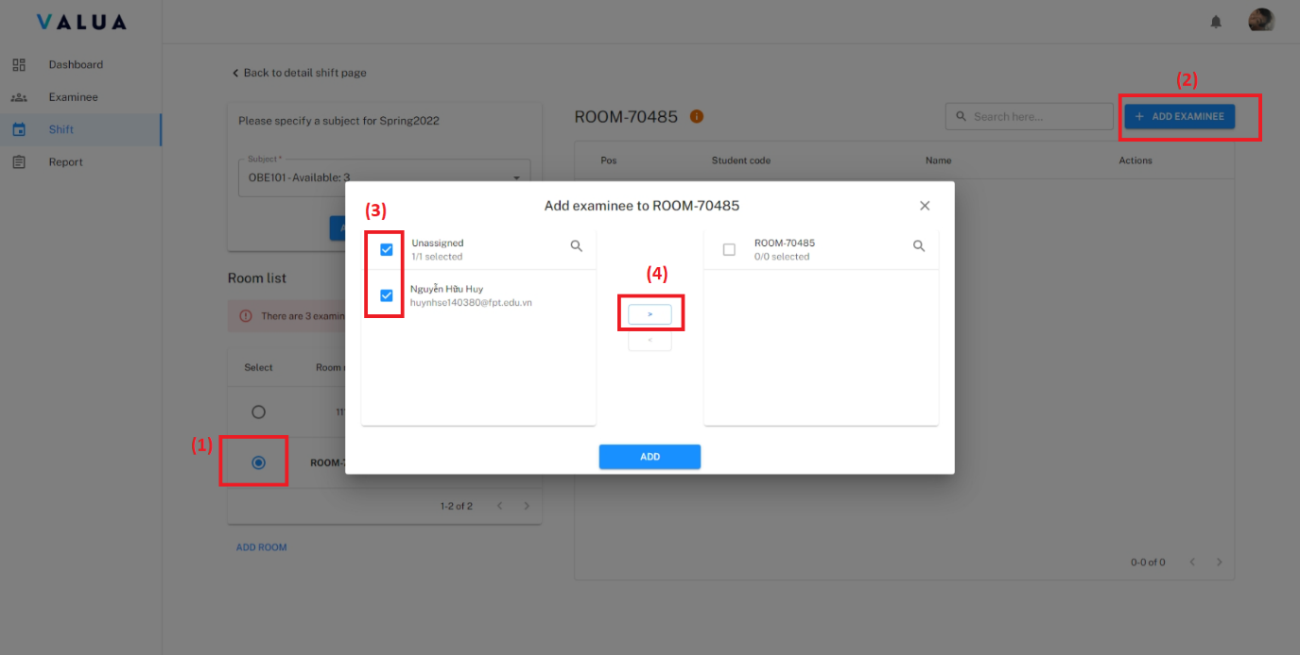

Figure 167. <Web> Create exam room - Move examinee 2

* Click on the “ADD” button.

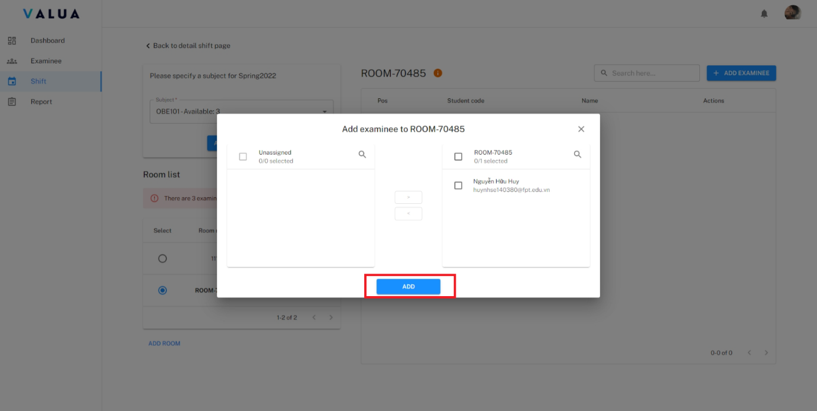

Figure 168. <Web> Create exam room - Move examinee 3

* Step 5: Click on the “CREATE” action (1) on each exam room row to create specific exam room or click on the “CREATE ALL” (2) button to create all exam rooms.

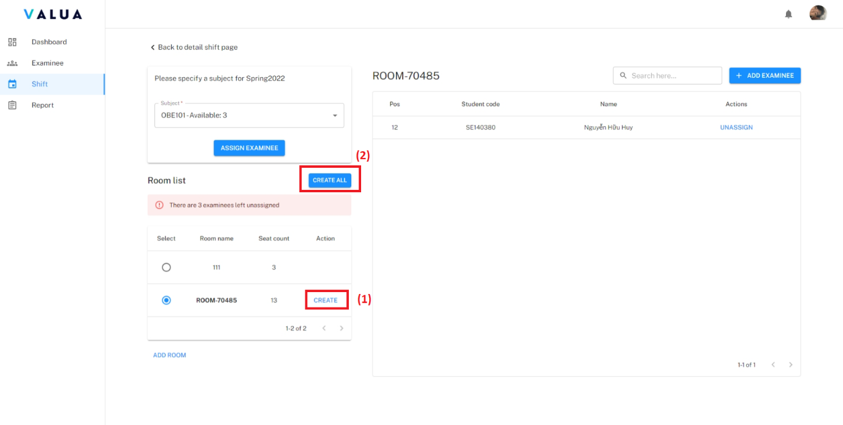

Figure 169. <Web> Create exam room (Step 5)

* + **<Shift Manager> View exam room detail:**
* Step 1: On the shift detail screen, click the “Action” ellipsis of specific exam room row (1).
* Step 2: Click the “View detail” option (2).

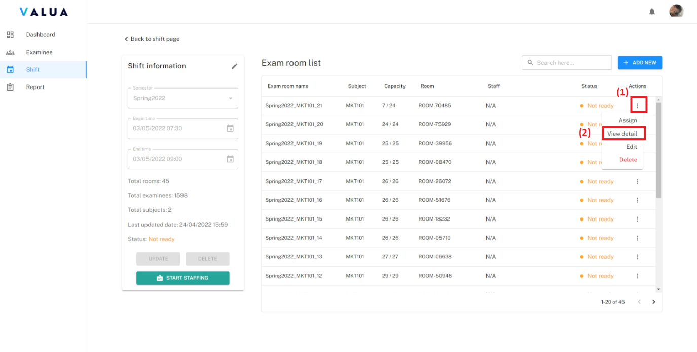

Figure 170. <Web> View detail semester (Step 1, 2)

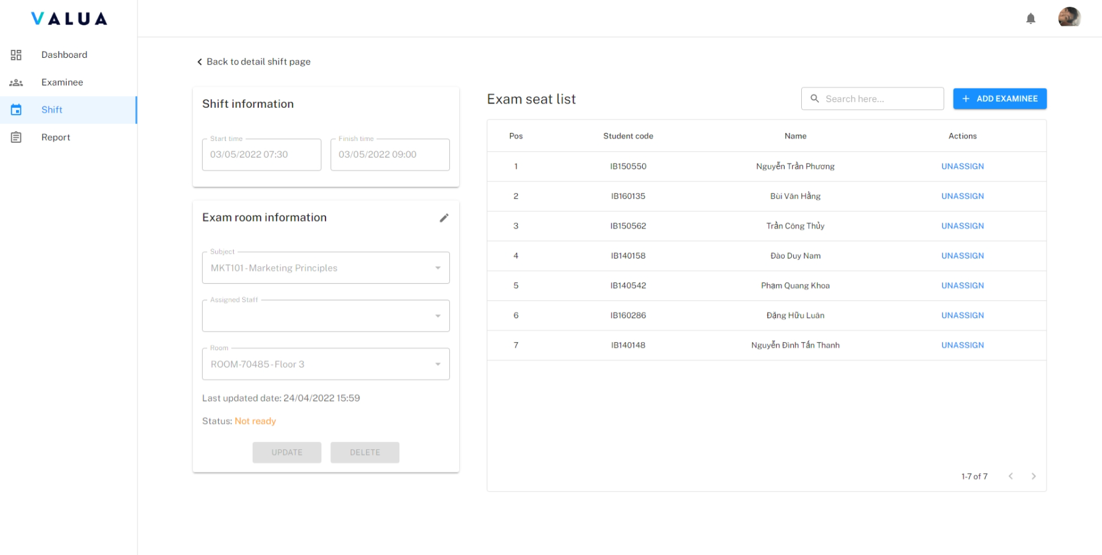

Figure 171. <Web> Exam room detail screen

* **<Shift Manager> Update exam room:**
* Step 1: On the shift detail screen, click the “Action” ellipsis of specific exam room row (1).
* Step 2: Click the “Edit” option (2).

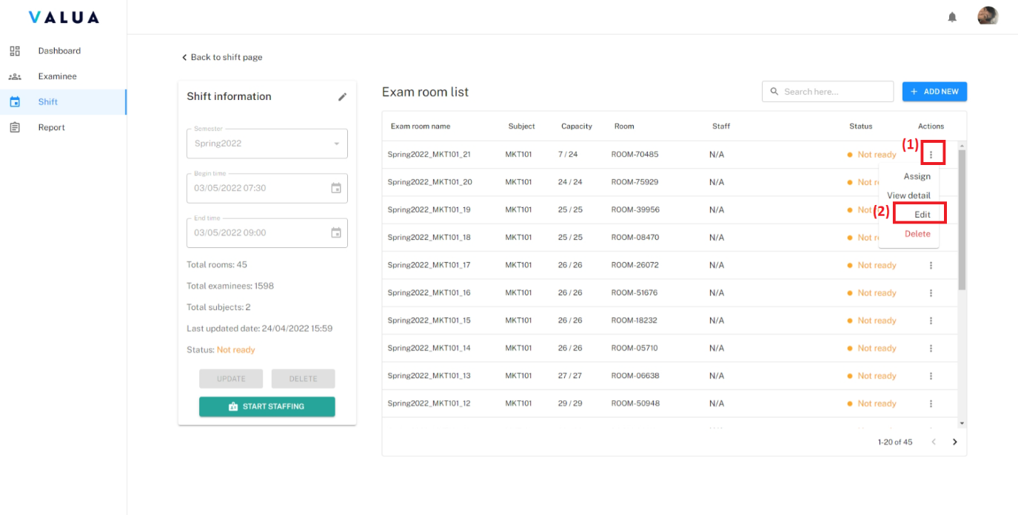

Figure 172. <Web> Update exam room (Step 1, 2)

* + - Step 3: Fill changed information.
    - Step 4: Click the “UPDATE” button.

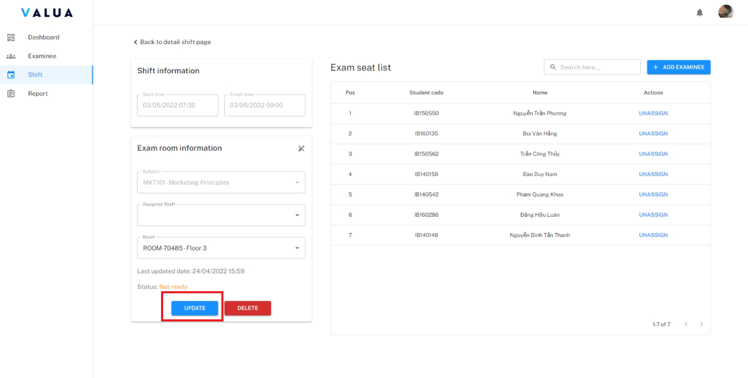

Figure 173. <Web> Update exam room (Step 4)

* **<Shift Manager> Remove exam room:**
  + - Remove exam room on shift detail screen:
      * Step 1: On the shift detail screen, click the “Action” ellipsis of specific exam room row (1).
      * Step 2: Click the “Delete” option (2).
      * Step 3: Click “Confirm” button.

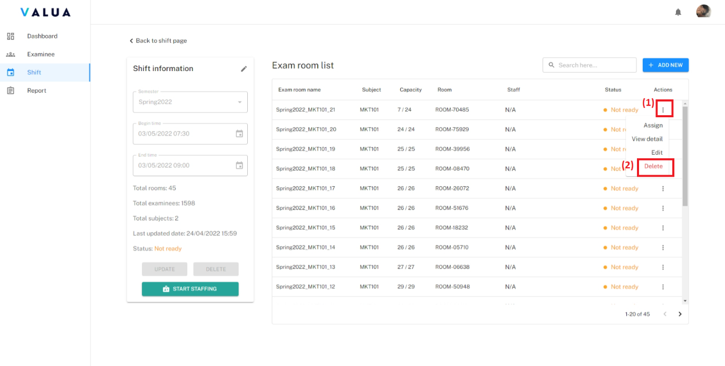

Figure 174. <Web> Remove exam room on shift detail screen (Step 1, 2)

* + - Disable exam room on exam room detail screen:
      * Click on the “SELETE” button then click “CONFIRM” button.

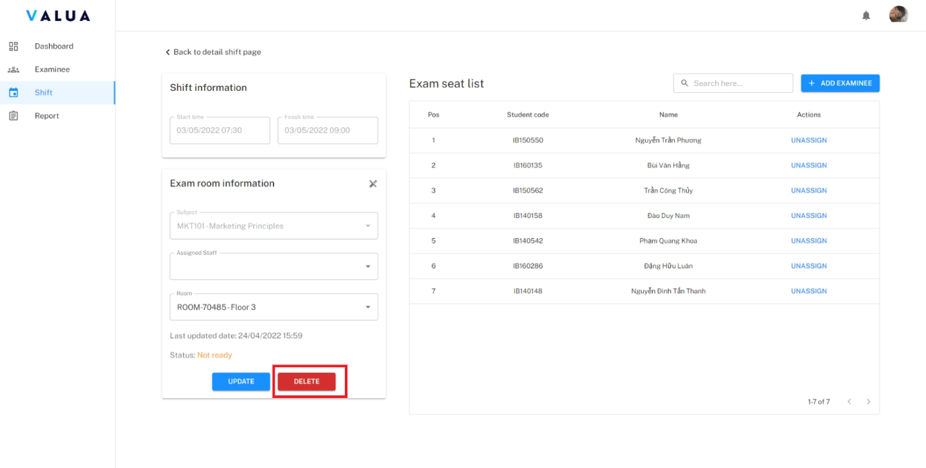

Figure 175. <Web> Remove exam room on exam room detail screen

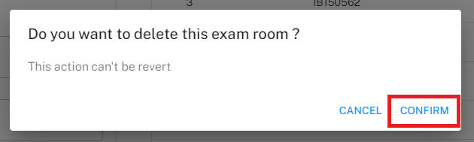

Figure 176. <Web> Confirm dialog for remove exam room

* **<Shift Manager> Assign staff:**
  + - Step 1: On the shift detail screen, click the “Action” ellipsis of specific exam room row (1).
    - Step 2: Click the “Assign” option (2).

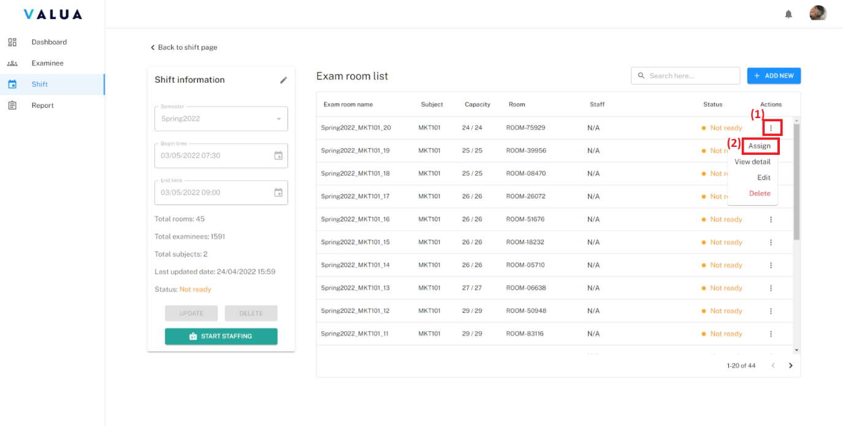

Figure 177. <Web> Assign staff (Step 1, 2)

* + - Step 3: Select staff.
    - Step 4: Click on the “Assign” button.

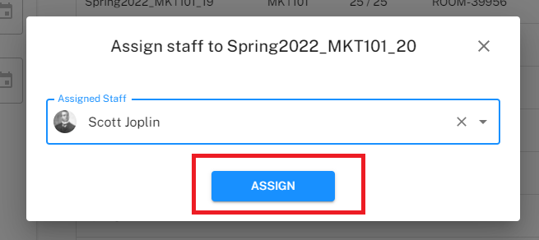

Figure 178. <Web> Assign staff (Step 4)

* **<Shift Manage> Create attendance:**
  + - Step 1: On the exam room detail screen, click the “ADD EXAMINEE” button.

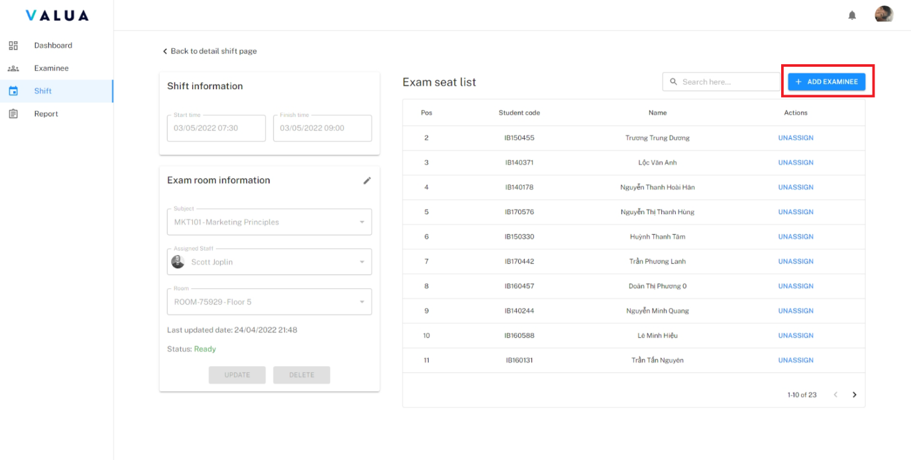

Figure 179. <Web> Create attendance (Step 1)

* + - Step 2: Select examinee.
    - Step 3: Click on the “ADD” button.

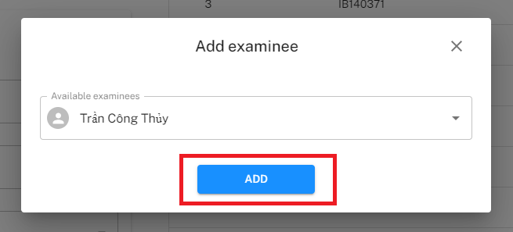

Figure 180. <Web> Create attendance (Step 3)

* **<Shift Manager> Delete attendance:**
  + - On the exam room detail screen, click the “UNASSIGN” action of specific attendance row.

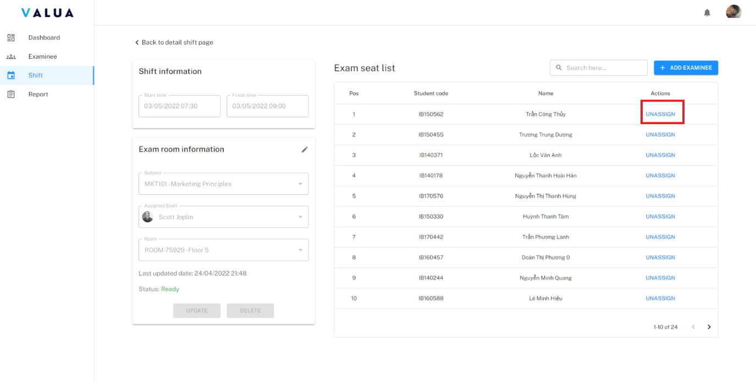

Figure 181. <Web> Delete attendance

* **<Shift Manager> Export attendances:**
  + - On the “Finished” shift detail screen, click on the “EXPORT ATTENDANCES” button.

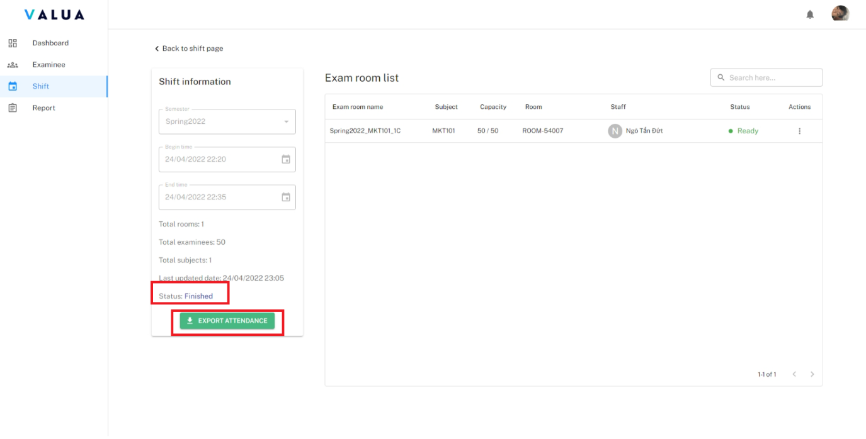

Figure 182. <Web> Export attendances

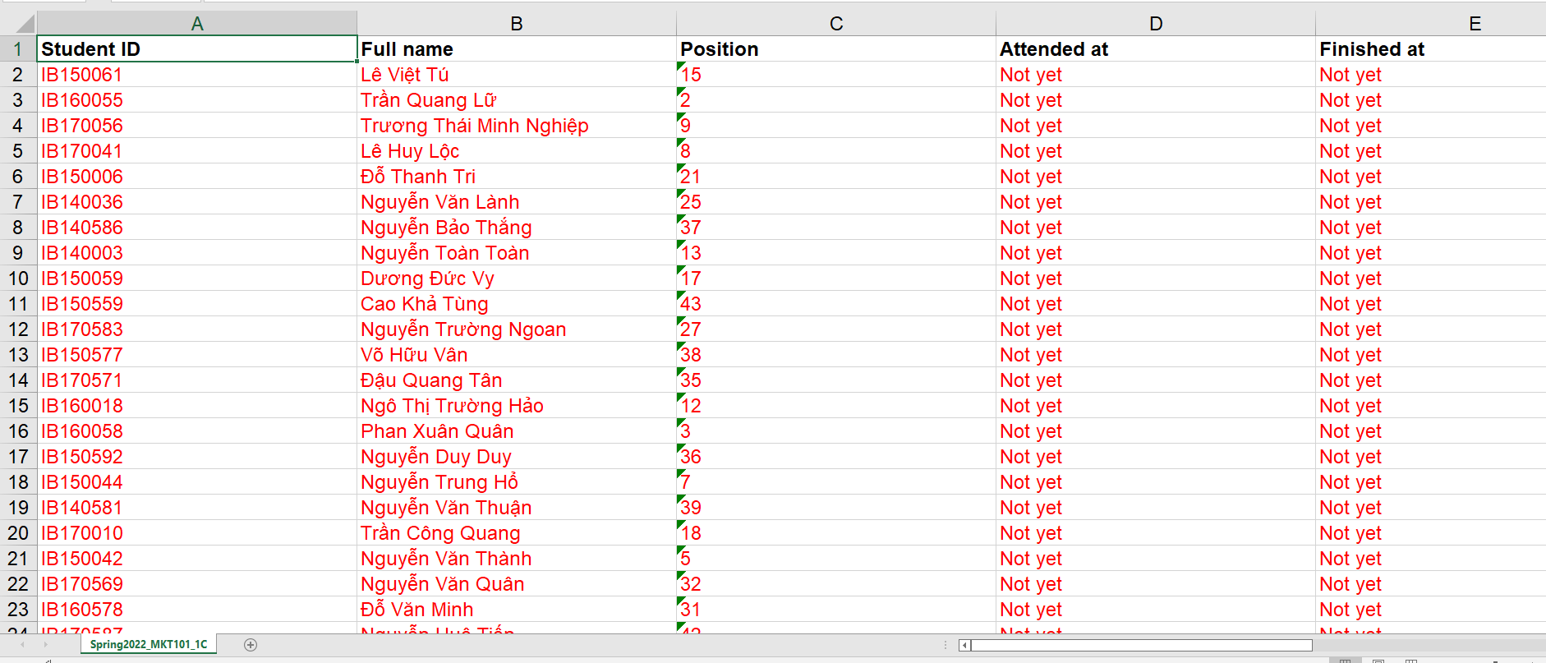

Figure 183. <Web> Export attendance - File excel example

###### Manage report

* Purpose: This feature allows Shift Manager to manage reports in VaLua System.
* Function:
* **<Shift Manager> View report list:**
  + - Click on the “Report” tab.

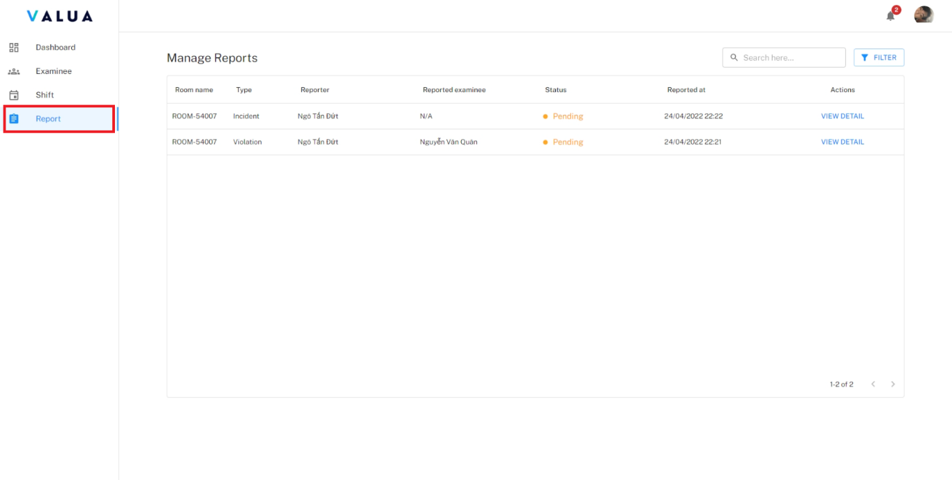

Figure 184. <Web> View report list

* + - Shift Manager can search reports by exam room name and can filter by status.

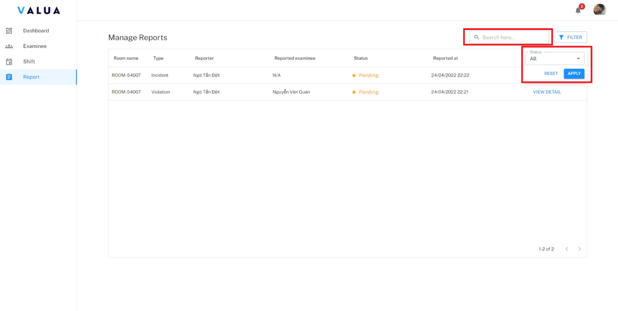

Figure 185. <Web> Search and filter report

* **<Shift Manager> View report detail:**
  + - Click on the “Report” tab (1) and click “VIEW DETAIL” action (2).

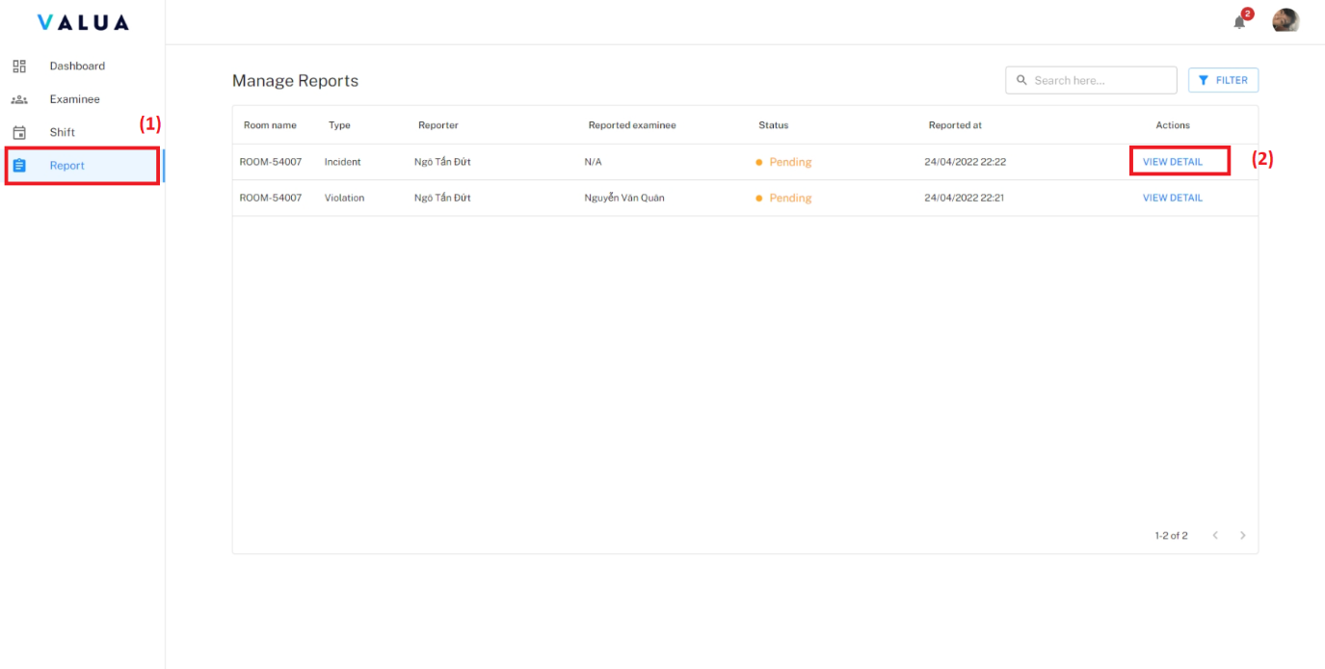

Figure 186. <Web> View report detail

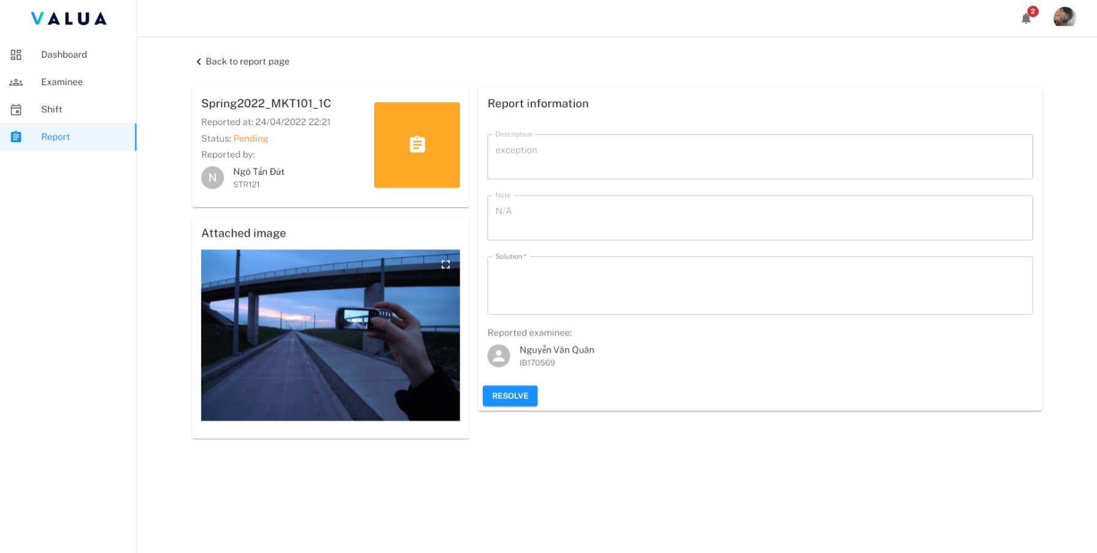

Figure 187. <Web> Report detail screen

* **<Shift Manager> Resolve report:**
  + - Step 1: On the report detail screen, fill solution field. (1)
    - Step 2: Click on the “RESOLVE” button. (2)

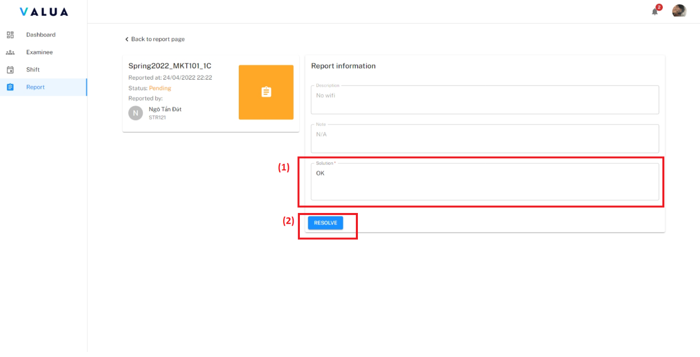

Figure 188. <Web> Resolve report

#### 3.2.2. For staff application usage

##### Overview:

* The application supports staff to view their assigned shift as well as register shifts

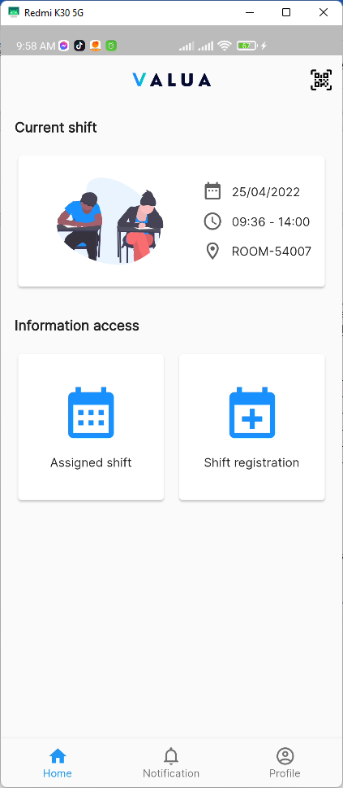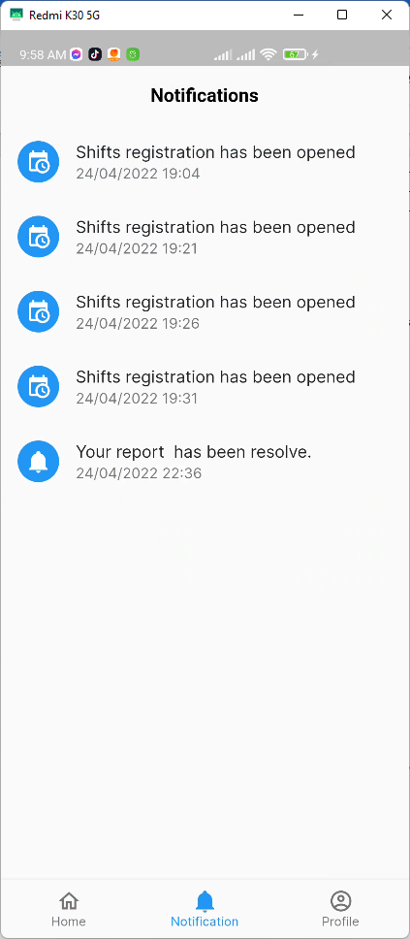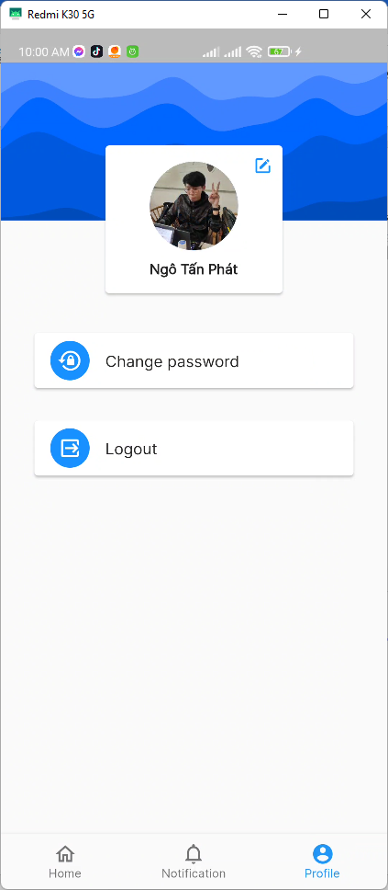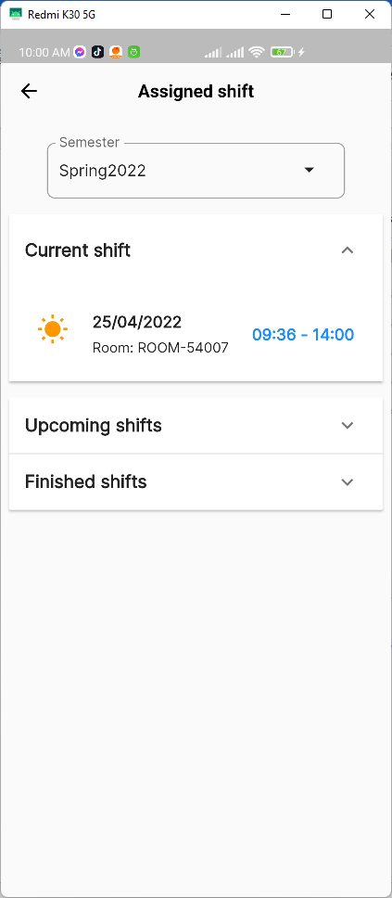

Figure 189. <Staff app> Overview

##### Features:

###### Log in/ Log out

* **Log in with the staff’s account**
  + Step 1: Enter email and password

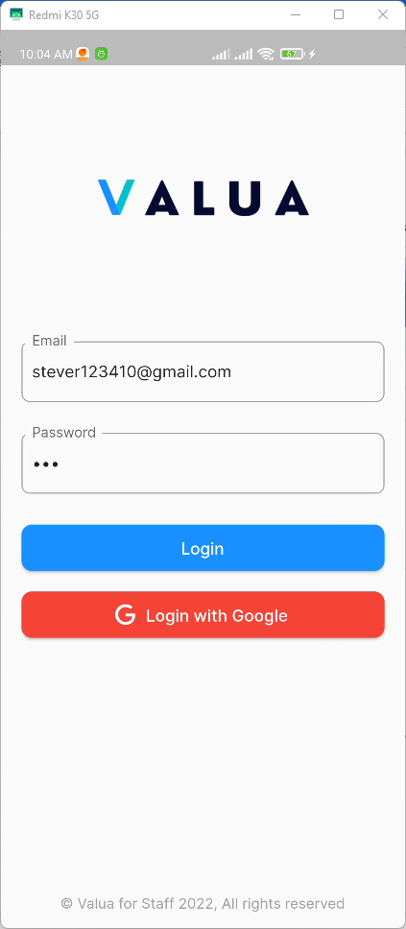

Figure 190. <Staff app> Login step 1

* Step 2: Press the “Login” button

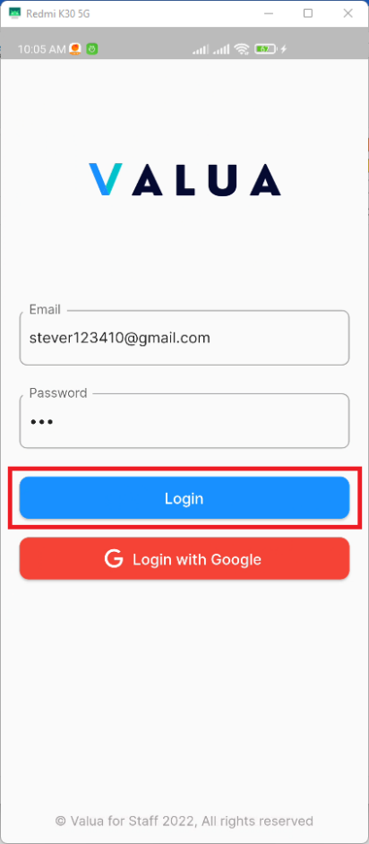

Figure 191. <Staff app> Login step 2

* Alternatively, you can login with your own google account by pressing the “Login with Google” button

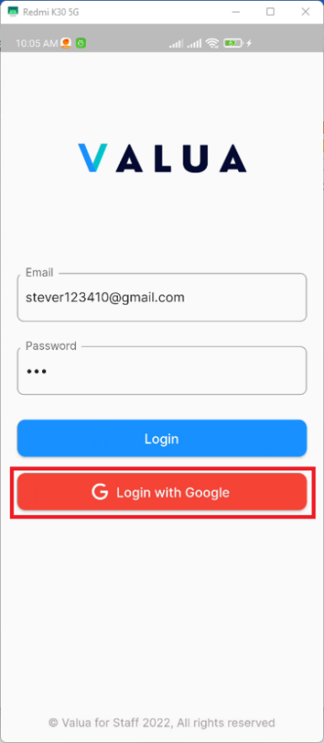

Figure 192. <Staff app> Login with google

* **Log out**
  + Navigate to the Profile screen, press the “Log out” button

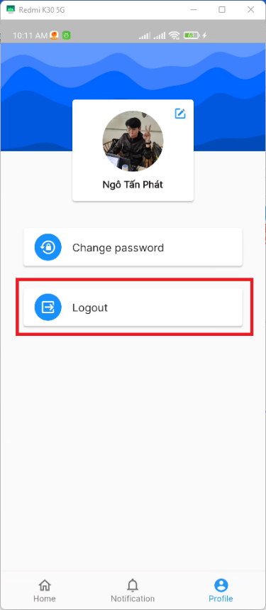

Figure 193. <Staff app> Log out

###### Shift registration

* + Step 1: From the Home screen, press the “Shift registration” button

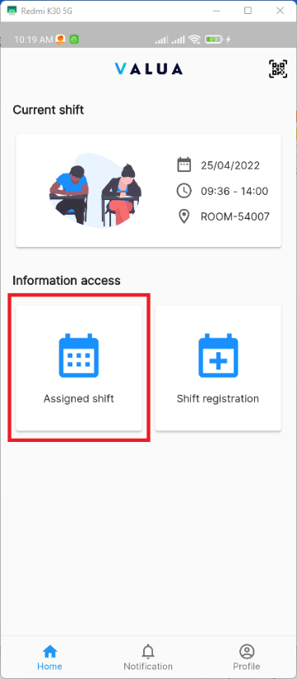

Figure 194. <Staff app> Shift registration (Step 1)

* + Step 2: After the available shifts loaded successfully, you can see all the shifts that are available for registration

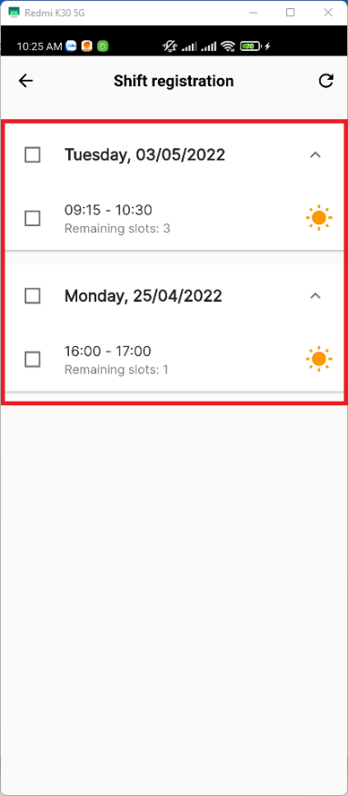

Figure 195. <Staff app> Shift registration (Step 2)

* + Step 3: Select shift(s) that you want to register and then press “Register”. A confirm popup will show, click “Ok” to confirm your registration.

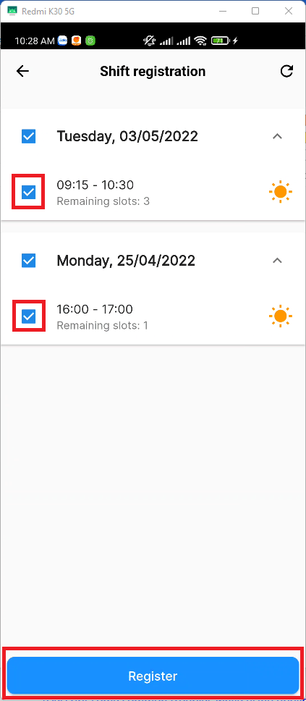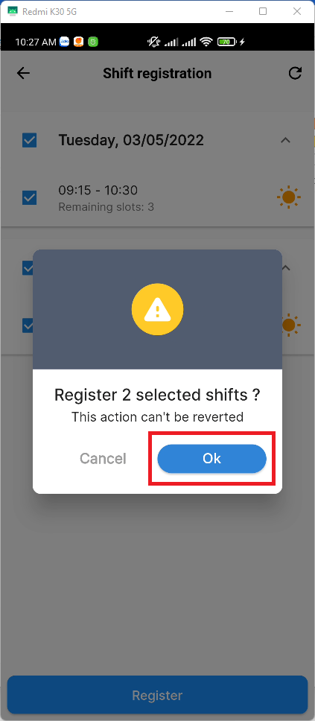

Figure 196. <Staff app> Shift registration ( Step 3)

###### View assigned shift

* + Step 1: From the Home screen, press the “Assigned shift” button to view all your assigned shift.

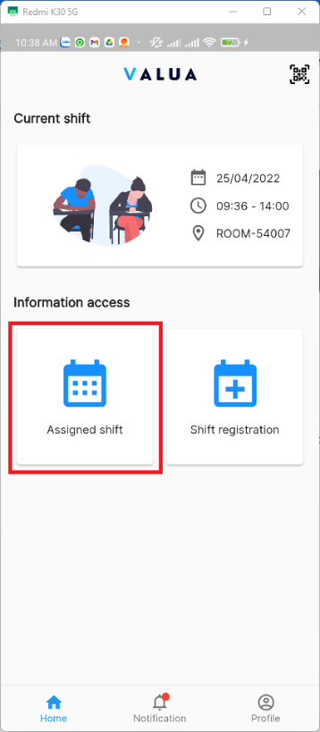

Figure 197. <Staff app> View assigned shift (Step 1)

* Step 2: You will see all assigned shift in this screen, the information will include the time and room of your assigned shift.

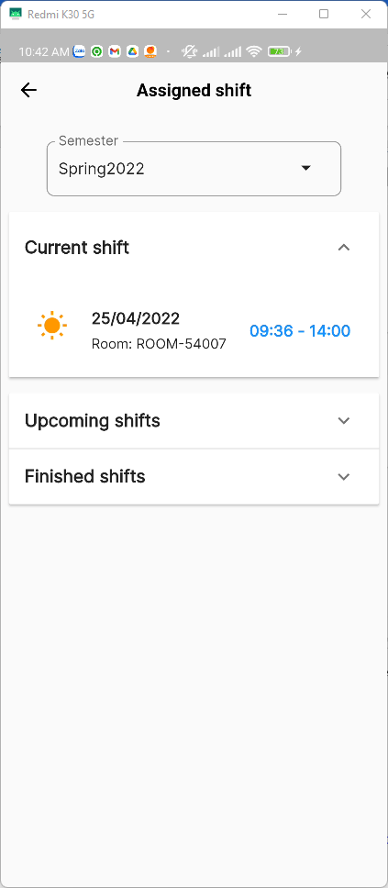

Figure 198. <Staff app> View assigned shift (Step 2)

###### View notifications

* + From the Home screen, navigate to Notifications to view all your notifications. You can press on the notification to redirect to the appropriate screen

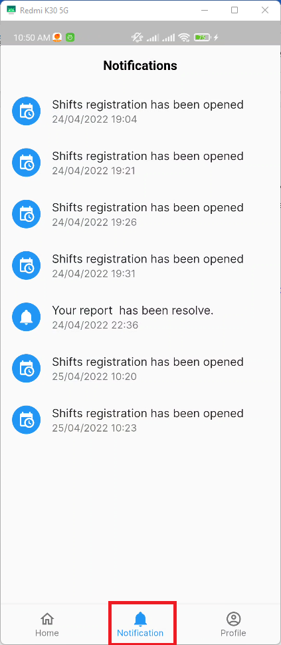

Figure 199. <Staff app> View notifications

###### Change password

* + Step 1: From the Home screen, navigate to Profile screen

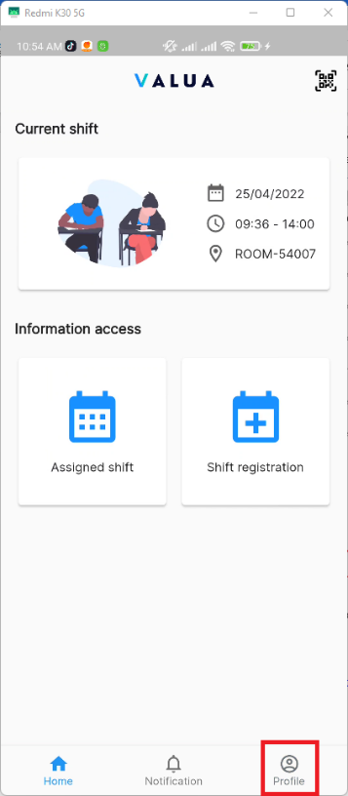

Figure 200. <Staff app> Change password (Step 1)

* + Step 2: Press the “Change password” button

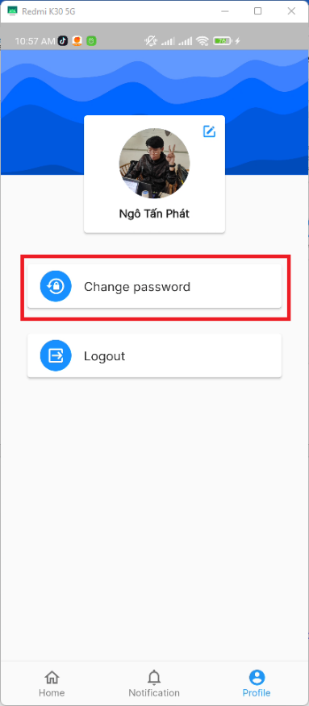

Figure 201. <Staff app> Change password (Step 2)

* + Step 3: Enter valid inputs to all fields

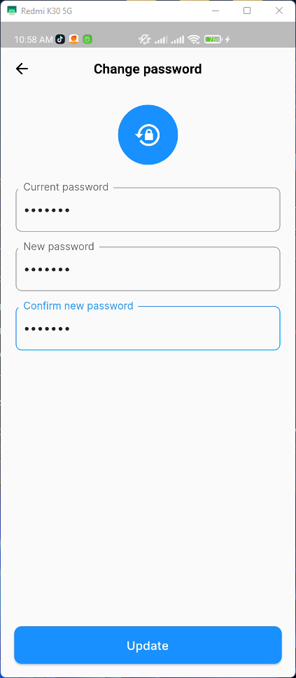

Figure 202. <Staff app> Change password (Step 3)

* + Step 4: Press the “Update” button

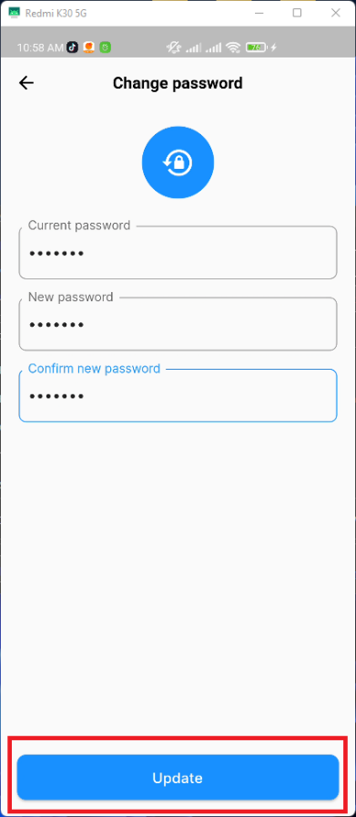

Figure 203. <Staff app> Change password (Step 4)

###### Update profile

* + Step 1: From the Home screen, navigate to Profile screen



Figure 204. <Staff app> Update profile (Step 1)

* + Step 2: Press the “Update profile” icon

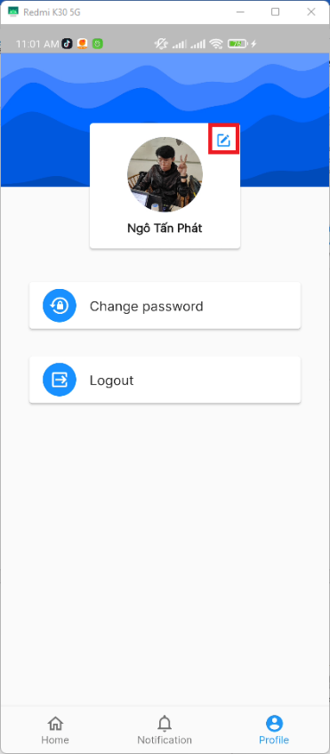

Figure 205. <Staff app> Update profile (Step 2)

* + Step 3: Enter valid inputs to all fields

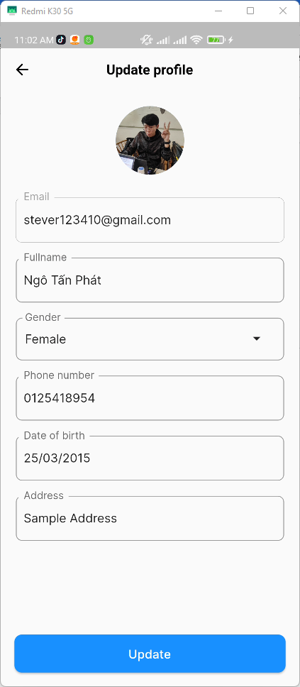

Figure 206. <Staff app> Update profile (Step 3)

* + Step 4: Press the “Update” button

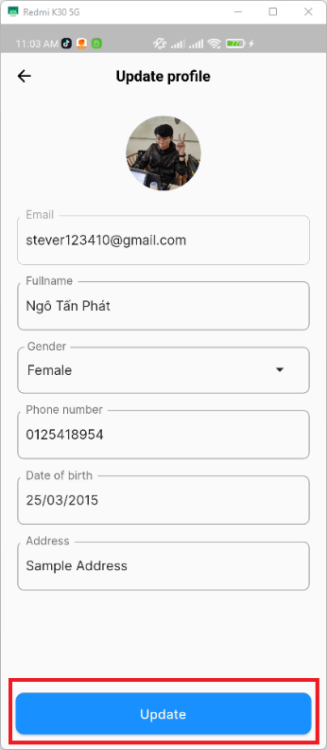

Figure 207. <Staff app> Update profile (Step 4)

###### QR Scanner

* + From the Home screen, pressed the “QR Scanner” icon on the top right corner of the screen.

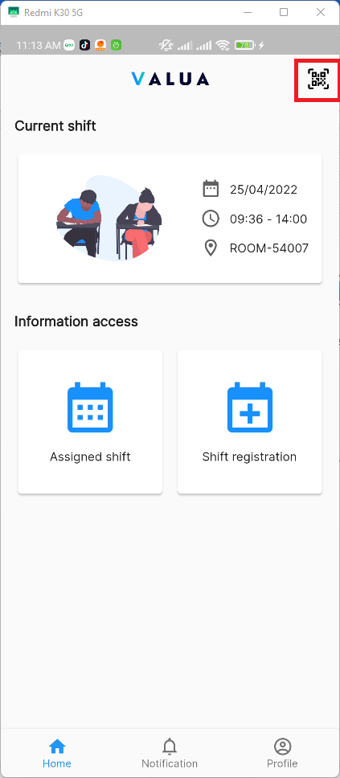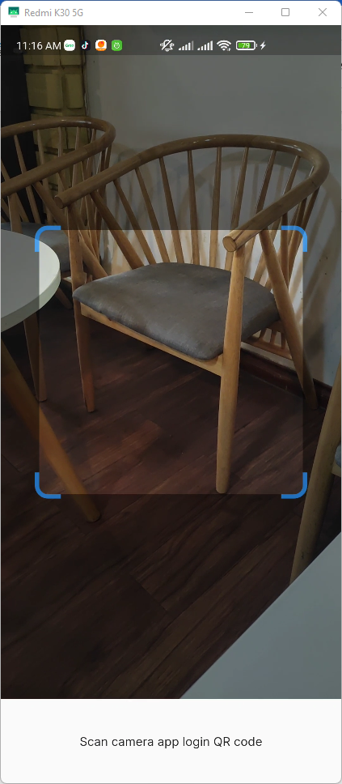

Figure 208. <Staff app> QR Scanner

#### 3.23. For examinee application usage

##### Overview:

* The application supports examinee to view their exam schedule, check-in attendance

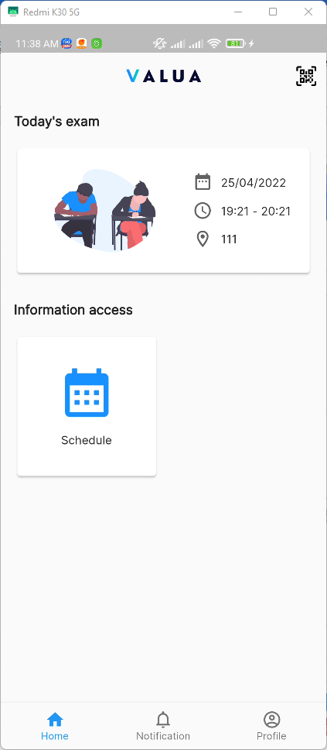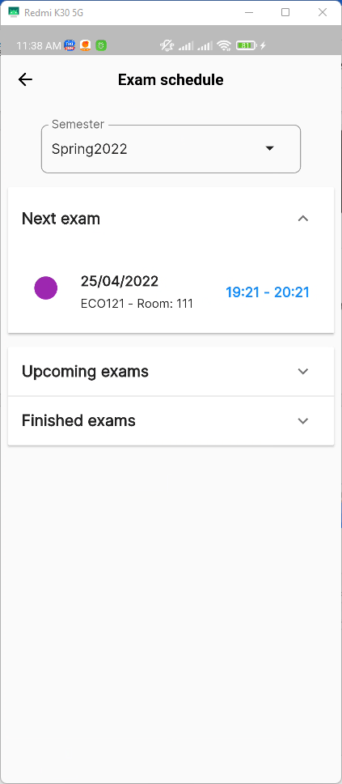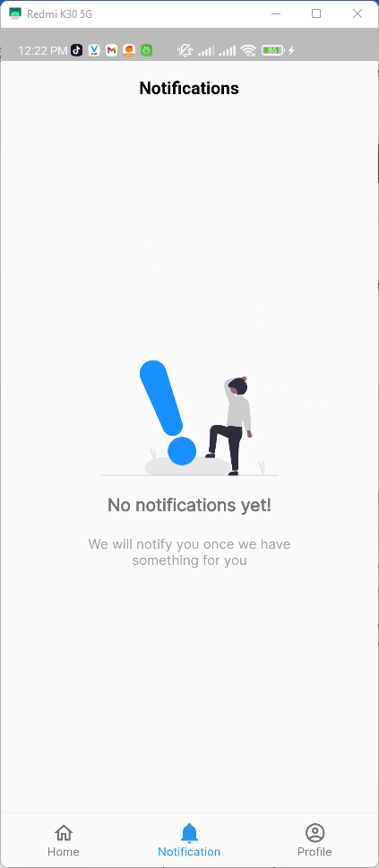

Figure 209. <Examinee app> Overview

##### Features:

###### Log in/ Log out

* **Log in with the examinee’s account**
  + Step 1: Enter email and password

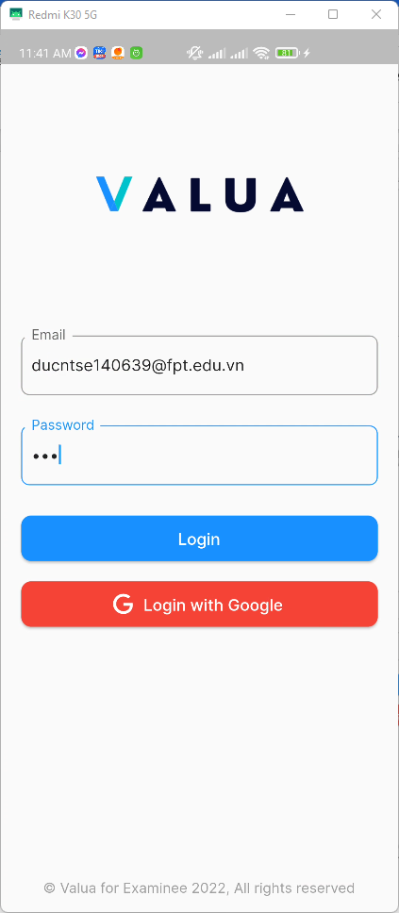

Figure 210. <Examinee app> Log in (Step 1)

* Step 2: Press the “Login” button

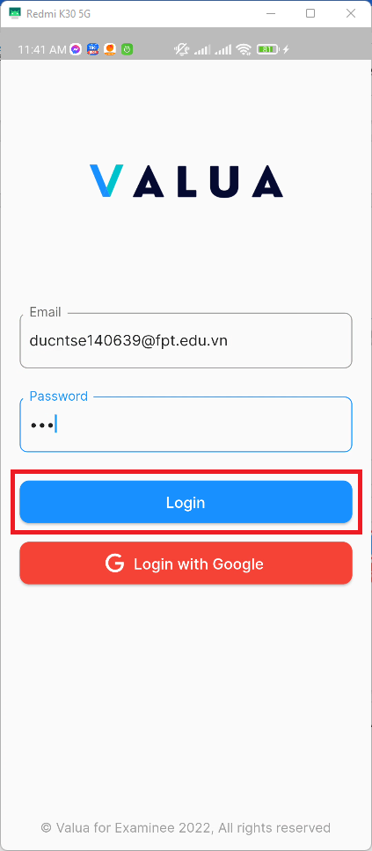

Figure 211. <Examinee app> Login (Step 2)

* Alternatively, you can login with your own google account by pressing the “Login with Google” button

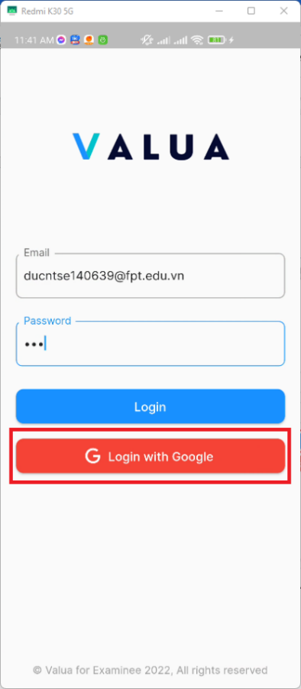

Figure 212. <Examinee app> Login with Google

* **Log out**
  + Navigate to the Profile screen, press the “Log out” button

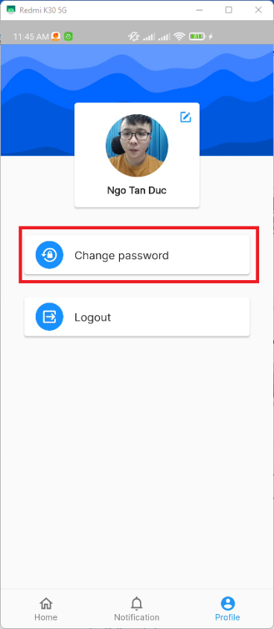

Figure 213. <Examinee app> Log out

###### View exam schedule

* + Step 1: From the Home screen, press the “Schedule” button to view all your assigned shift.

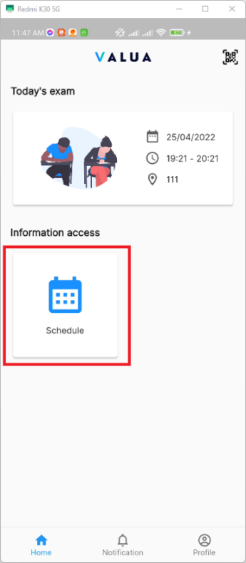

Figure 214. <Examinee app> View exam schedule (Step 1)

* Step 2: You will see all assigned shift in this screen, the information will include the time, room and subject code of your exam.

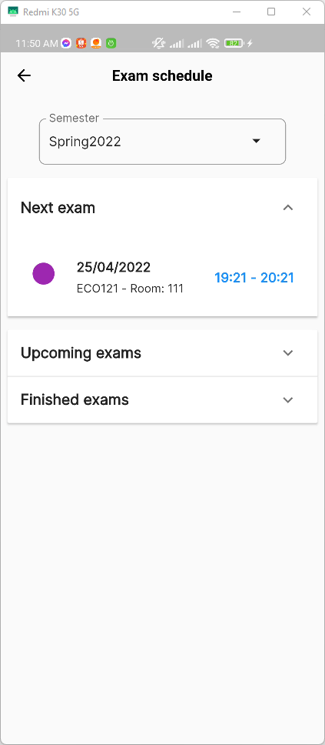

Figure 215. <Examinee app> View exam schedule (Step 2)

###### View notifications

* + From the Home screen, navigate to Notifications to view all your notifications. You can press on the notification to redirect to the appropriate screen



Figure 216. <Examinee app> View notifications

###### Change password

* + Step 1: From the Home screen, navigate to Profile screen

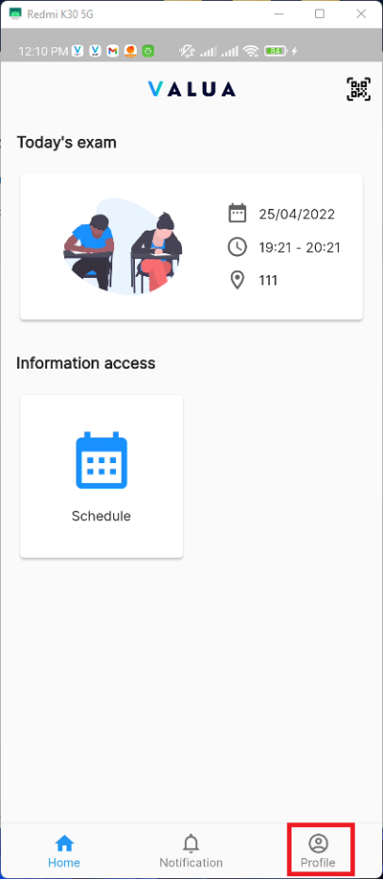

Figure 217. <Examinee app> Change password (Step 1)

* + Step 2: Press the “Change password” button

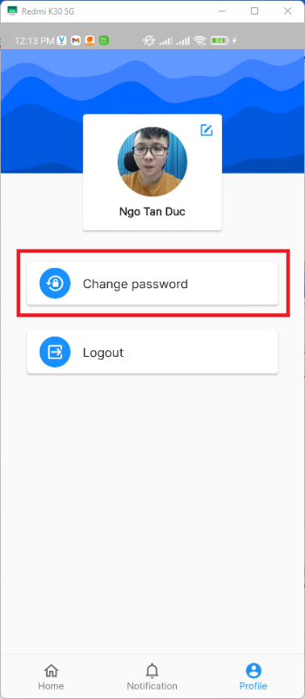

Figure 218. <Examinee app> Change password (Step 2)

* + Step 3: Enter valid inputs to all fields



Figure 219. <Examinee app> Change password (Step 3)

* + Step 4: Press the “Update” button



Figure 220. <Examinee app> Change password (Step 4)

###### Update profile

* + Step 1: From the Home screen, navigate to Profile screen

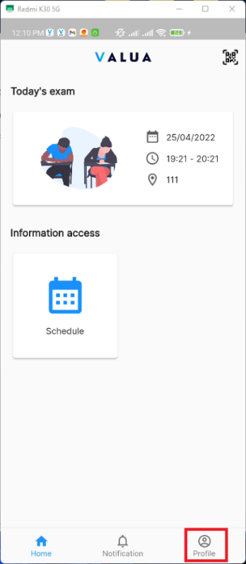

Figure 221. <Examinee app> Update profile (Step 1)

* + Step 2: Press the “Update profile” icon

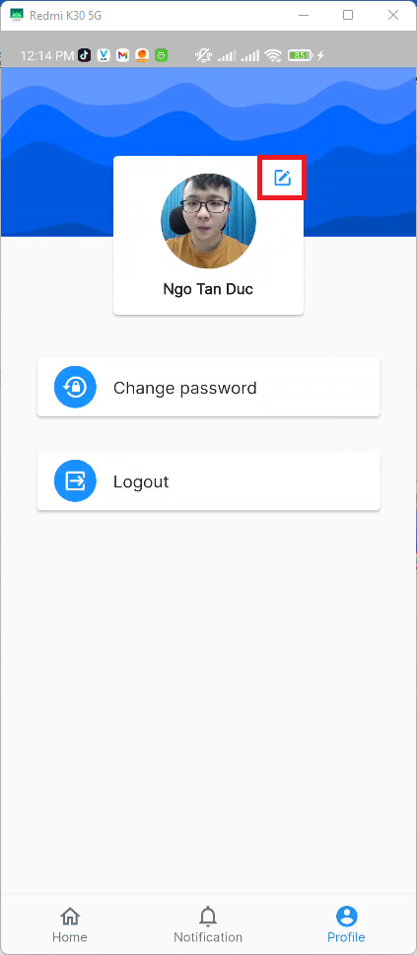

Figure 222. <Examinee app> Update profile (Step 2)

* + Step 3: Enter valid inputs to all fields

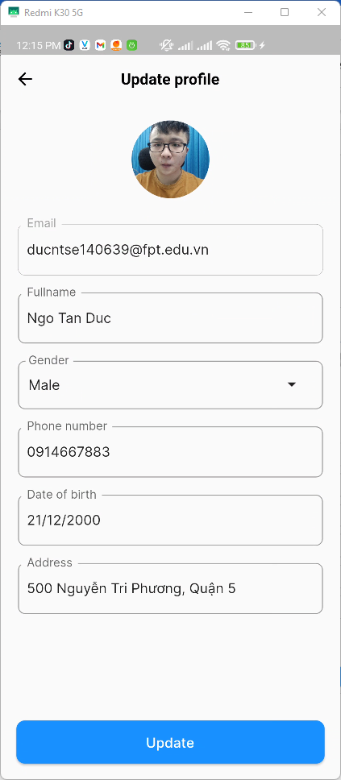

Figure 223. <Examinee app> Update profile (Step 3)

* + Step 4: Press the “Update” button

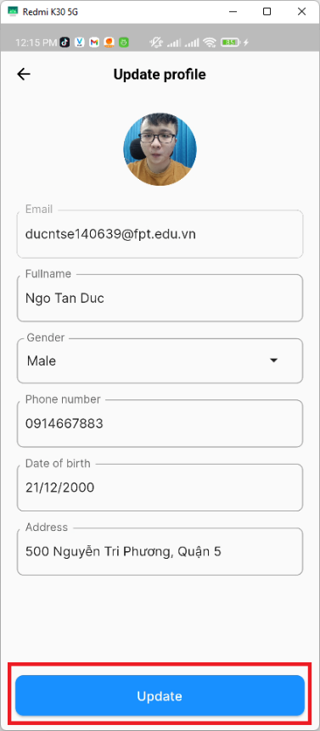

Figure 224. <Examinee app> Update profile (Step 4)

###### QR Scanner

* + From the Home screen, pressed the “QR Scanner” icon on the top right corner of the screen.

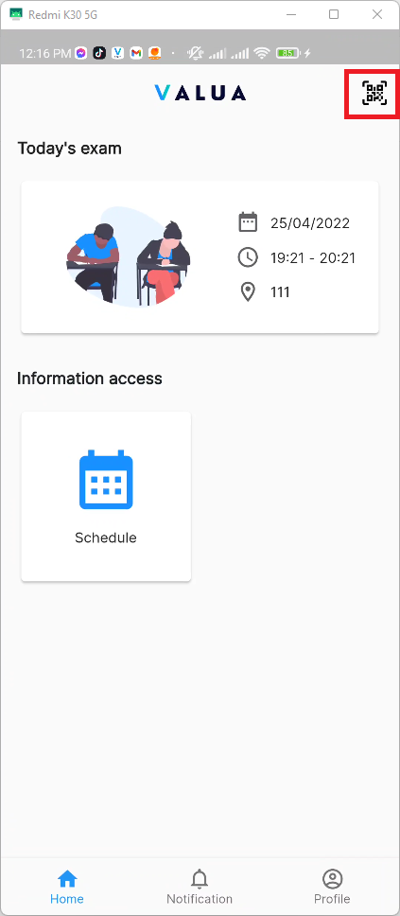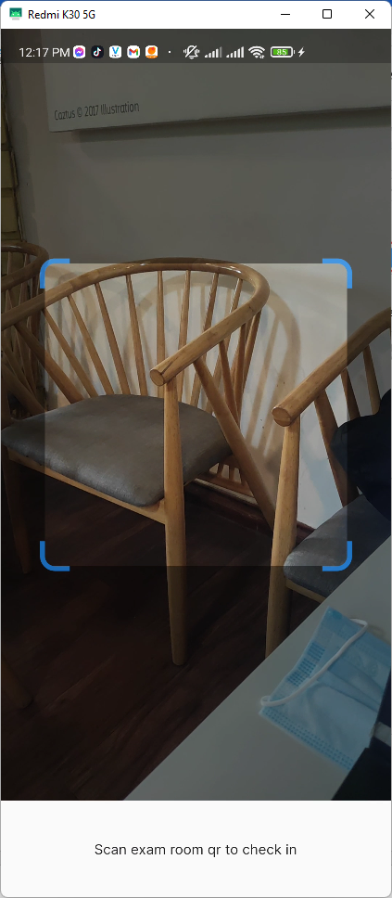

Figure 225. <Examinee app> QR Scanner

#### 3.2.4. For camera application usage

##### Overview:

* The application supports examinees to check attendance. It also supports staff to update attendance, create and update report.

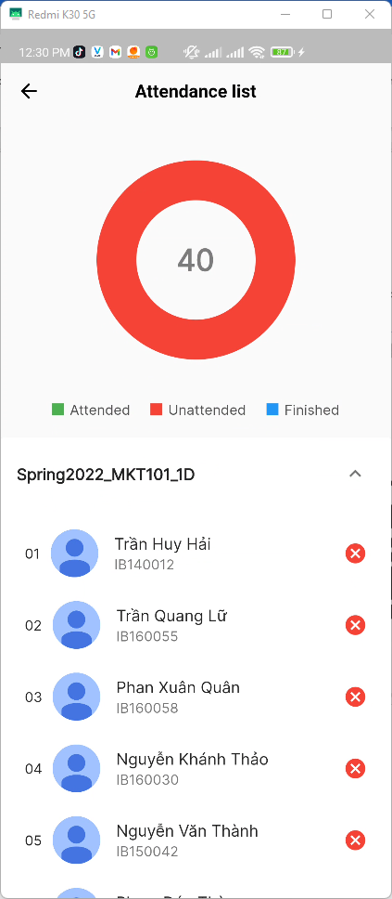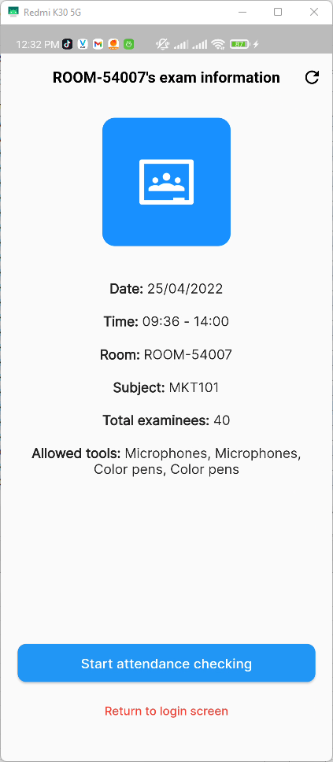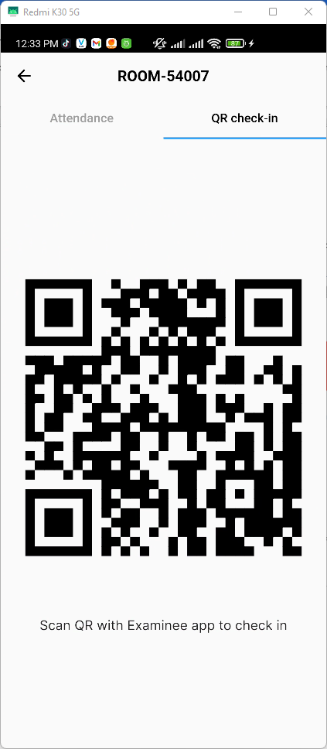

Figure 226. <Camera app> Overview

##### Features:

###### Log in

* **Log in with the staff’s account**
  + Step 1: Enter email and password

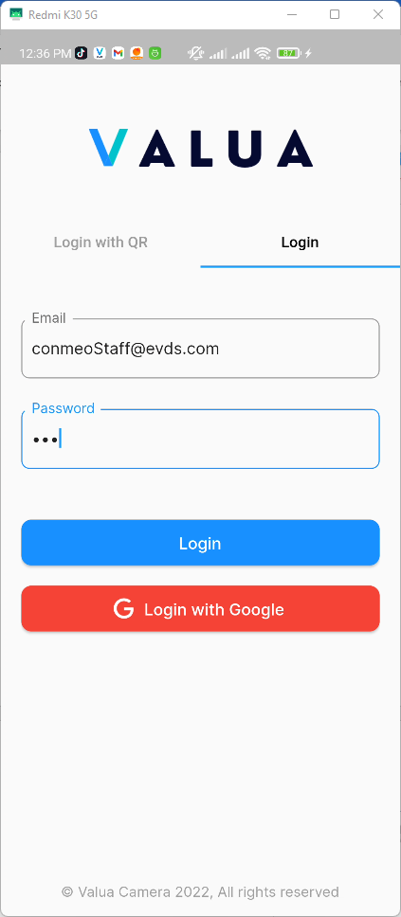

Figure 227. <Camera app> Login (Step 1)

* Step 2: Press the “Login” button

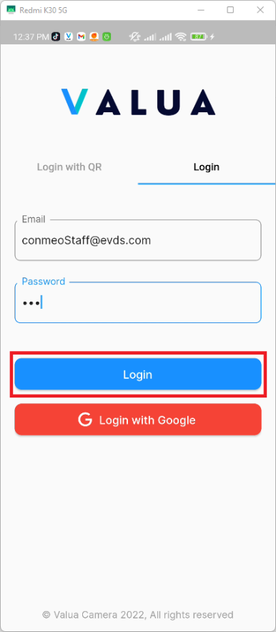

Figure 228. <Camera app> Login (Step 2)

* Alternative 1: you can login with your own google account by pressing the “Login with Google” button

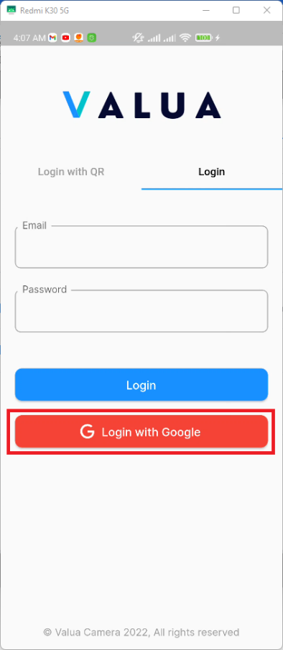

Figure 229. <Camera app> Login with Google

* Alternative 2: Login with QR
  + Navigate to Login with QR

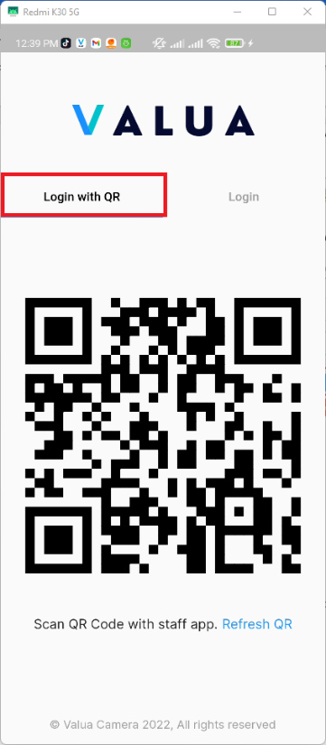

Figure 230. <Camera app> Login with QR

* + Use QR Scanner of Staff app to scan the QR.

###### Check attendance

* Step 1: To start check attendance, staff pressed “Start attendance checking” in exam room information screen

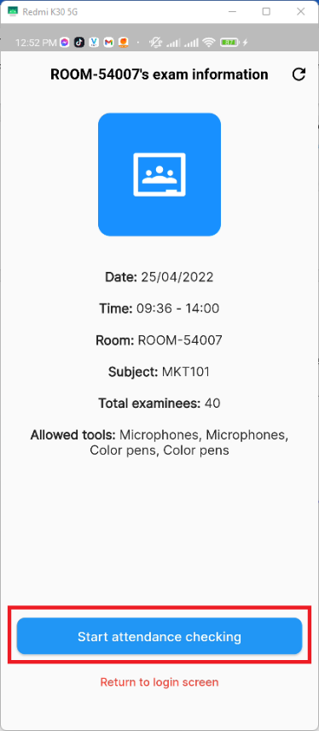

Figure 231. <Camera app> Check attendance (Step 1)

* + Step 2: Navigate to QR check-in tab

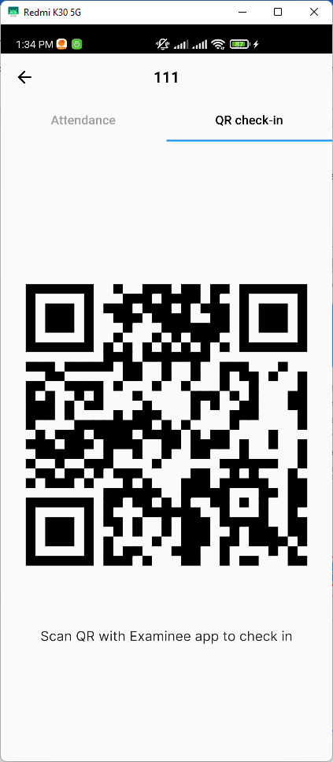

Figure 232. <Camera app> Check attendance (Step 2)

* + Step 3: Examinee will use the QR Scanner on examinee app to scan the QR Code to check-in. If the examinee has an attendance in the current exam room, the camera will navigate to the camera screen and will automatically take a picture after 5 seconds



Figure 233. <Camera app> Check attendance (Step 3)

* + If the examinee face in the image matches with their face data, camera will show the information about the attendance including their name, attempt image, attend time and their seat position.

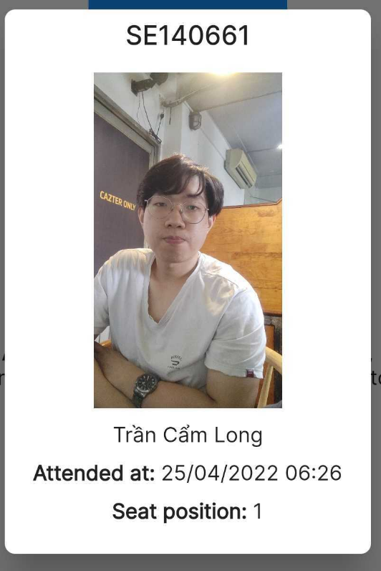

Figure 234. <Camera app> Successful attempt modal

* + If their face doesn’t match, it will show the following error:

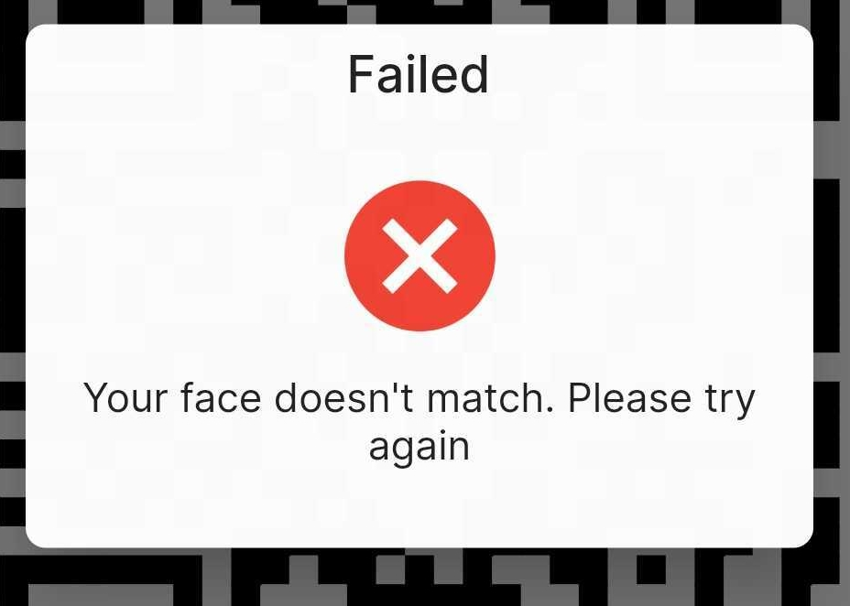

Figure 235. <Camera app> Failed attempt modal

* + You can view the if the attendance was checked by navigate to attendance tab

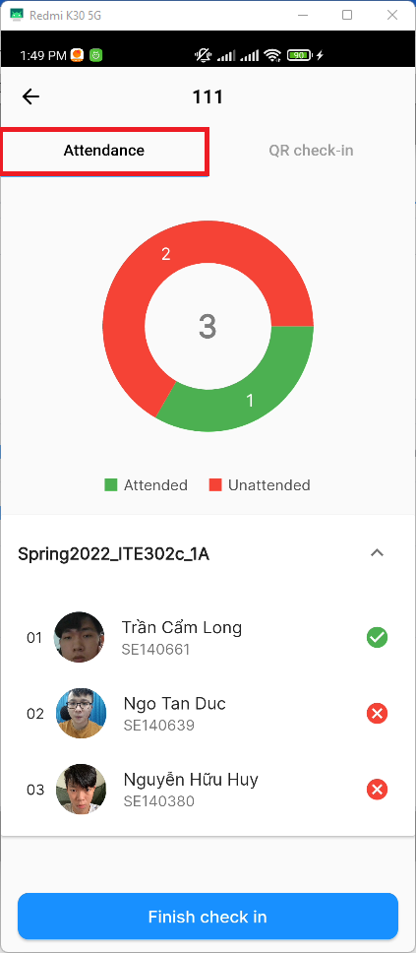

Figure 236. <Camera app> Attendance tab

* + Step 4: When finish checking attendance, press “Finish check in”

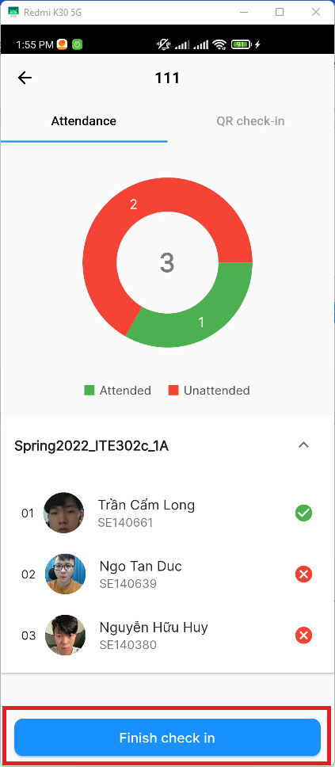

Figure 237. <Camera app> Check attendance (Step 4)

* + Step 5: Camera app will prompt a password field that required staff to fill in. Press “Submit” to navigate to exam room dashboard

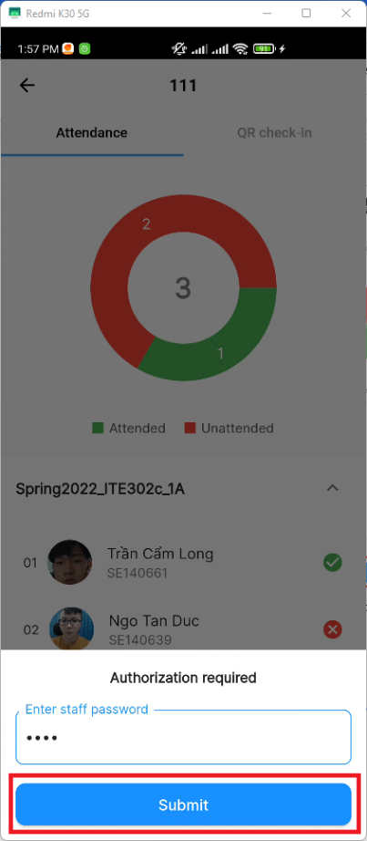

Figure 238. <Camera app> Check attendance (Step 5)

###### View current exam room detail

* + Navigate to exam room dashboard, press “Info” to view the current exam room detail

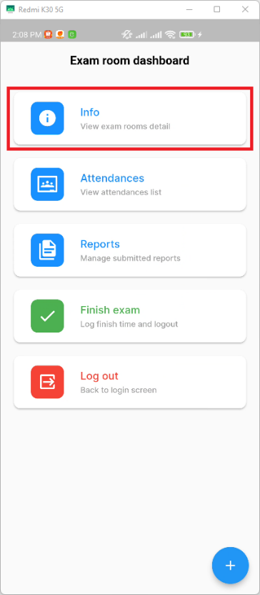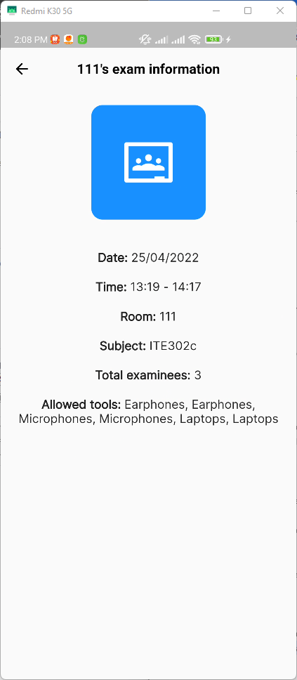

Figure 239. <Camera app> View current exam rooms detail

###### Update attendance

* + Step 1: From exam room dashboard screen, press on “Attendances” button to navigate to attendances screen

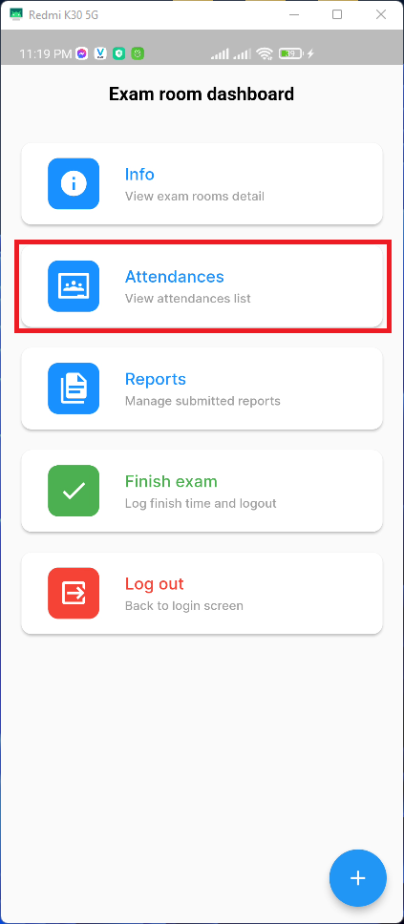

Figure 240. <Camera app> Update attendance (Step 1)

* + Step 2: From the attendance screen, if the status of attendance is unattended, you can swipe the attendance list tile from right to left and press “Check” to check the attendance

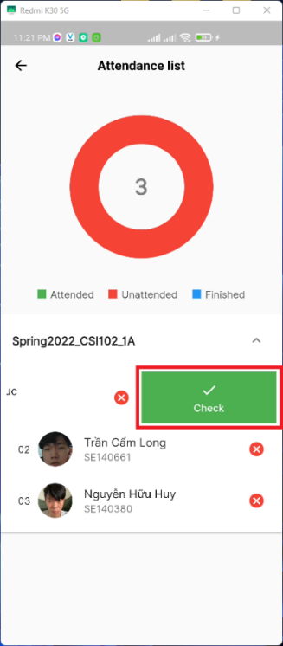

Figure 241. <Camera app> Update attendance (Check)

* + If the status of the attendance is attended:
  + You can swipe the attendance list tile from right to left and press “Uncheck” to uncheck the attendance

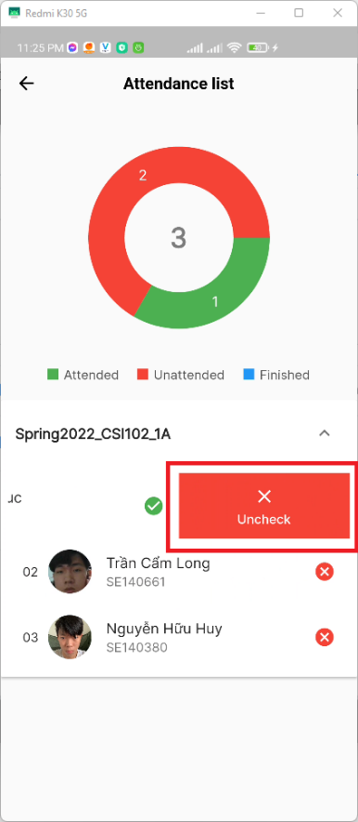

Figure 242. <Camera app> Update attendance (Uncheck)

* + Or from left to right and press “Finish” to log the time the attendance finishes their exam

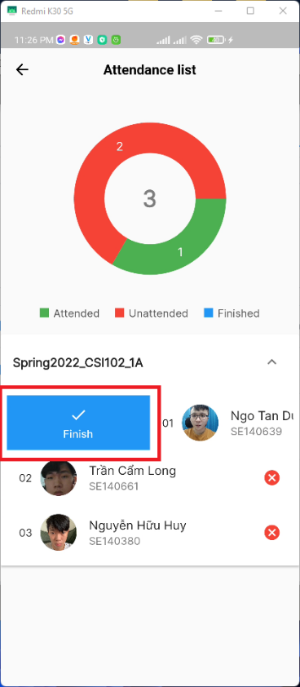

Figure 243 <Camera app> Update attendance (Finish)

###### Create report

* + Step 1: From exam room dashboard screen, press on “Create report” button at the bottom right of the screen

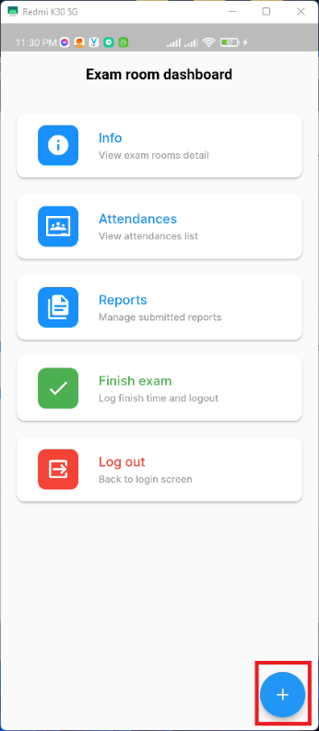

Figure 244. <Camera app> Create report (Step 1)

* + The app will prompt a modal bottom sheet that allow you to choose the report type you want to create

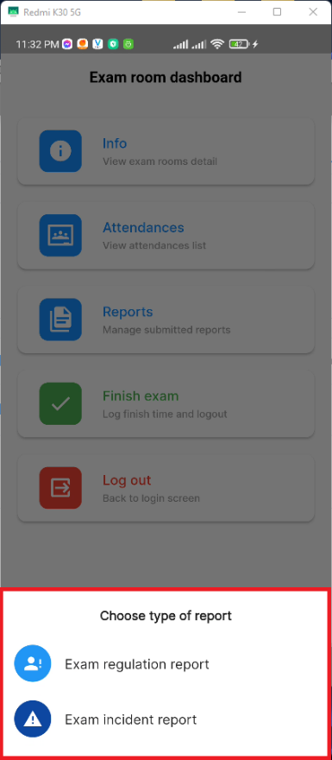

Figure 245. <Camera app> Choose report type modal

* + Step 2: After you select the type of report, the app will navigate you to the appropriate “Create report” form

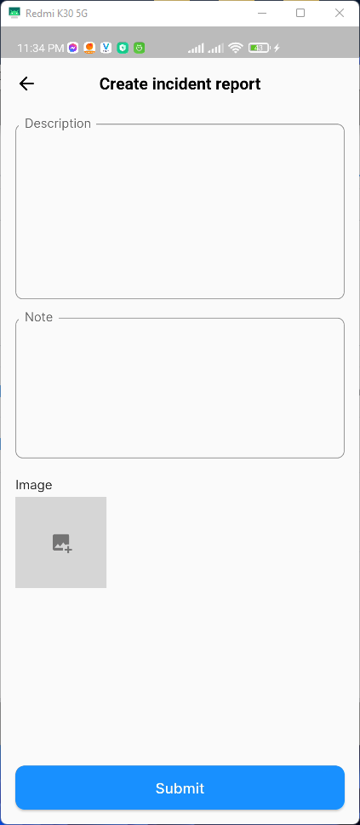 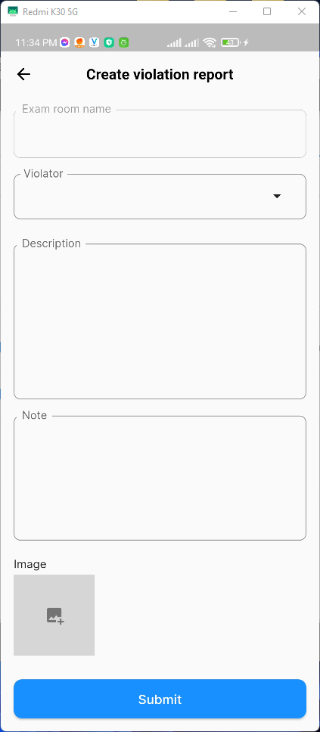

Figure 246. <Camera app> Create report form

* + Step 3: When finish filling the form, press “submit” to create report

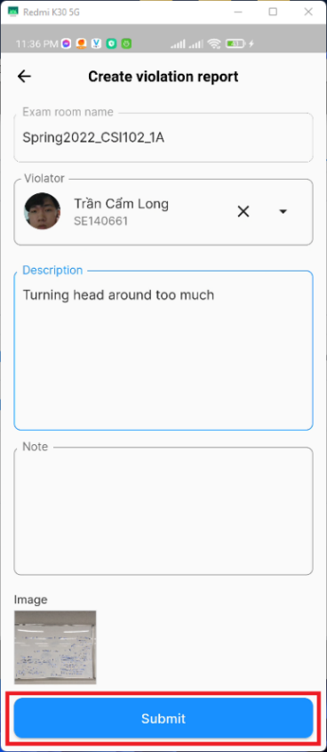

Figure 247. <Camera app> Create report (Step 3)

###### Update report

* + Step 1: From exam room dashboard screen, press on “Reports” button to navigate to reports screen

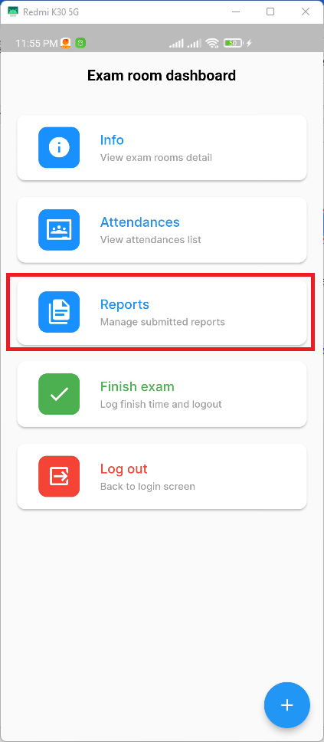

Figure 248. <Camera app> Update report (Step 1)

* + Step 2: Click on the report you want to update

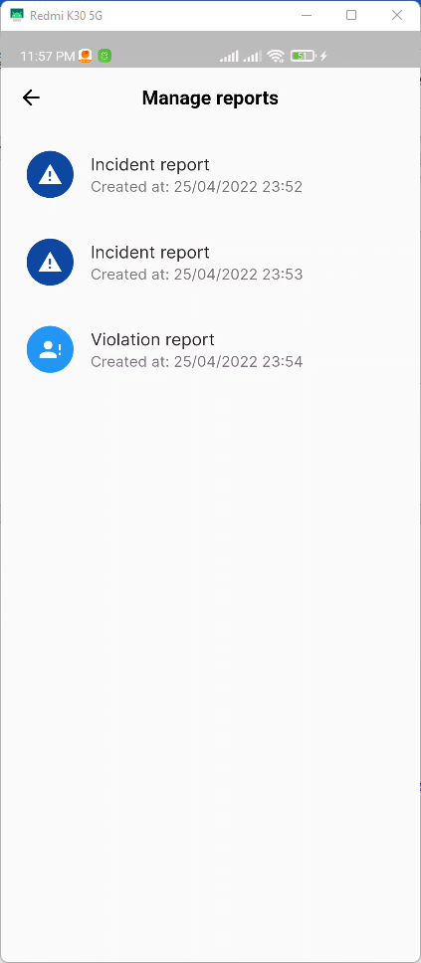

Figure 249. <Camera app> Update report (Step 2)

* + Step 3: Edit the fields you want to update

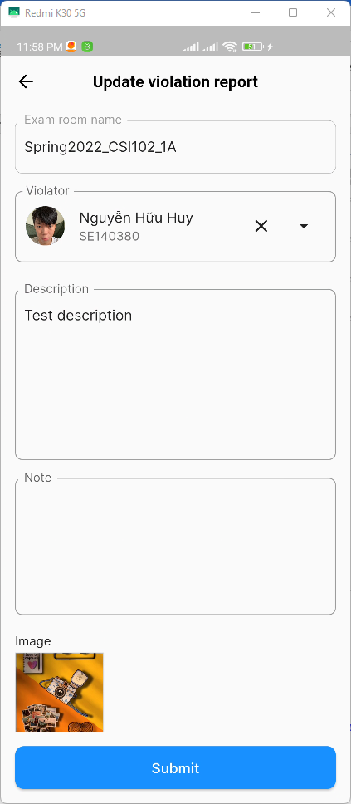

Figure 250. <Camera app> Update report (Step 3)

* + Step 4: Press “Submit” to update the report

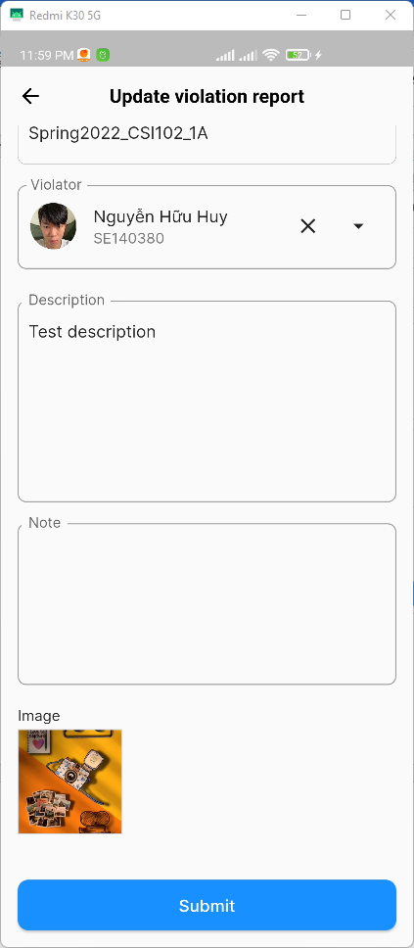

Figure 251. <Camera app> Update report (Step 4)

###### Finish exam

* + Navigate to exam room dashboard, press “Finish exam” to finish the exam and log the finish time. After you finish the exam, you will be re-navigating to the Login screen

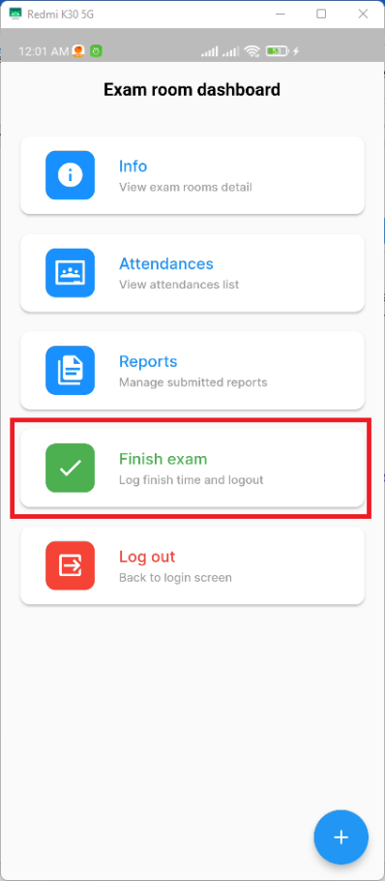 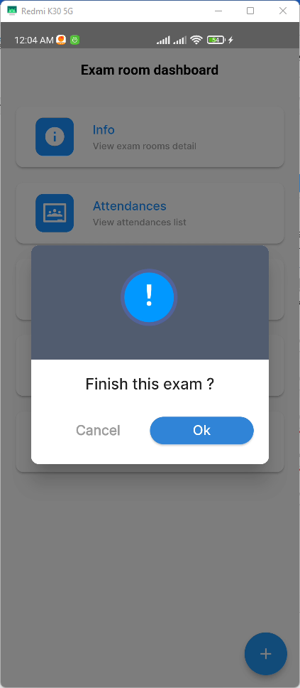

Figure 252. <Camera app> Finish exam

###### Log out

* + Navigate to exam room dashboard, press “Logout” to go back to login screen

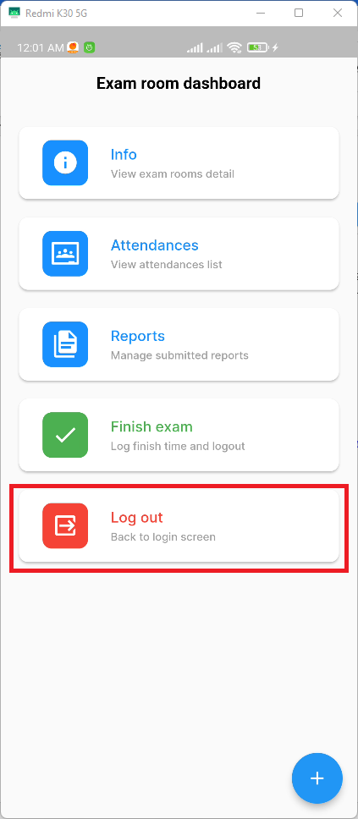

Figure 253. <Camera app> Log out